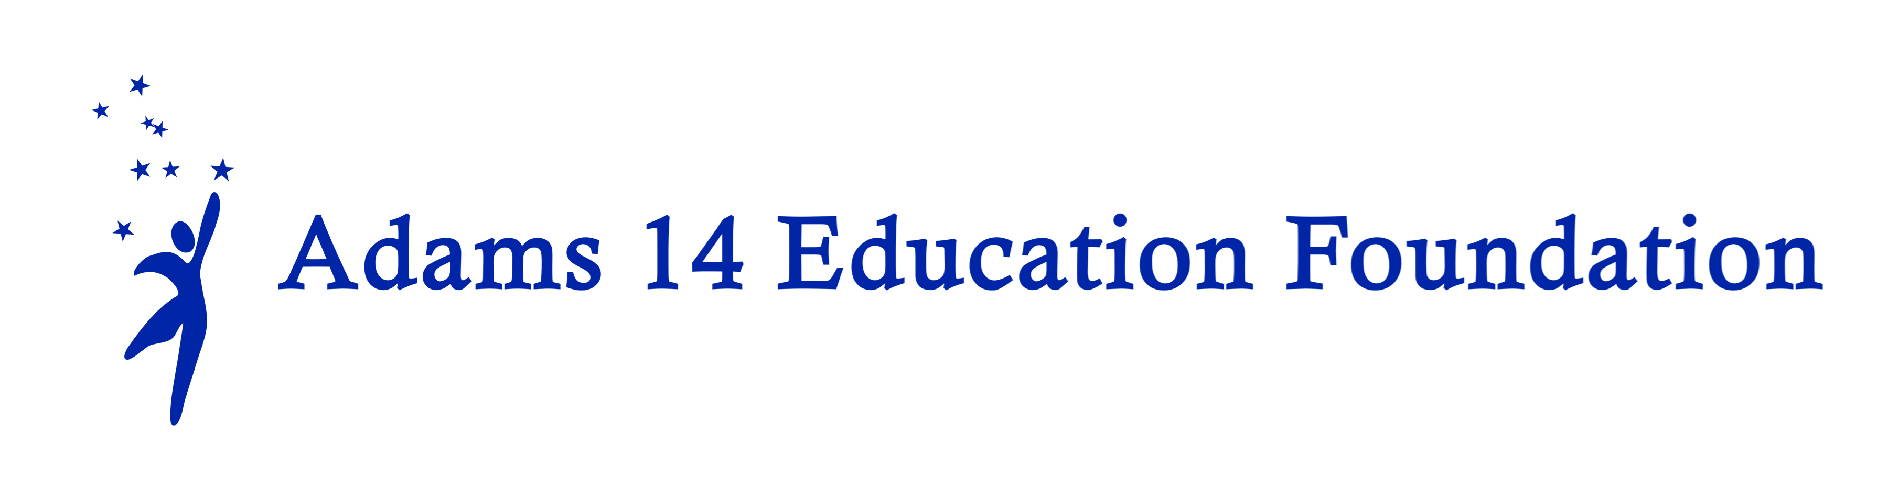

Funding the UnFunded(FTU)

2024-25

(Mini-Grants)

Creative approaches to enhance student achievement and expand student learning opportunities through projects not typically supported by traditional school funding
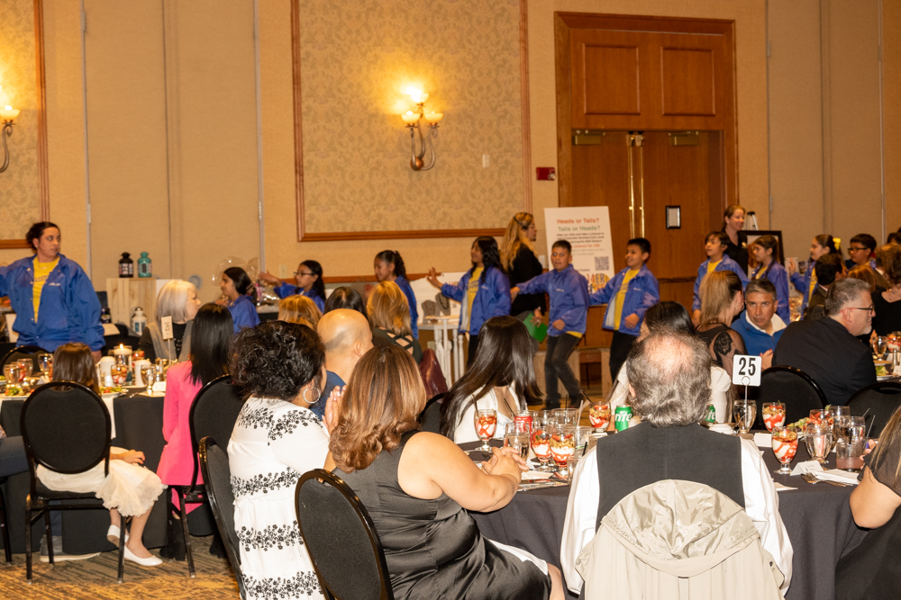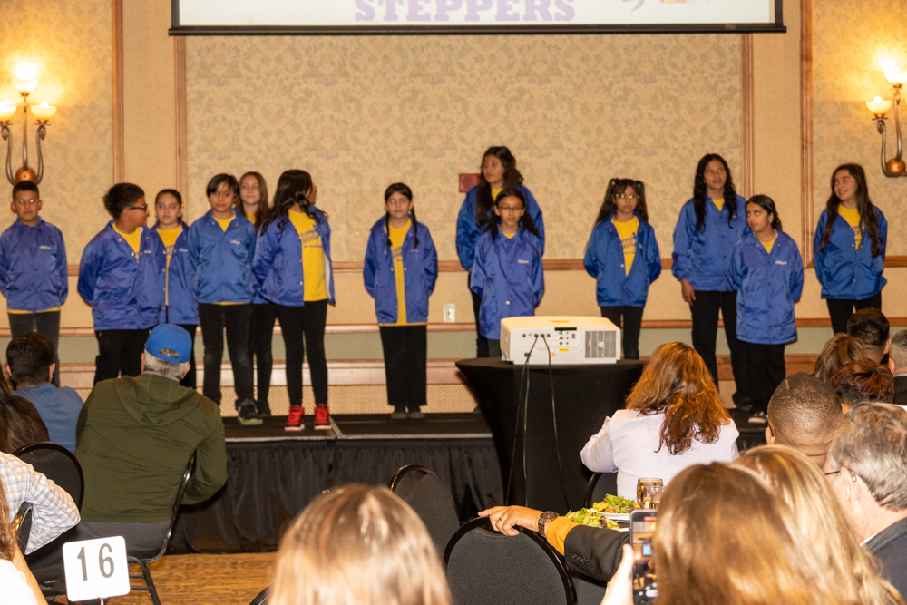
Ms. Wattley and Ms. Houghton have created one of our district’s great in-school programs, The Rosehill Steppers. The students learn new routines, leadership and team work throughout the year. They perform for district functions regularly. The Foundation has helped purchase jackets and a new speaker system for the Steppers.
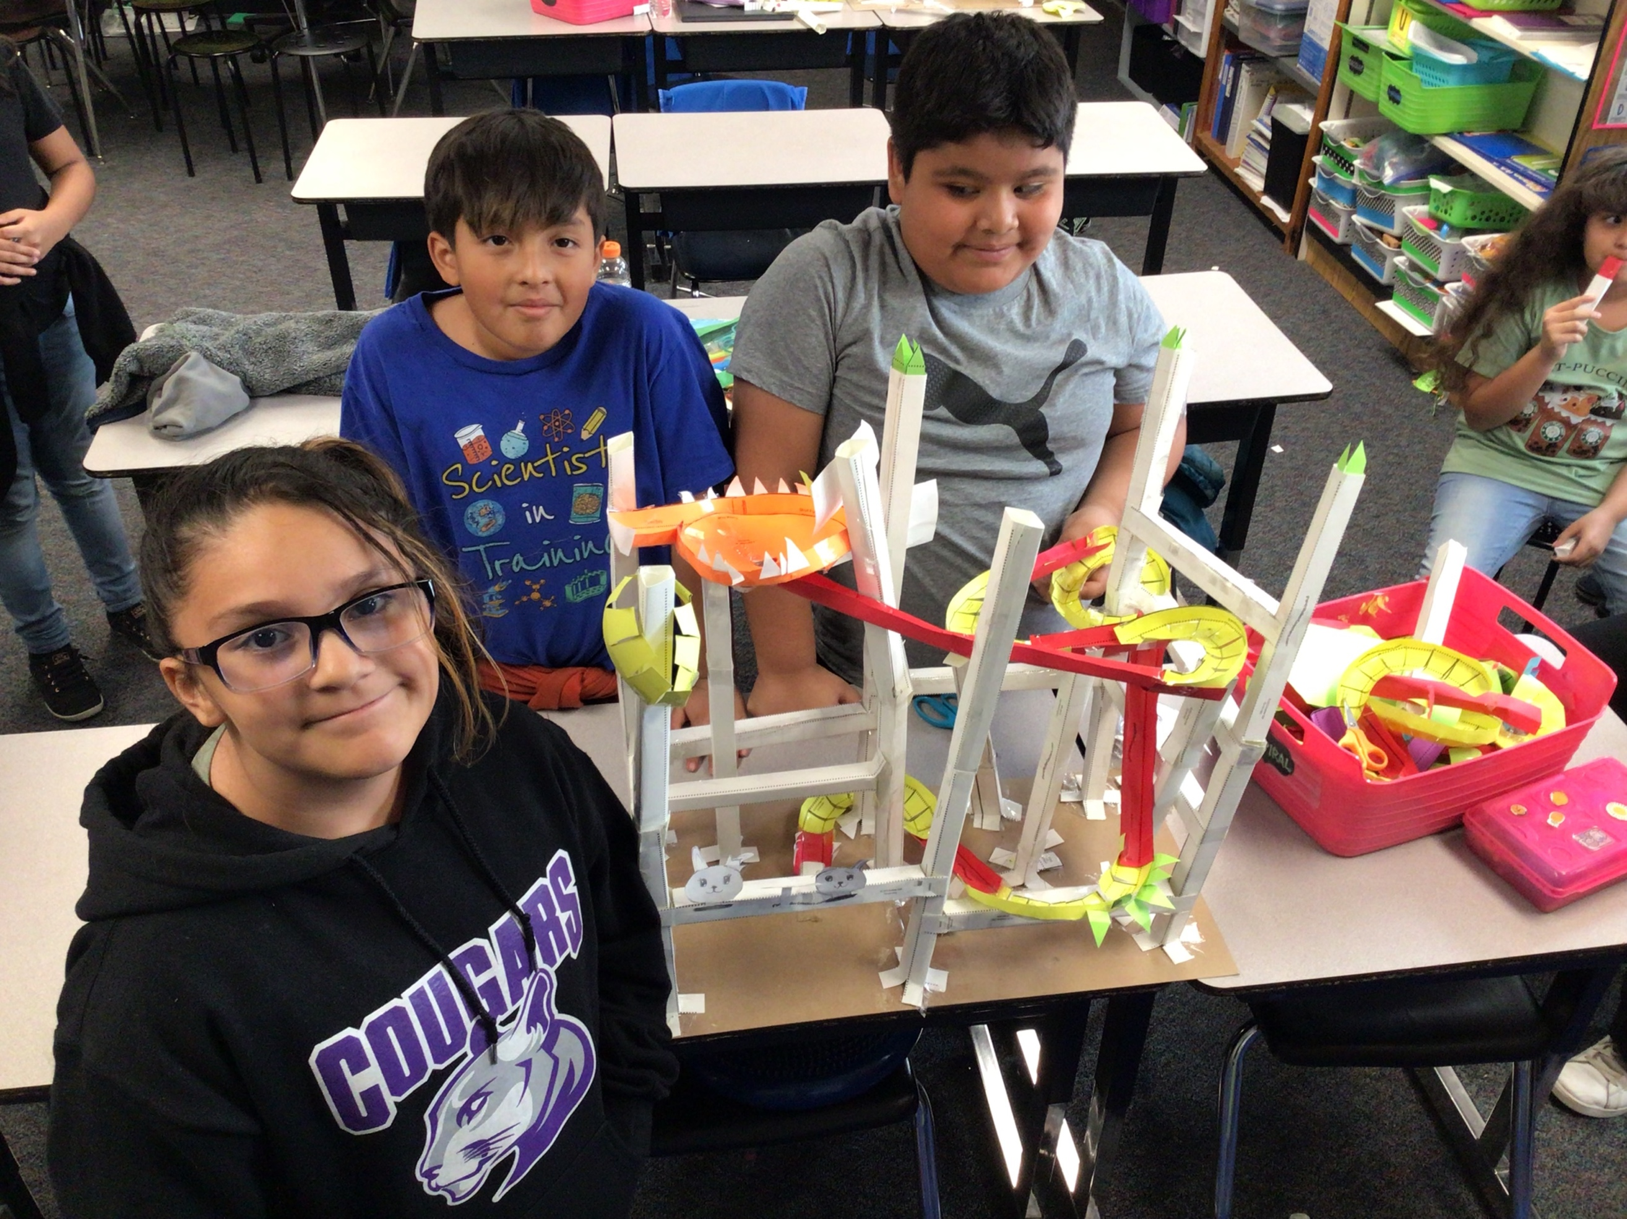
Ms. Johnson’s Paper Rollercoaster Potential and Kinetic Energy project provides students with a full range of science and engineering practices to make sense of natural phenomena and solve problems that require understanding of how energy is transferred and conserved.

Guidelines

MISSION | The Adams 14 Education Foundation provides funds for creative approaches to enhance student achievement or expand student-learning opportunities through projects not typically supported by traditional school funding.
ELIGIBILITY | All Adams County School District 14 employees or teams of employees are welcome to apply. Funded recipients may only re-apply for one consecutive grant period for the same project. Previous recipients may also submit a grant proposal for a new project
APPLICATION REQUIREMENTS | Applications must include:  - A completed funding application form. Please note that impact data is required for funding. An electronic version of the application is preferred.  - Signature by the applicant and supervisor/principal (submitting by email is considered an electronic signature with cc: to supervisor)  - A detailed budget showing how the dollars will be spent. You must submit website links to specific products needed for the project.  - No more than three pages including the budget. Do not attach any other papers or materials.  - A brief description of the impact of their project(s) at the end of the grant period. You may be asked to share your results at the 14er Fest in 2025 and on the Adams 14 Education Foundation website. Results should include how the funding assisted students to increase competencies via data, (i.e. satisfaction survey or test scores.) Photographs are appreciated.
GRANTS WILL NOT BE MADE FOR:  GRANTS WILL NOT BE MADE FOR: | - Transportation costs for field trips, etc. (Possible exceptions may be made by the Adams 14 Education Foundation Board from time to time.)  - Technology hardware (e.g., iPad, tablets, e-readers, etc.) Software requests may still be considered but must be approved by the Adams 14 Technology Department prior to purchase.  - Capital equipment and/or improvements to District facilities  - Substitute Teachers  - Stipends for District staff to attend conferences, seminars or classes  - Staff salaries  - Honorariums  - Projects normally funded by the school district’s regular operating budget.  - Duplicate proposals for the same project.  - Proposals identical to previously funded projects without a report or summary of the project’s previous impact and success.
AMOUNT OF GRANTS | From $300 to $1,500 per project  PLEASE NOTE: Grant funding must be obligated by the end of the school year for the Adams 14 Education Foundation’s end of year accounting.
APPLICATION DEADLINE | There will be two grant cycles.  Round one applications are due by Friday September 6, 2024 at 5 P.M. Electronic submissions preferred.  Round two application opening and deadline will be announded by December 1, 2024  lori.young@adams14.org
NOTE TO LAST YEAR’S RECIPIENTS | Be sure that you have submitted a final report on your previous project and provided accounting with a list of your expenditures. You will not be eligible for new funds until the program and accounting report for your previous funding has been completed.
If you have questions, please call or e-mail: | Lori Young, Executive Director  (720)218-7680 (Mobile)  lori.young@adams14.org

Review Process

A committee made up of Foundation Board members will review the grants and make the final awards. Remember that not all readers will be familiar with all grade levels and/or curricular areas. Please give a complete explanation of the project to assist the readers in their review.

Committee members will read and rate each application using the criteria listed below. Maximum score is 50 pts.

(10pts) Clarity: Project is clearly stated, describing project’s objectives and activities. Reviewer is able to visualize project "in action." Relevant project dates are included. Application is typed.

(15 pts) Originality/Innovation/Enrichment: Project involves a creative, unique approach to meet student needs while supporting district and school goals for achievement. Please note that FTU funds are NOT intended to pay for general supplies or activities normally supported by the basic curriculum or general budget. Mini-grants are expected to be "pilot" projects, and the Foundation does not expect to fund multiple or duplicate grants for the same project, whether year-to-year or from different teachers whether from the same or different schools. Collaborative proposals are encouraged.

(10 pts) Impact on Students Served: Project clearly describes how it will serve students including the number of students and parents. Please indicate if the project is sustainable and will serve students in future years.

(10 pts) Evaluation Process: Project includes criteria for measuring success. Specifically, what problem is being addressed? What results do you want to see?

(5 pts) Budget: Budget is detailed, complete, and realistic. If total project funding exceeds more than $1,500, include sources of any additional funding.

