LEADERSHIP COMMERCE CITY
Course Book

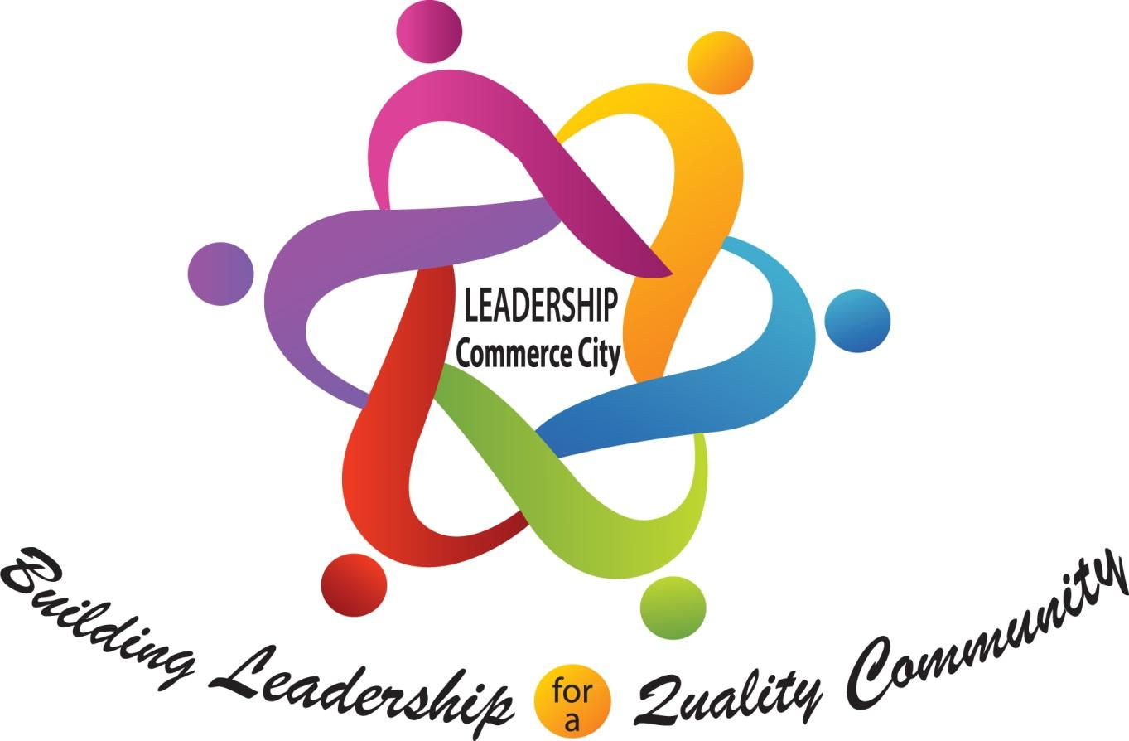

2024-25

What is Leadership Commerce City?
This 10-month community outreach and engagement opportunity was designed to allow community leaders to gain a better understanding of the Commerce City community and become more aware of all the city has to offer. The program allows the participants to create new networks and find areas to support beyond the class. The program begins the 2nd Friday of September with an orientation session and completes in mid-June with a graduation ceremony.
WHAT WILL I LEARN?
The program is designed, through the monthly presentations, to give each participant a “behind the scenes” tour of our city. From the history to the current issues facing our community, the class will hear from the experts via presentations. The course features site visits to organizations that the public normally does not see. The class is interactive, and participants will be encouraged to attend every session and help develop a community service project to be implemented before the program ends.
OBJECTIVES/Outcomes
- Gain a better understanding of the existing public and private originations servicing Commerce City and how each operates.
- Look for opportunities to support current structures by volunteering, running for office or serving on a board.

HISTORY AND FOUNDING OF LEADERSHIP COMMERCE CITY
The original concept of Leadership Commerce City (LCC) started on a much smaller scale in 2014. The program was slated to be called “Leadership Adams14.” After several meetings with school district and community leaders it was determined that a more robust program should be developed encompassing the entire Commerce City community. Thanks to the support of the Adams 14 School District, City of Commerce City, community leaders, the Aurora Chamber of Commerce, and their Leadership Aurora program, LCC launched August of 2015. LCC is designed to provide perspective, networking, learning, and leadership experiences for those who live, work, and serve in Commerce City.

PROGRAM HIGHLIGHTS

- You will learn more about the Commerce City community, to build leadership for a quality community.

- Leadership Commerce City equips participants to grow professionally and ascend to the next level in their business and community endeavors via training in several areas from effective communication skills to interacting with elected officials. This can help build a strong community foundation for future growth.

- The program brings diverse people together to broaden their experiences and perspectives. This Leadership program commences each September and continues through June with a graduation in Mid-June.

- Leadership skills are emphasized in all classes which challenge participants to enhance their management and leadership skills through class assignments and field trips.

- The community becomes the classroom as classes are held in a variety of forums throughout Commerce City. This will give you the opportunity to expand your business horizons.

- Participants learn through various channels including presentations given by prominent speakers within the Commerce City and Denver area.

- Participate in a capstone project that will positively impact the City of Commerce City.

Application available: adams14foundation.org

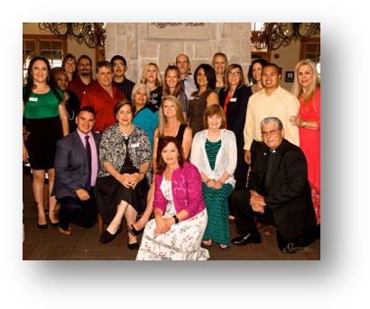

LEADERSHIP PROGRAM CLASS TOPICS AND SCHEDULES
Dates and Topics
SEPTEMBER 13, 2024 Orientation/Leadership Team Building 8:00 a.m. to 4:00 p.m.
(2nd Friday)
OCTOBER 4, 2024 Meet the City 8:00 a.m. to 4:00 p.m.
NOVEMBER 1, 2024 Economic Development 8:00 a.m. to 4:00 p.m.
DECEMBER 6, 2024 Water, Sanitation and the Environment 8:00 a.m. to 4:00 p.m.
JANUARY 10, 2025 Commerce City Non-Profit Organizations 8:00 a.m. to 4:00 p.m.

FEBRUARY 6, 2025 Civic Day at the Colorado Capitol 8:00 a.m. to 4:00 p.m.
(Thursday)
MARCH 7, 2025 Meet Adams County School District 14 8:00 a.m. to 4:00 p.m.
and meet School District 27J
APRIL 4, 2025 Public Safety – Fire & Police Departments 8:00 a.m. to 4:00 p.m.
MAY 2, 2025 Quality of Life 8:00 a.m. to 4:00 p.m.
JUNE 6, 2025 Past, Present and Future of Commerce City 8:00 a.m. to 4:00 p.m.
JUNE 20, 2025 Graduation Day 8:30 a.m. - 10:00a.m.

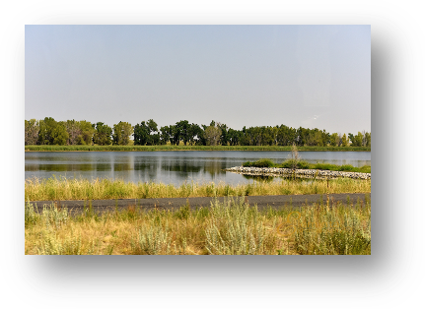

LEADERSHIP COMMERCE CITY
General Information

Building Leadership for a Quality Community
September 8th, 2023-June 21st, 2024
First Friday of every month (except when noted differently)
8:00 a.m. – 4:00 p.m. (unless noted differently)
Light breakfast served each session
Speakers to include a diverse group of people within the city to include Local, State and National officials, Economic Development leaders, Business leaders, Non-Profit leaders, and Minority Organization leaders
Lunch to be served for each session
Evaluation sheet completed at the end of each session

Class Locations
Rocky Mountain Arsenal National Wildlife Refuge
6550 Gateway Road, Commerce City, CO 80022 (303-289-0930)
Commerce City- Civic Center
7887 East 60th Avenue, Commerce City, CO 80022 (303-289-3612)
Commerce City Heritage and Cultural Center
6505 East 60th Avenue, Commerce City, CO 80022 (303-288-2590)
Adams City High School
7200 Quebec parkway, Commerce City, CO 80022 (303-289-3111)
Adams County Communications Center
7321 Birch St, Commerce City, CO 80022 (303-288-1535)
South Adams County Fire Department Headquarters
6050 Syracuse Street, Commerce City, CO 80022 (303-288-0835)
South Adams County Water and Sanitation District
(Stevenson Administration Building)
6595 East 70th Avenue, Commerce City, CO 303-288-2646)
Adams 14 ESS Building
5291 East 60th Avenue, Commerce City, CO 80022 (303-853-3333)
Eagle Pointe Recreation Center
6060 Parkway Drive, Commerce City, CO 80022 (303-289-3760)
Brighton 27J School District
Various Locations
SUNCOR Commerce City Refinery
5455 Brighton Blvd., Commerce City, CO 80022 (303-286-5701)
Stout Street Foundation
7251 E. 49th Avenue, Commerce City, CO 80022 (303-321-2533)
Boys and Girls Club
6201 East 62nd Avenue, Commerce City, CO 80022
Adams County Government Center
4430 South Adams County Parkway, Brighton, CO 80601 (303-659-2120)
Colorado State Capitol
200 E. Colfax Avenue, Denver, CO 80203 (303-866-2604)
Flatrock Training Center
23600 E. 128th Avenue, Commerce City, CO 80022 (720-523-7500)
Bison Ridge Recreation Center
13905 E. 112th Avenue, Commerce City, CO 80022 (303-289-1500)
Reunion Coffee House
10601 Reunion Parkway, Commerce City, CO 80022 (720-477-0847x715)

AND MORE
POLICIES AND TERMS OF COURSE
General Terms
- Must be able to actively participate and devote the time and commitment required to complete the Leadership Commerce City Program.
- Write a brief statement (English or Spanish) on What Leadership Means to Me and tell us what you expect to get from your time in Leadership Commerce City.
- Must attend 8 classes to graduate. (First Friday of every month starting September 13, 2024) The first class is mandatory.
- I agree to be interviewed by members of the Leadership Commerce City Committee as part of the application process.
- Interviews will be completed by August 23rd, 2024.
- Notification will be sent out regarding acceptance by email.
- Application deadline is August 6, 2024. Payment is due with the application.
- Application must be completed (adams14foundation.org).

Cancellation & Refund Policy
1. Cancellations must be made in writing and received by the Leadership Commerce City Administrator by 5:00 p.m. on the dates specified below.
2. Cancellations before August 11th will be given a full refund of any tuition paid.
3. Cancellations after August 18th and prior to the start of the opening session will be given a 50% refund of the full tuition amount. If scholarship money has been provided, no tuition refund will be provided to the participant. If no tuition has been paid, 50% tuition will be due.
4. Cancellations the day of the opening session and after will be given no refund. Any candidate who misses the first session will be dropped from the class and will still be responsible for the full tuition amount.
5. Even though circumstances do arise, any participant missing more than three sessions may not graduate with the class, and no portion of tuition will be refunded.
6. In addition, any participant who does not fulfill all the attendance requirements related to class projects and capstone projects may not graduate with the class, and no portion of tuition will be refunded.

Attendance Policy
In order to accomplish Leadership Commerce City’s objectives, the full commitment and participation of each individual session is necessary. Participants are expected to attend all sessions including:
1) First Session September 13th, 2024.
2) Sessions are held on the first Friday from September 13th, 2024 to June 6th, 2025 (unless otherwise noted). The session time is 8:00 a.m. to 4:00 p.m.
3) Graduation Program–2-hour session and ceremony on June 20, 2025.
4) A Capstone Project is required independent of class sessions. (Must be completed prior to graduation).
A maximum excused absence time of sixteen (16) hours will be allowed during the program year. Time absent will be counted if a class member arrives late or leaves early. Please arrive on time and stay until the session ends.
If a class member is absent more than the allowed sixteen hours, then the participant must submit a written statement to the Leadership Commerce City Committee as to the reason for the absence(s).
The Committee may decide to require the class member to make-up the day by attending a Leadership Commerce City session the following year, doing an independent study day, writing a one-page typed paper about the topic missed, or attending some alternate event, etc. and will be handled on a case-by-case basis.
Absences over the allowable sixteen hours may be excused only because of severe illness, catastrophe, or extenuating circumstances based upon a written statement to, and approval by, the Leadership Commerce City Committee. Participants that are absent more than sixteen hours will be required to attend those sessions missed the following year and may be able to graduate with future classes.
Class members will be kept informed throughout the program year of the number of hours they have been counted absent.
If you have questions regarding the attendance policy, please contact the Administrator.

Other
To be courteous to your class members and presenters, please silence your cell phones, I-Pads, Tablet, and other electronic devices during class sessions. Limit interruptions for yourself and others.
Where appropriate, keep your Leadership Commerce City experience confidential. Maintaining confidentiality helps speakers feel comfortable being open and honest. Fellow classmates also need to know that what they say is being held in confidence.
Complete your evaluation survey at the end of each session. Your comments help determine the format for future classes. Please feel free to elaborate on your comments. Suggestions are always welcome.
Leadership Commerce City reserves the right to remove any participant from the program.

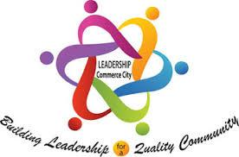
SESSION 1 (Friday, Sept. 13, 2023) 8:00 a.m. - 4:00 p.m.
LEADERSHIP COMMERCE CITY ORIENTATION

This is the first class and orientation of the program and expectations of the course.

Class Objectives:
- Learn about the Leadership Commerce City course and expectations.
- Introductions of all participants.
- Class officer discussion and elections
Class Outline: Class Leaders: Lori Young
- Meet at Bison Ridge Recreation Center
- Breakfast at 8:15 a.m.
- Welcome and Introductions – Lori Young-Hayes
- Program overview
- Day Presenter – Russ Jenson
- Discussion and election of Class Officers

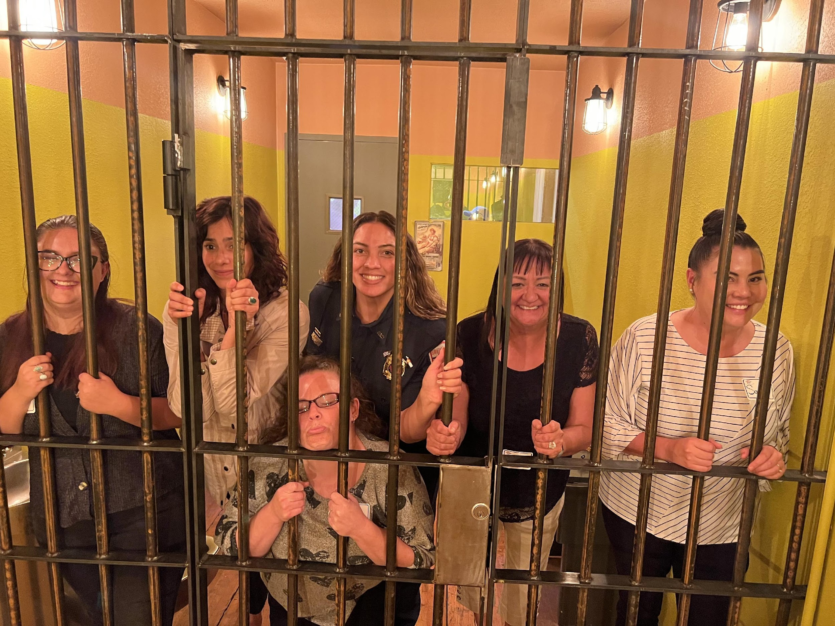
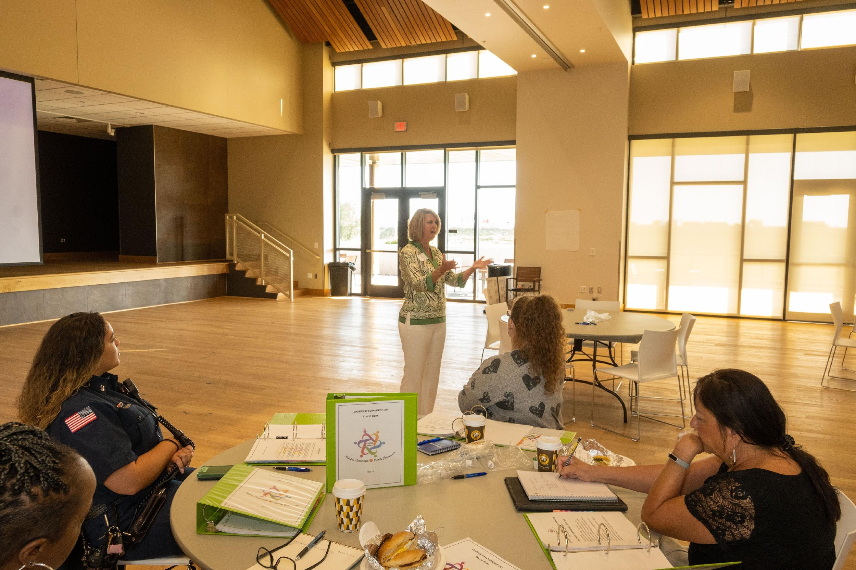
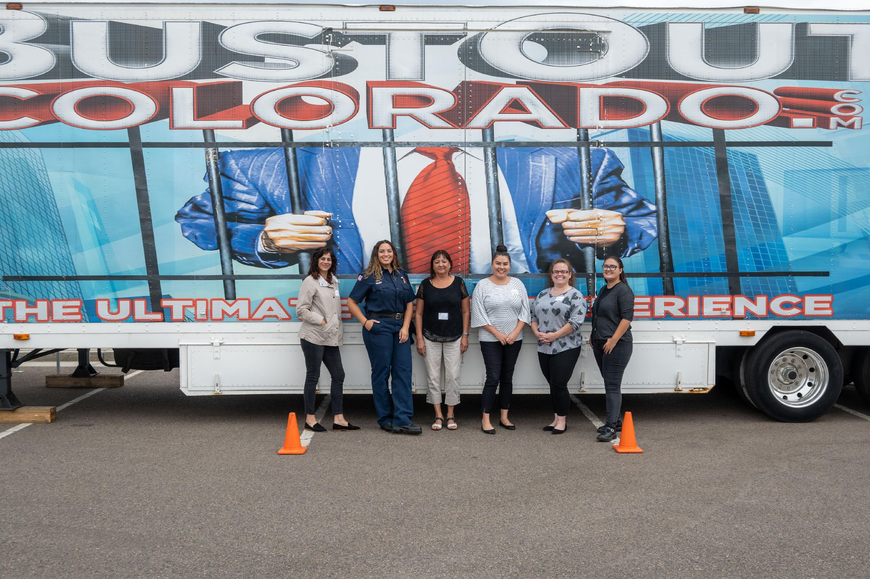

SESSION 2 (Friday – October 4, 2024) 8:00 a.m - 4:00 p.m.
MEET THE CITY DAY

This day will be an introduction to the City of Commerce City operations.
Class Objectives:
1. Learn about the city.
Class Outline: Class Leaders: Lisa Nordholt, Lori Young
Meet at the civic center.
Breakfast at 8:15 a.m.
Welcome and Introductions – 8:30 a.m.
Mayor Welcome- 8:45 - 9:00 a.m.
Council Member Introduction – 9:00-09:15 a.m.
City Manager overview of the city operations /State of the City– 9:15-
10:15 a.m.
City Clerk, Governance, Elections and Courts – 10:15 - 11:15 a.m.
Finance and Human Resources – 11:15 a.m. - 12:00 p.m.
Budget, Taxes and Metro Districts/Urban Renewals
LUNCH – 12:00 -12:30 p.m.
Tour of Civic Center – 12:30 - 1:30 p.m.
Growth & Development – 1:30-2:30 p.m.
Land Use/Zoning, Economic Development, Capital Improvement Projects
Residential Services & Amenities – 2:30-3:30 p.m.
Code Enforcement, Permits,
Arts & Culture
Public Works
Parks, Recreation & Golf
Emerging Issues – 3:30 p.m.
Wrap up – 3:45 p.m.
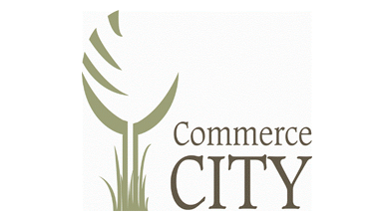
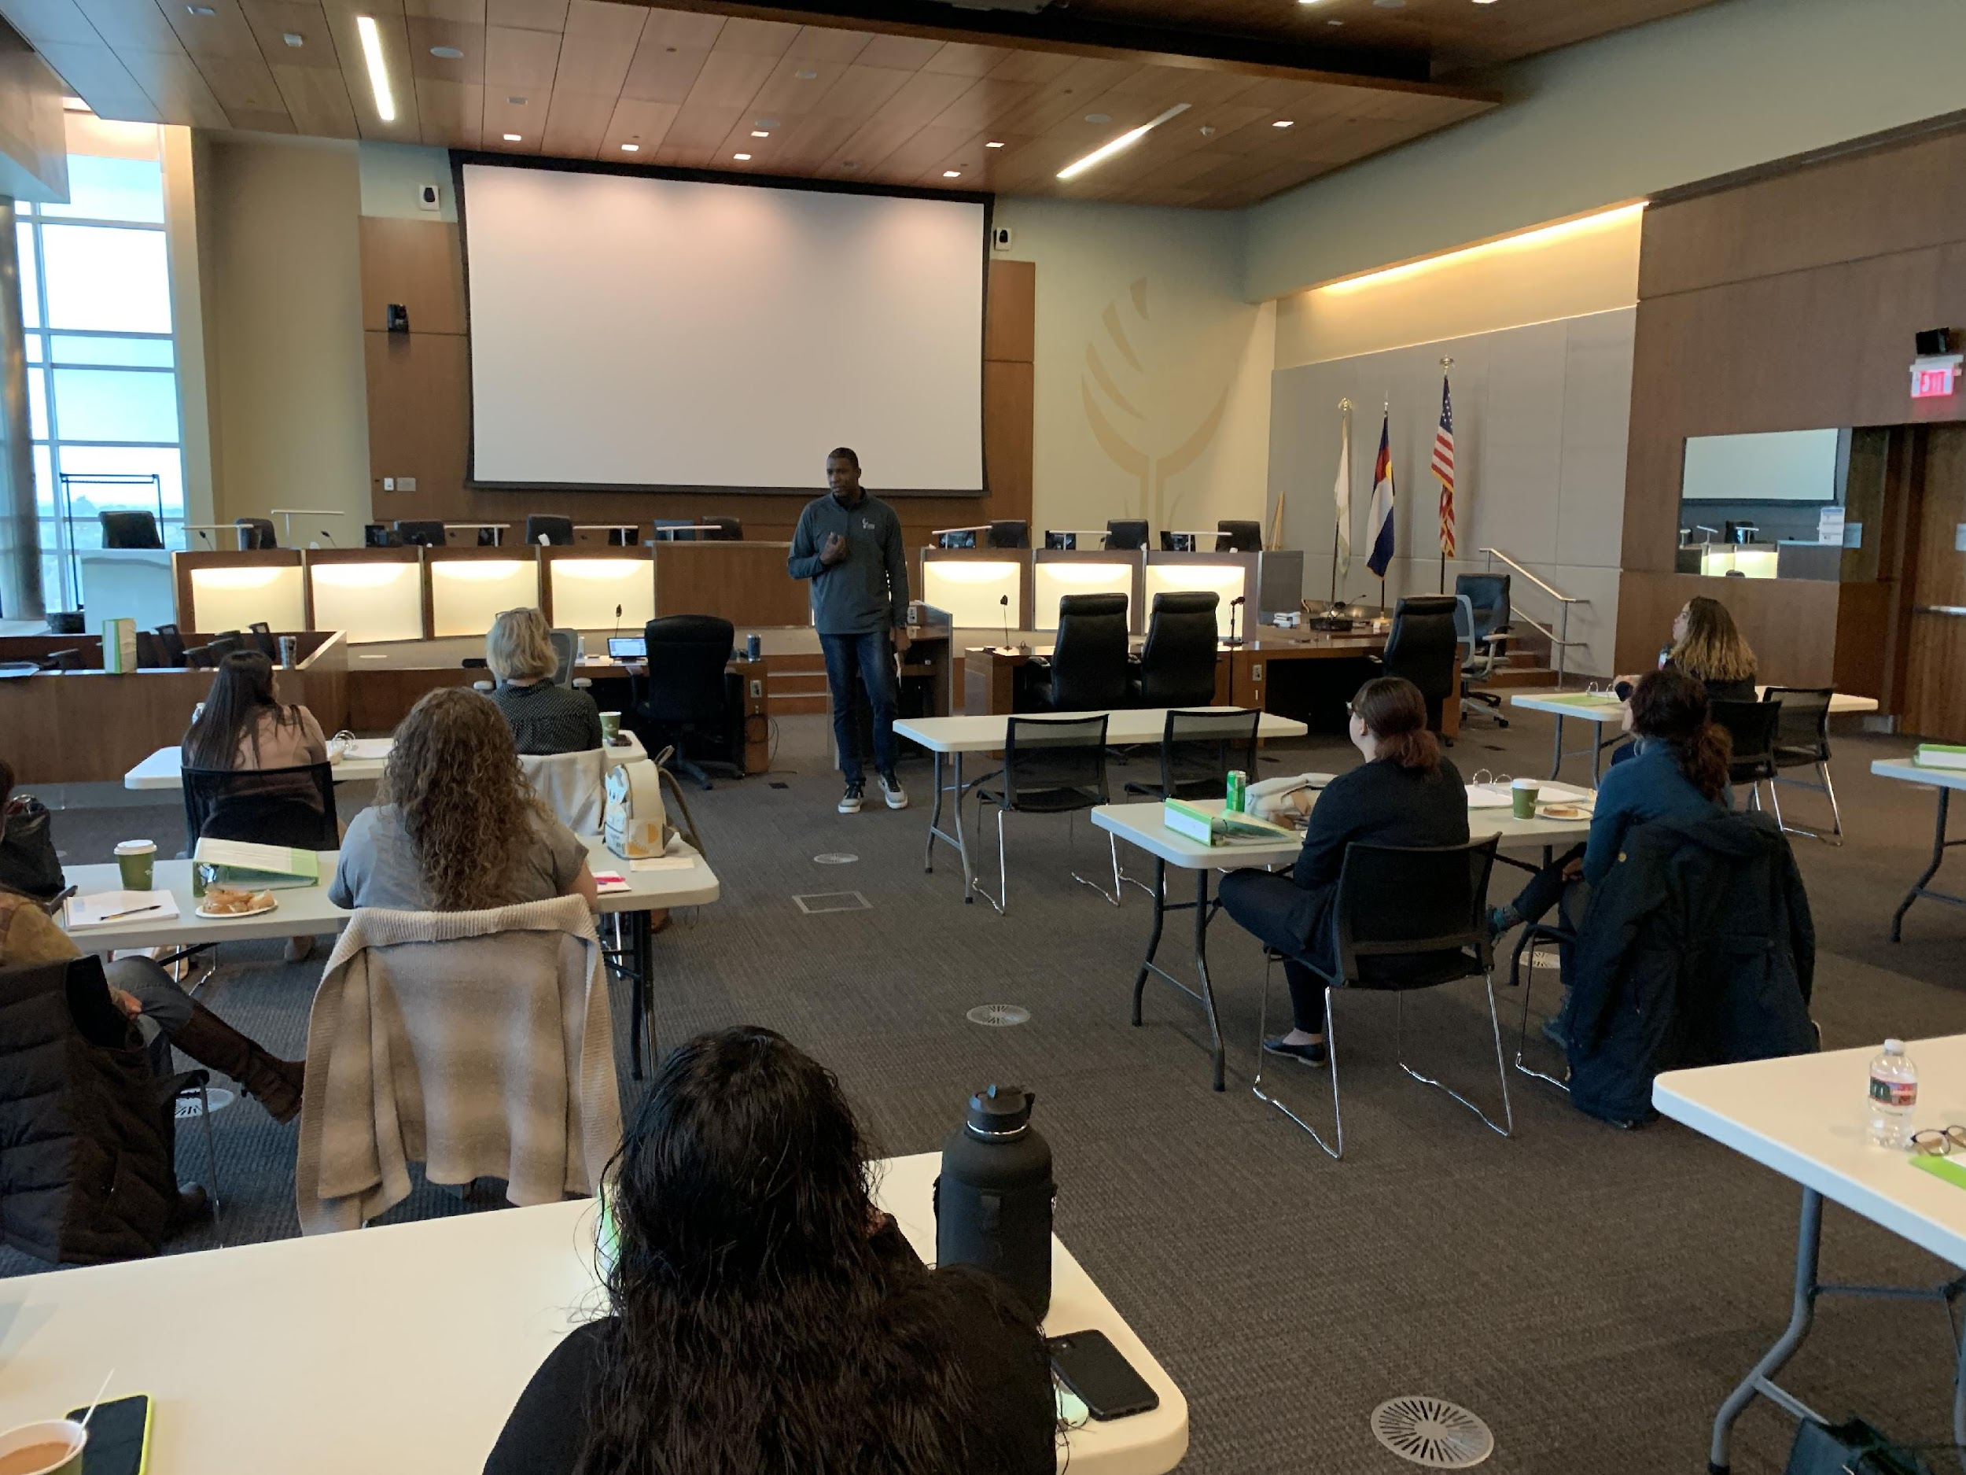

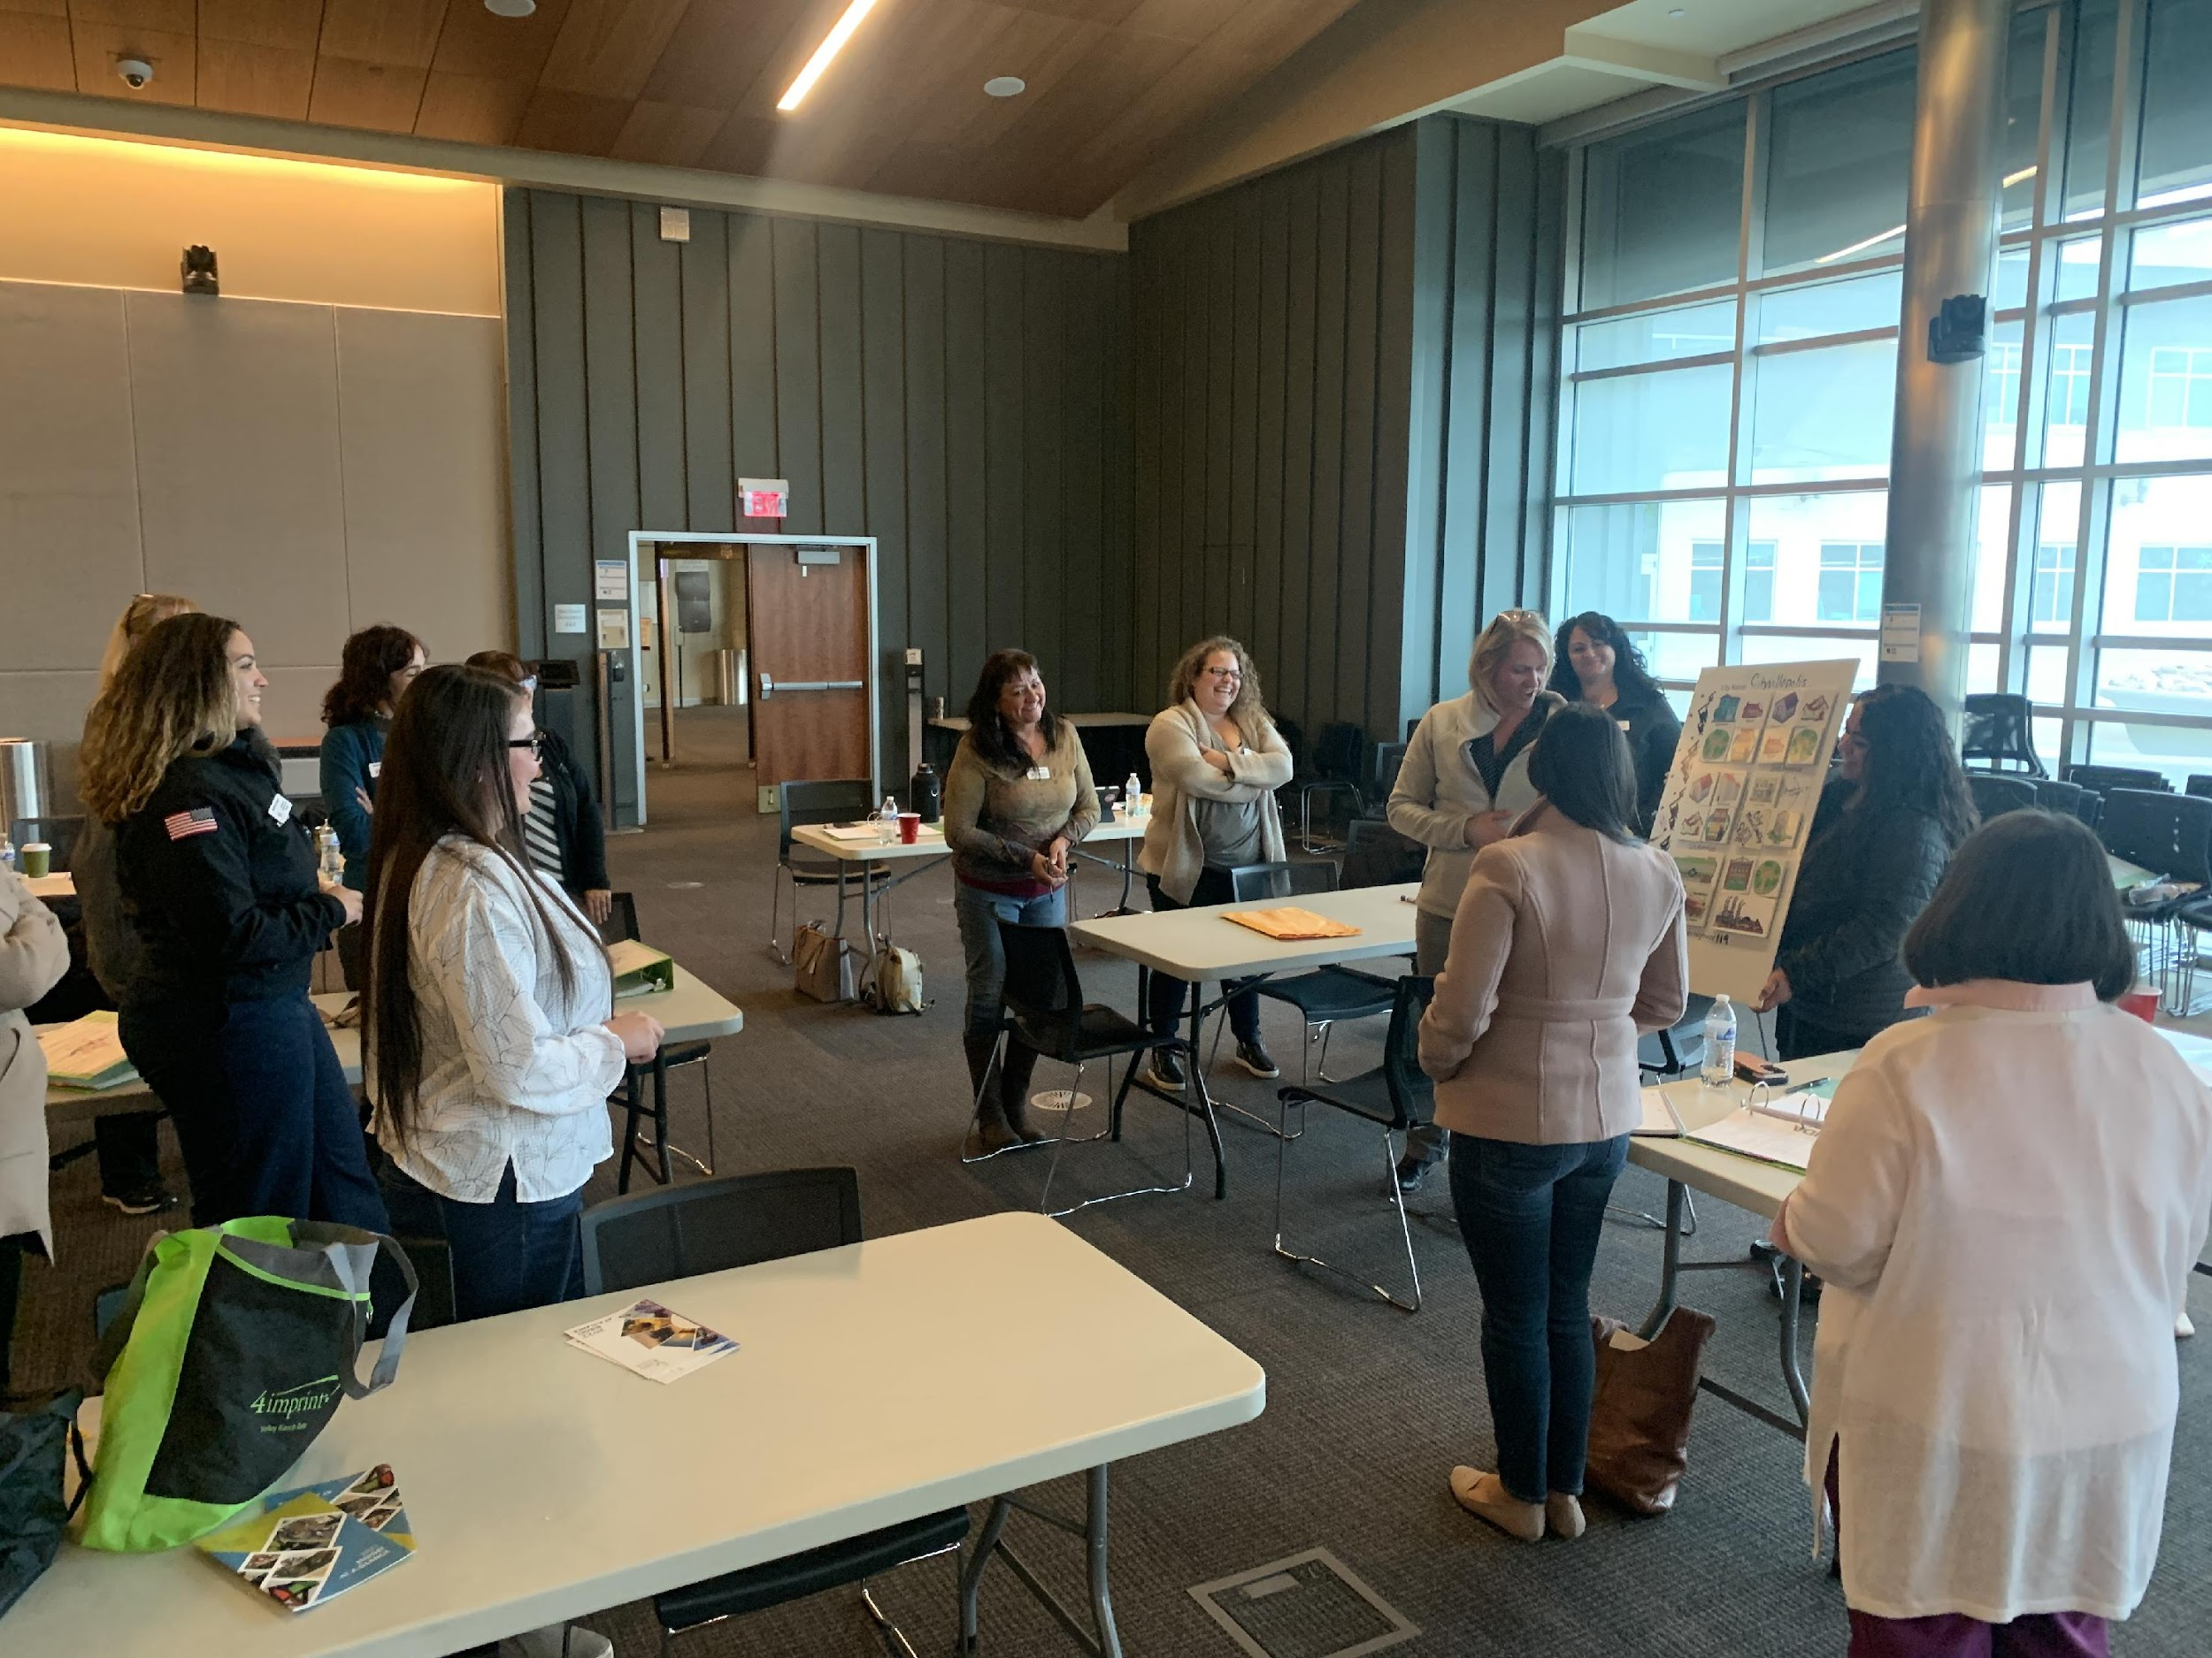

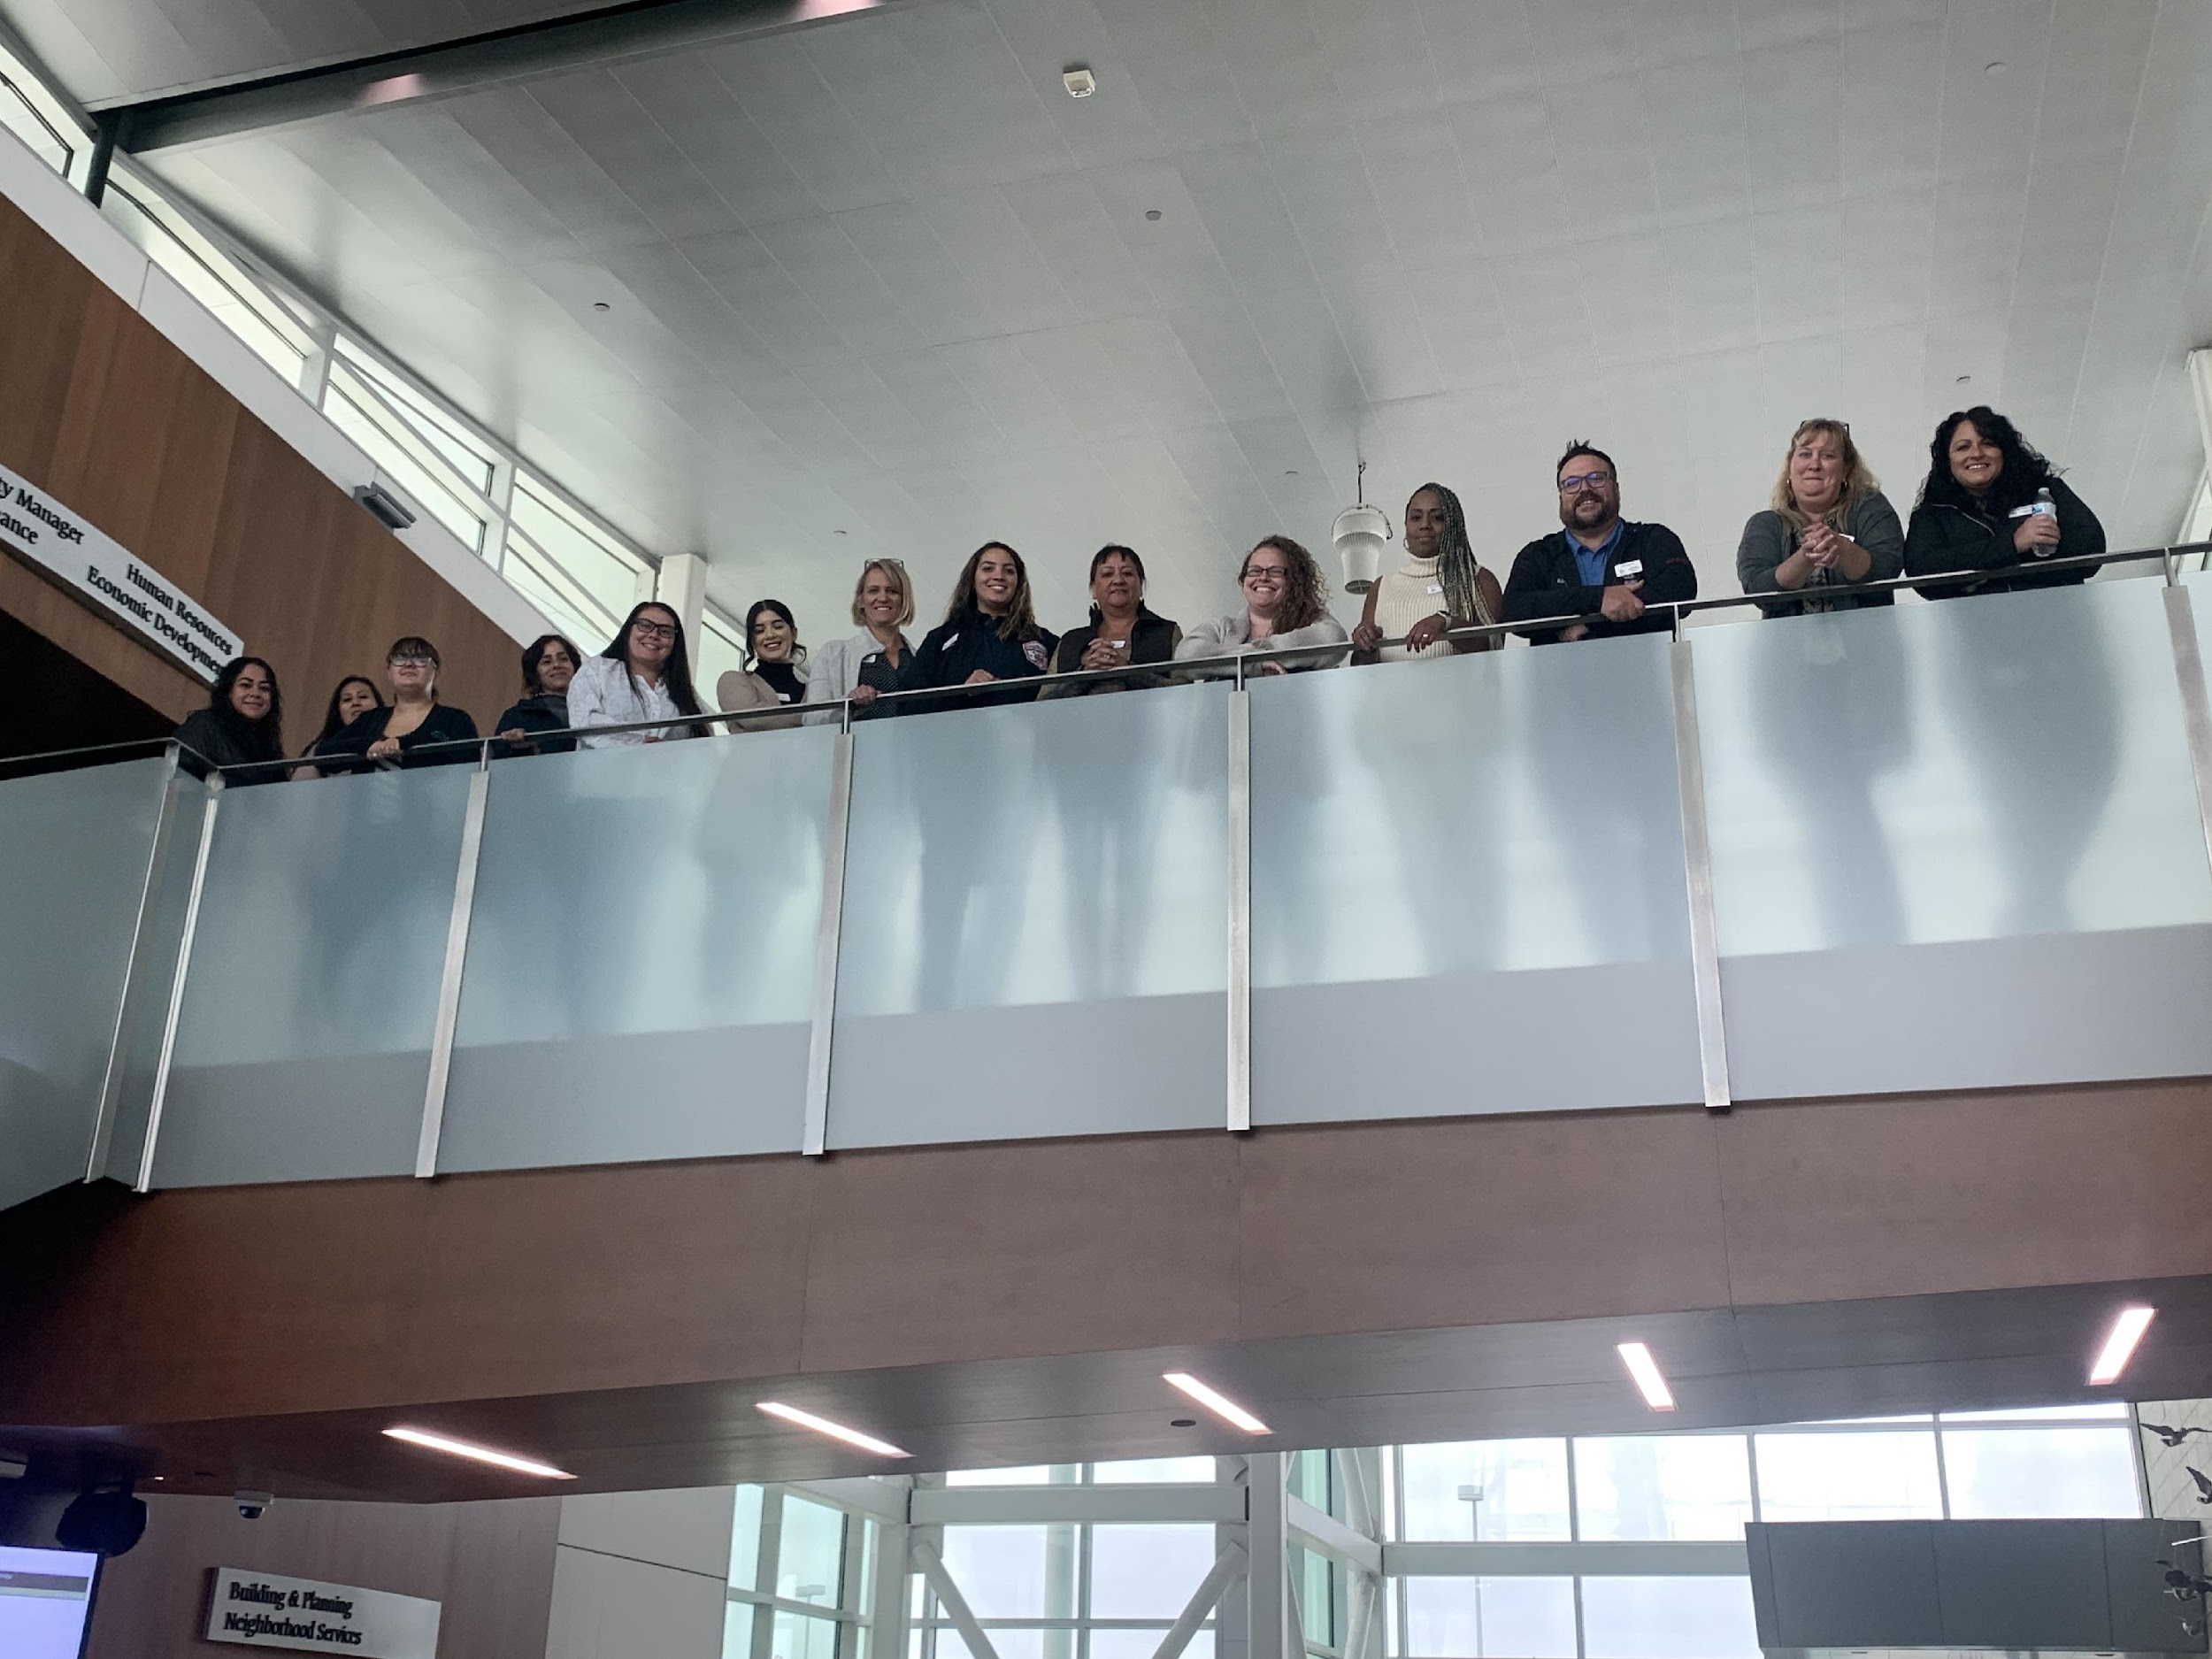

SESSION 3 (Friday – November 1, 2024) 8:00–4 pm
BUSINESS DAY- ECONOMIC DEVELOPMENT
Class held at the Adams County Government Center
This day will start with a presentation on tips for dealing with public relations if confronted on behalf of your organization or self.

Panel discussions will be held with local businesses, Economic Development entities to include: Adams County Regional Economic Partnership, Commerce City Economic Development Department, Commerce City Chamber and Housing and Land Development organizations.

Class Objectives:
1. Learn etiquette and feel more confident as a professional business person.
2. Learn how to talk to the media and learn some public relations tips.
3. Learn about the Economic Development process in Commerce City and Adams County.
4. Learn about small, medium, and large business needs in Commerce City.

Class Outline: Class Leaders: Tom Green, Brenda Chairez Moreno, Kayla Burby
8:00-8:30 Breakfast
8:30-9:30 Media 101 – Tom Green
9:30-10:30 Land and Use Development- Commerce City Developers
10:45-11:45 Adams County Presentation
11:45-12:15 Lunch
12:15-1:15 Economic Panel Discussion
1:30-2:30 Business Panel Discussion
2:30-3:15 Local Real Estate Discussion

3:15-4:00 Tour of Adams County Government Center
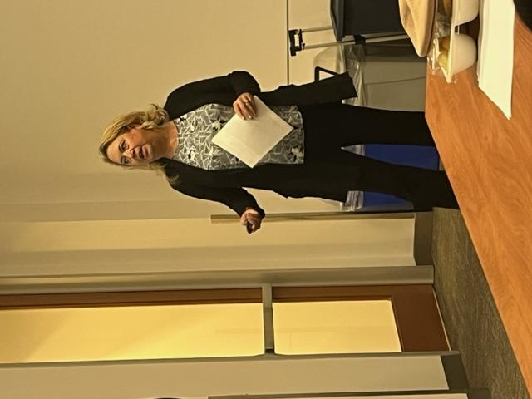
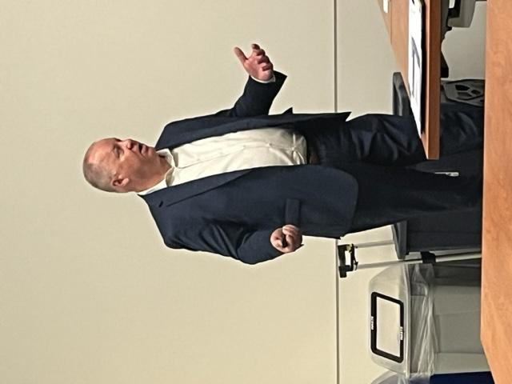

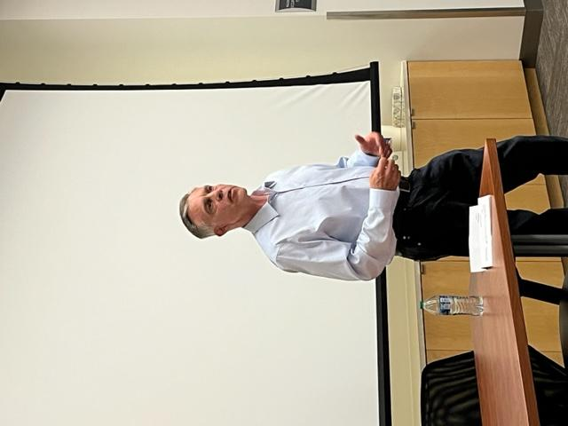
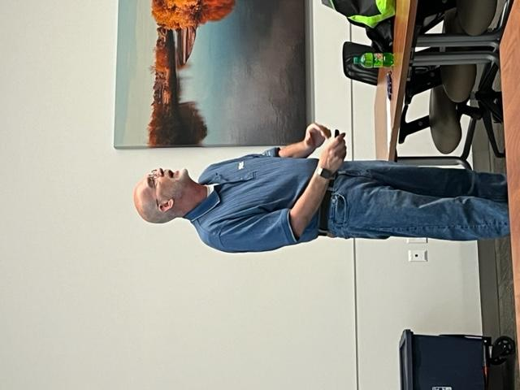

SESSION 4 (Friday – December 6, 2024) 8-4 pm
WATER, SANITATION AND THE ENVIRONMENT

Commerce City has a wealth of natural resources within its municipal borders. Water continues to be an part of any discussion. Quality, availability, safe to consume, softness, and uses are some of the leading discussions. Commerce City also has a large footprint in the recycling of unused and discarded materials.

Class Leaders: Theresa Friess, Jaime Robinson, Lori Young

Class Objectives:
1. Learn about the history and services provided by the South Adams County Water and Sanitation District.
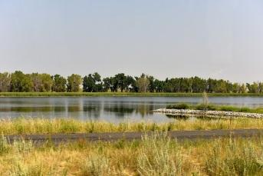
2. Understand the leadership skills needed to manage environmental resources and balance community growth.
3. Explore other water and material recycling facilities.
4. Introduction to the city parks and trails.
Class Outline: Class Leaders: Theresa Friess, Jaime Robinson
8:00 – 8:30 Breakfast – Klein Water Treatment Facility
8:30 – 11:30 Presentations and tour of the Facility
11:30- 11:45 Travel
11:45- 12:15 Lunch
12:15-2:30 Water Treatment Plant
2:30 – 2:45 Travel to RMR
2:45 – 3:45 Presentation/Tour RMR

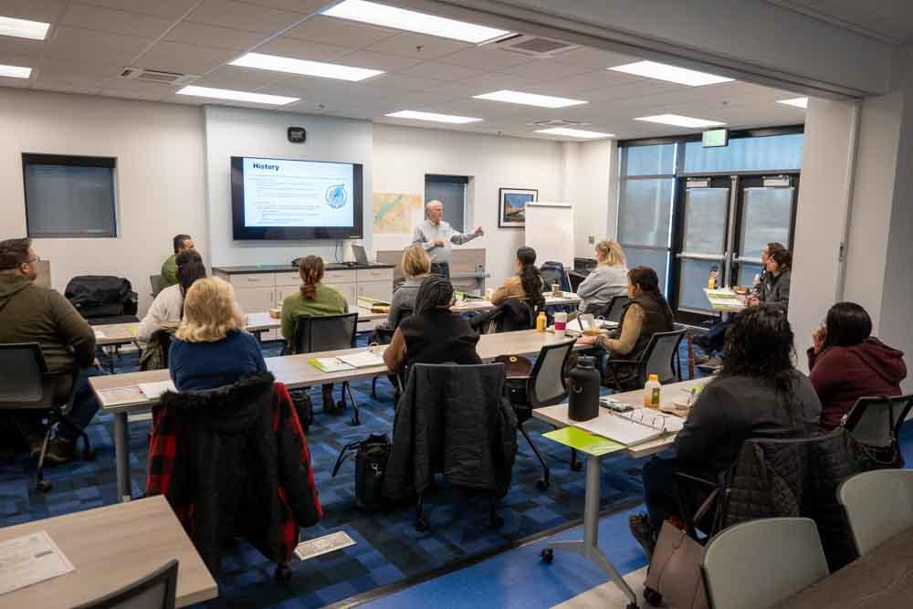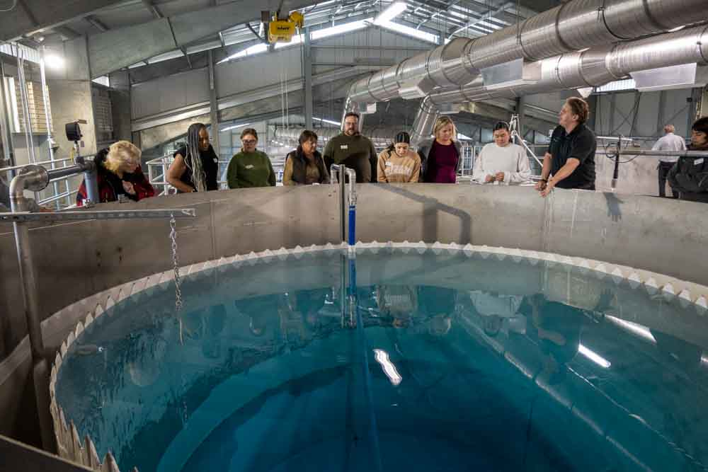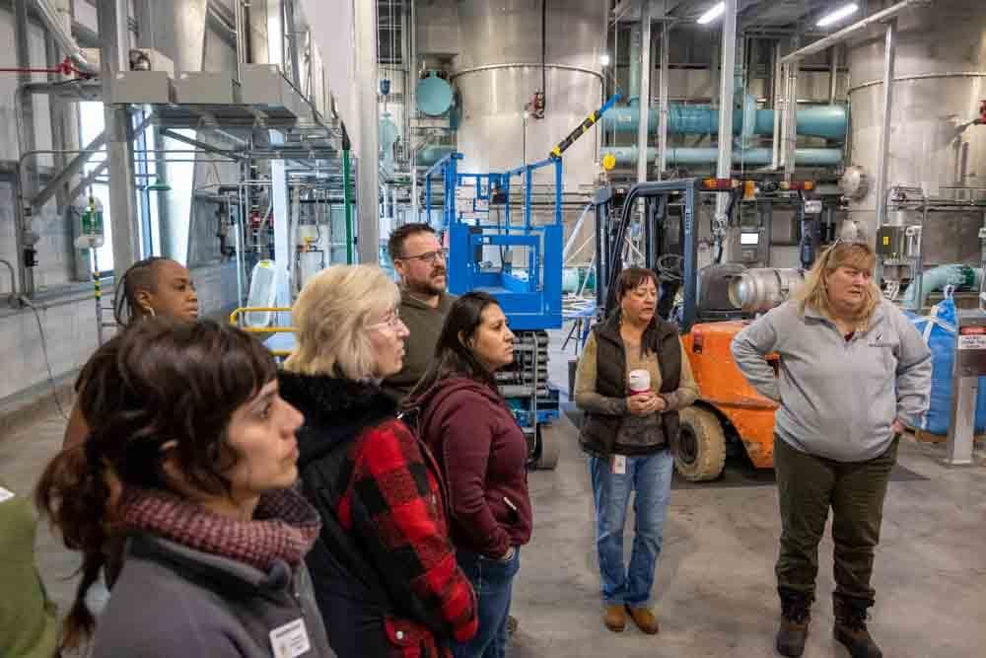
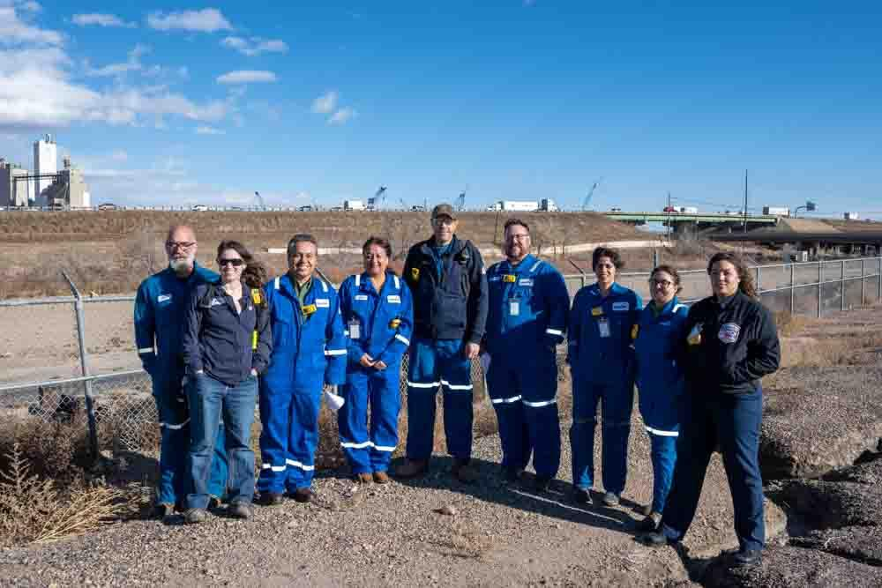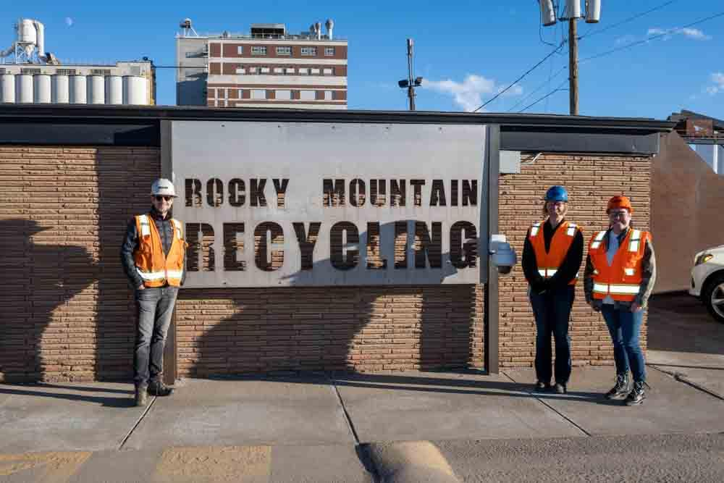

SESSION 5: Friday, January 10, 2025, 8:00–4 pm
COMMERCE CITY NON-PROFIT DAY

Class members will have the opportunity to learn about the diverse nature of our community. Participants will be introduced to an array of support services and organizations in our neighborhoods dedicated to meeting the wide- ranging needs of our area residents.
A true leadership challenge is building and strengthening the community in which we work and live. How we collectively foster our individual potential and work to address the needs of our residents will significantly impact their lives as well as our own.

Class Objectives:
- To learn about Commerce City non-profit organizations.
- Planning with the class capstone project.
- To learn about volunteer opportunities within Commerce City.
Class Outline: Class Leaders: Lori Young, Yolanda Gotier & Whitney Gustin Connor
8:15 – 8:30 Meet at Stout Street
8:30 - 10:00 Stout Street and breakfast
10:00 - 10:15 Bus Ride to Suncor Boys and Girls Club
10:15 - 11:00 Boys and Girls club
11:00 –11:15 Bus Ride Kids First
11:15- 12:00 Presentation/Tour Kids First
12:00- 12:30 Lunch
12:30- 12_45 Bus Ride to Stout Street

12:45 – 3:00 pm Presentations from multiple Nonprofits serving Commerce City
3:15 - 4:00 Project work
THE CAPSTONE PROJECT

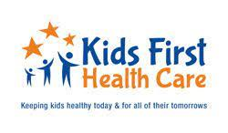








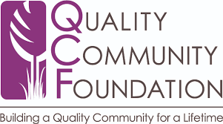
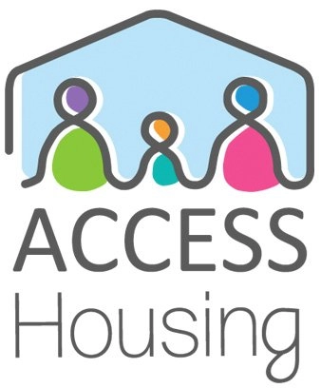

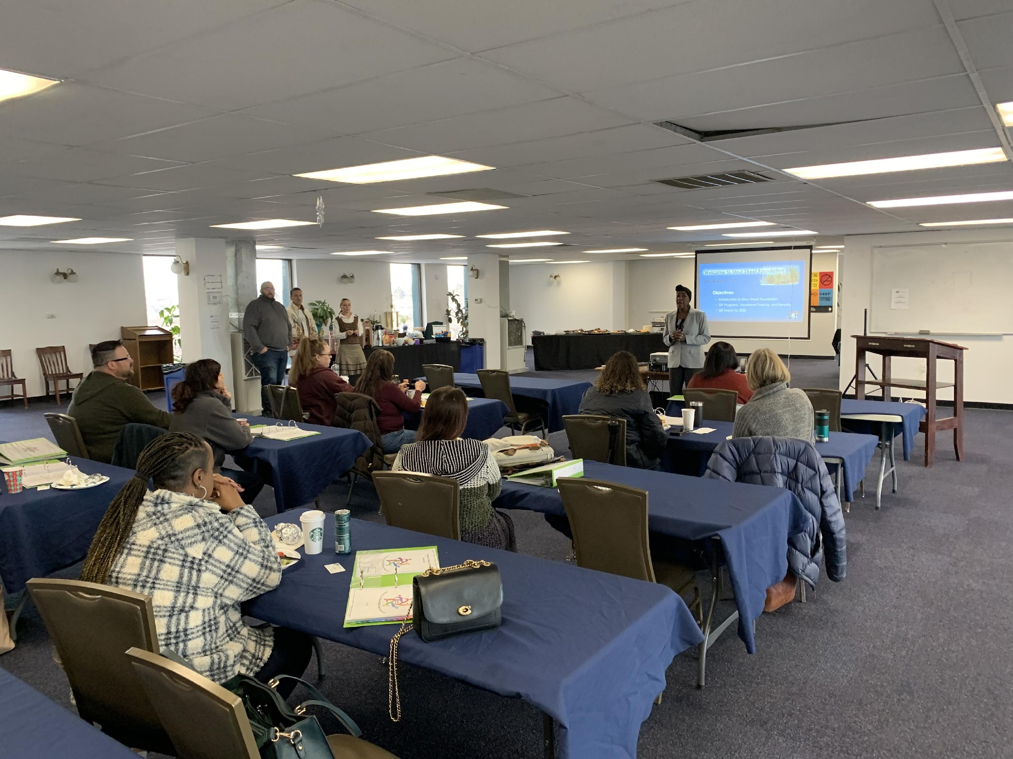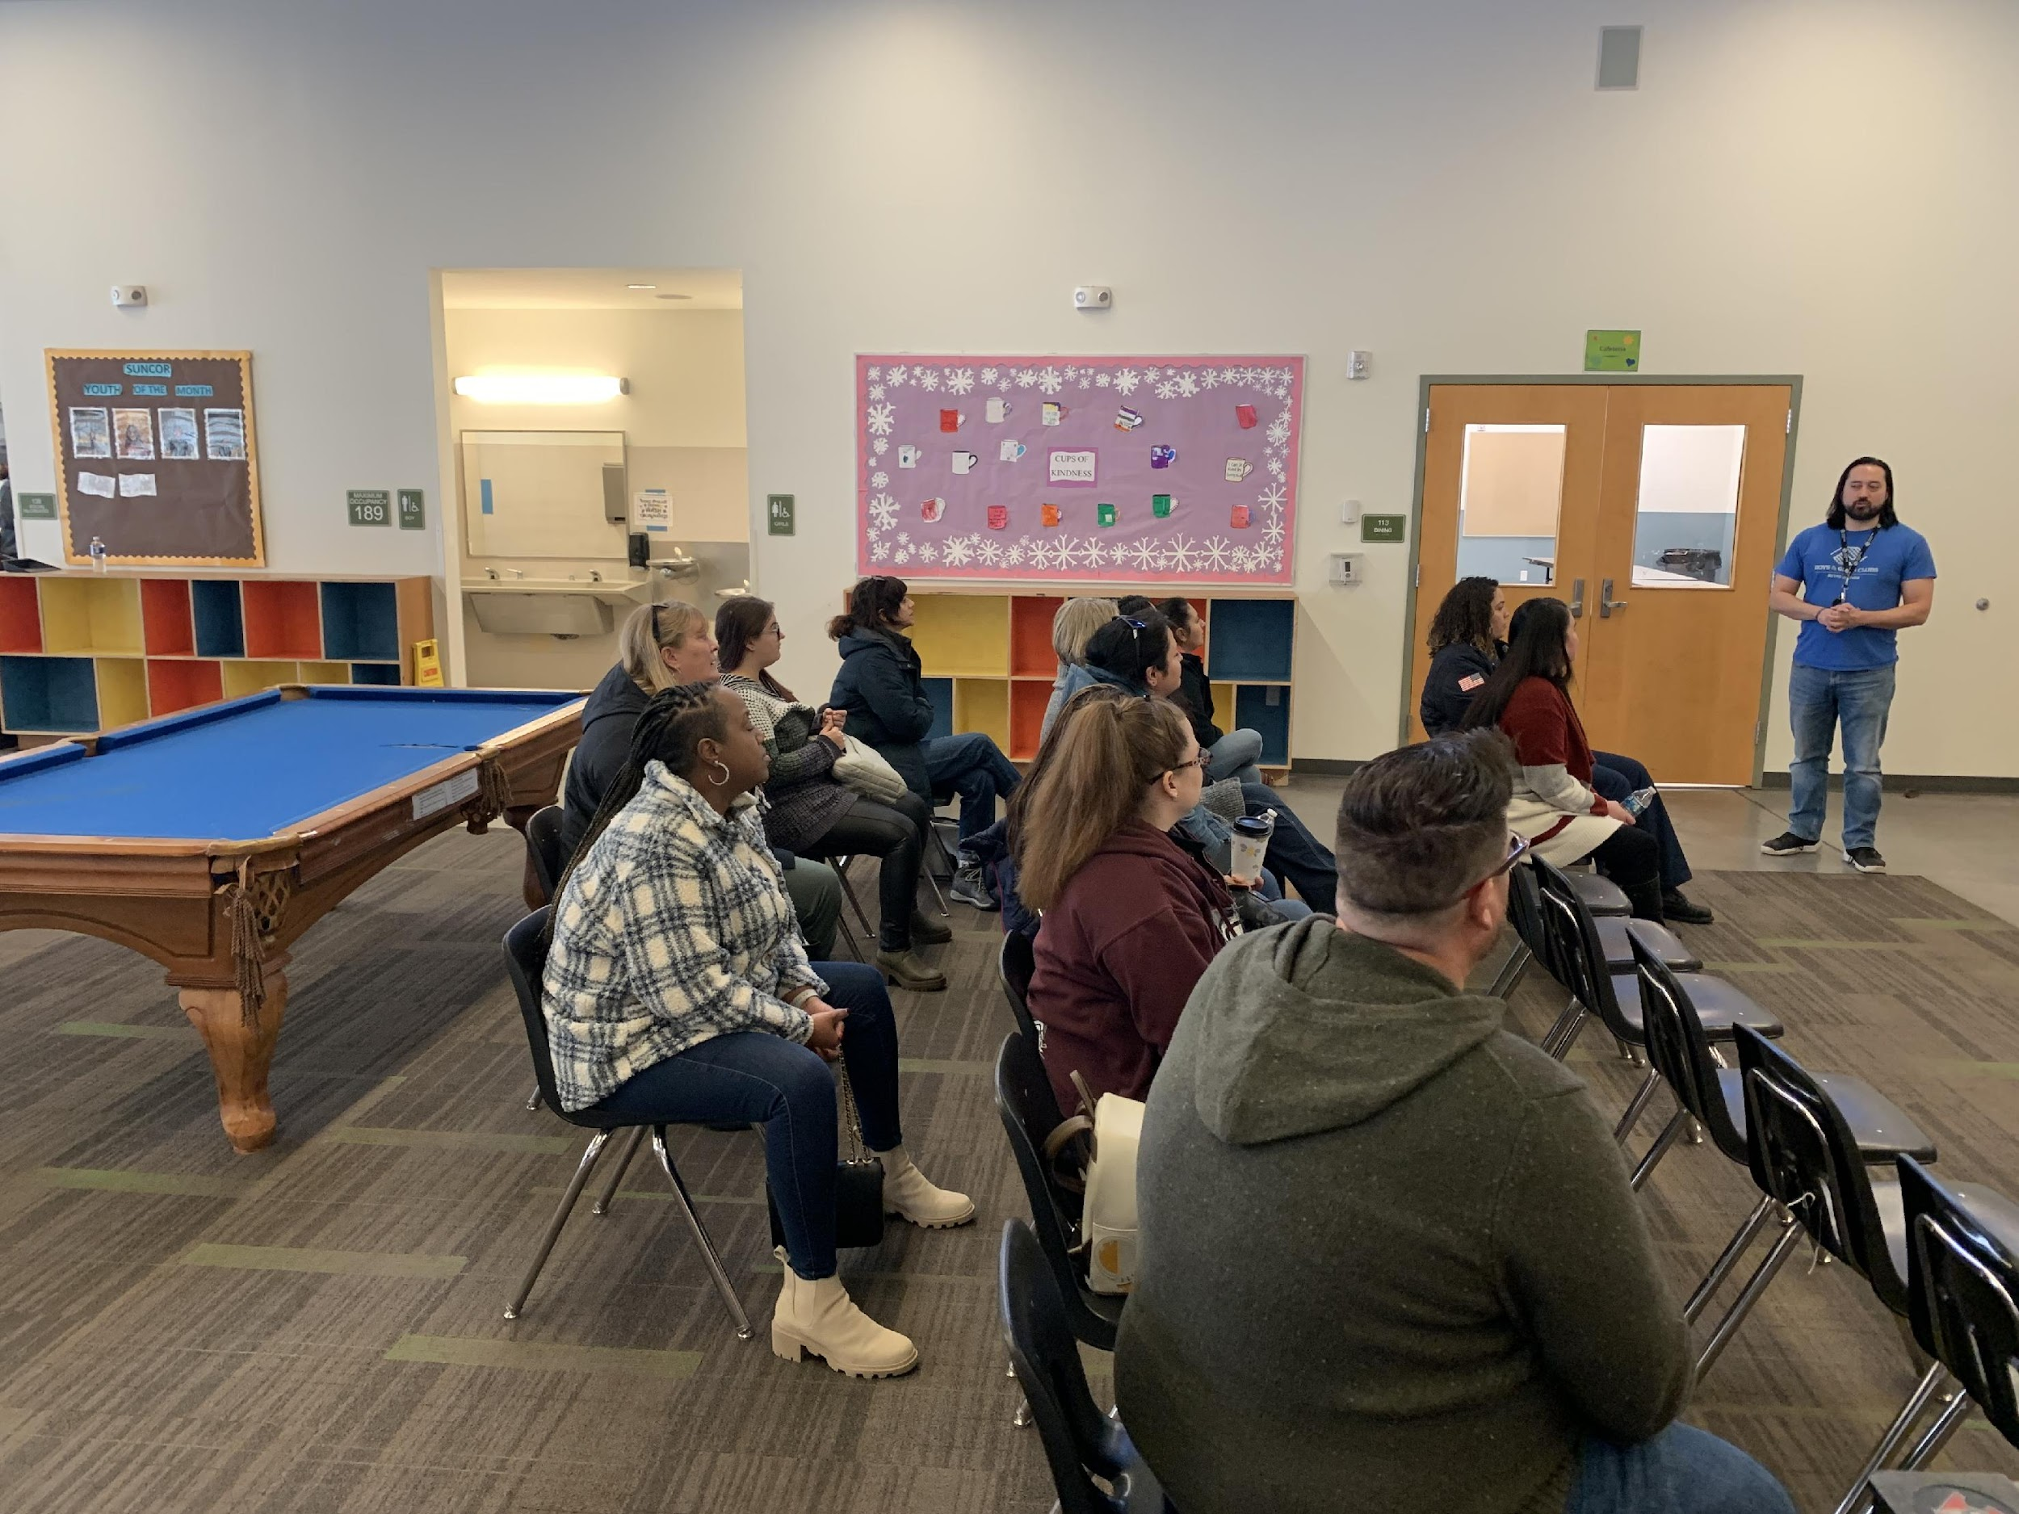
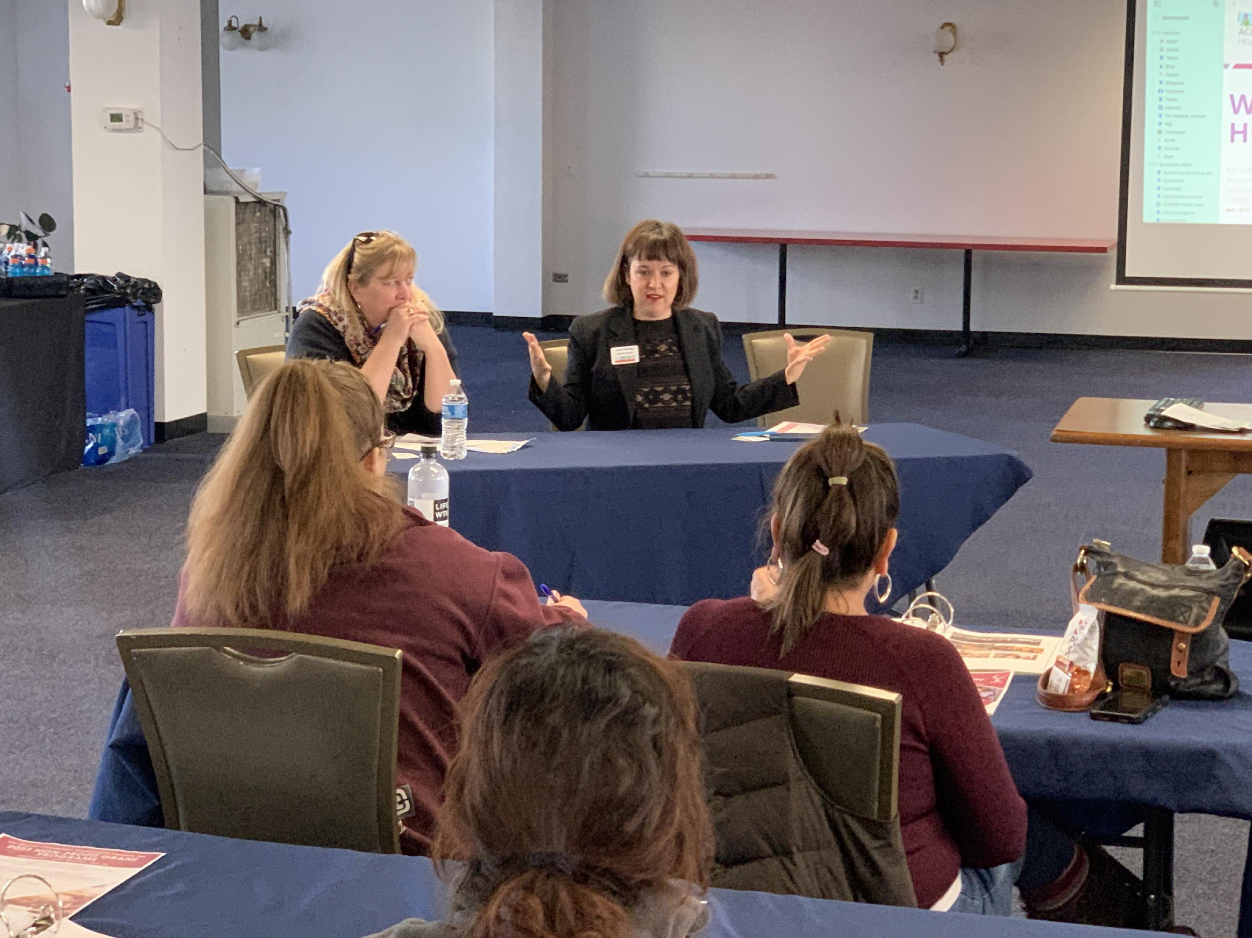
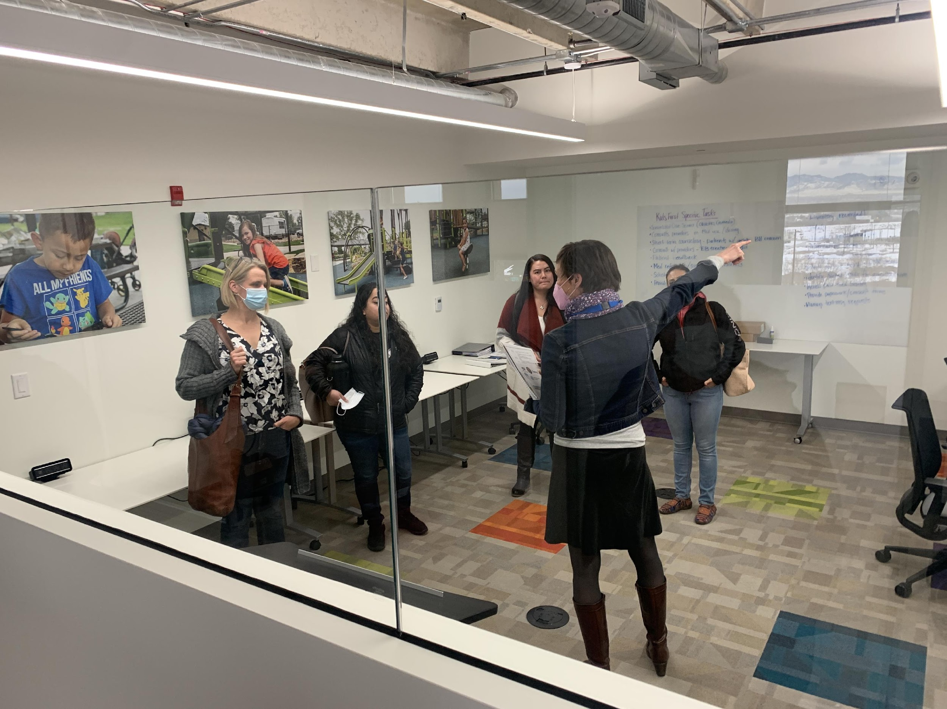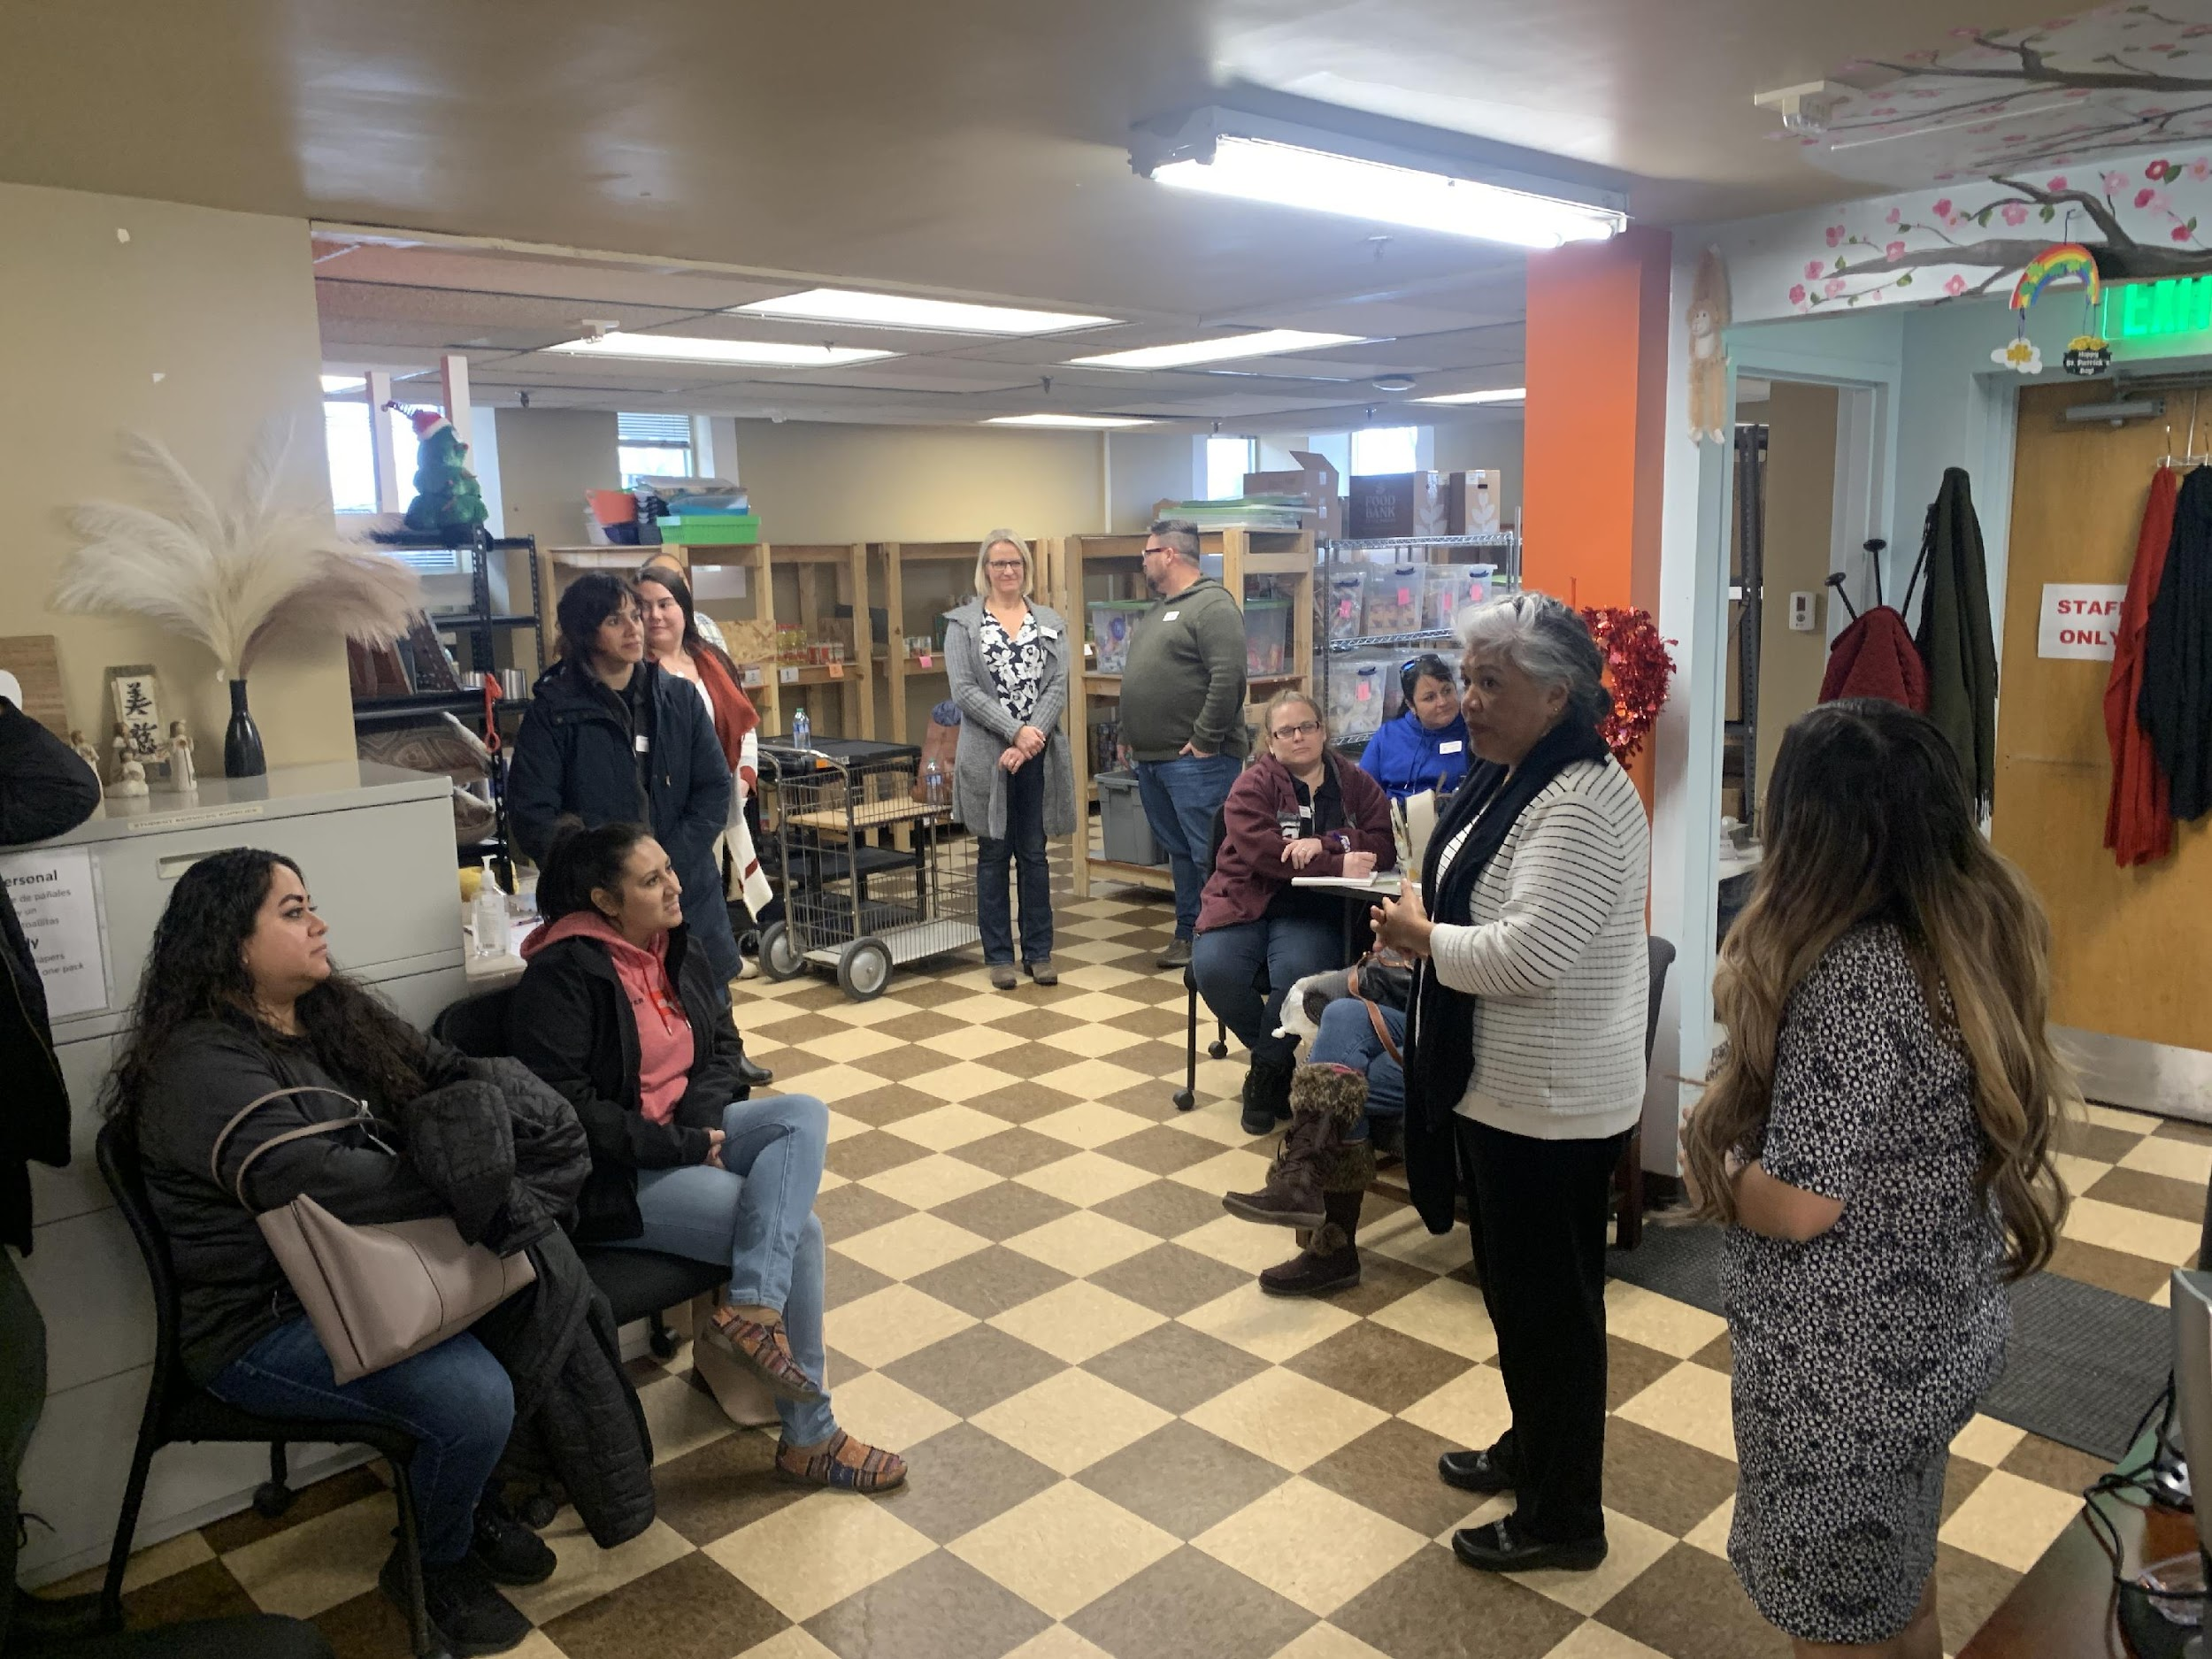
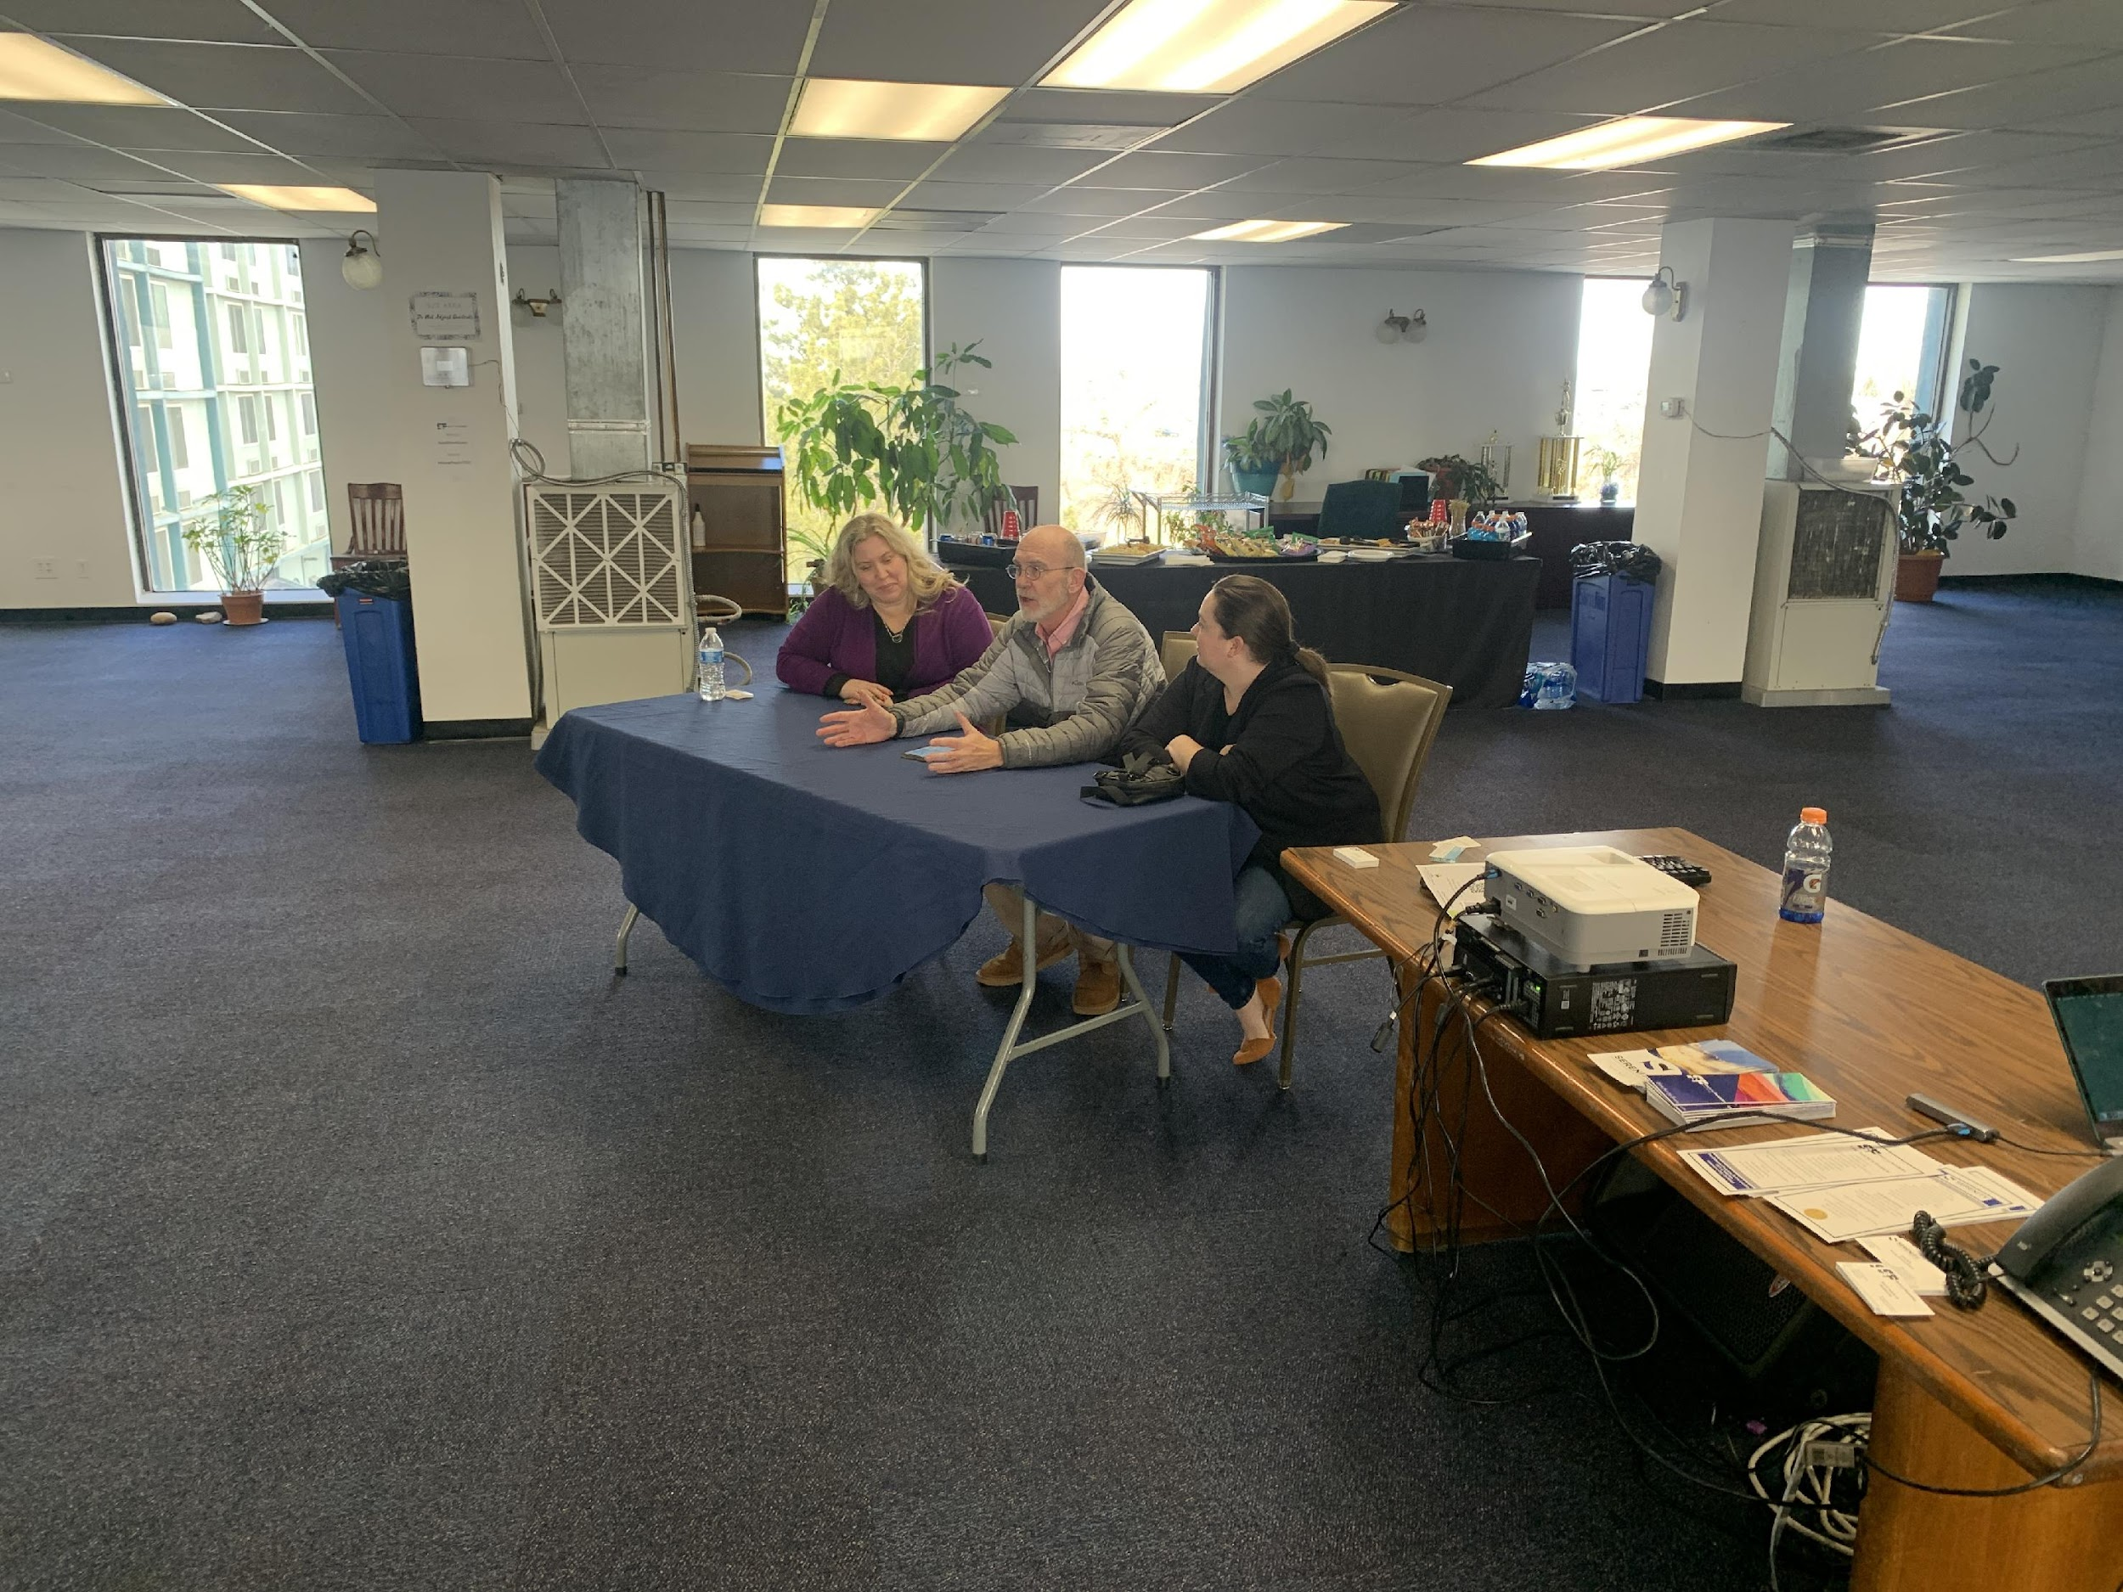

SESSION 6 (Thursday, February 6, 2024)8:30–4 pm
CIVIC DAY AT THE COLORADO STATE CAPITOL

Civic Day will be held at the state capital. This session will introduce participants to the important links between state and federal government to municipal operations and the development of a vibrant community.

Class Objectives:
1. Understand how the federal and state legislative process works.
2. Recognize the interconnectedness among the various levels of government.
3. Meet state legislators, executive branch, and federal representatives.

Class Outline: Class Leaders: Lisa Nordholt, Erin Goff, Lori Young
- 8:30-9:30 Meet at Husch Blackwell Strategies Breakfast and Presentation.
1600 Broadway, Suite 510, Denver, CO 80202
- 9:30-9:45 -Walk to Capitol Bldg.
- 9:45-11:15 -Visit House and Senate Chambers
- 11:15- 11:30 -Walk back to Husch Blackwell Strategies
- 11:30-12:40 -Lunch and Meet with Commerce City Legislators
- 12:40-12:55 -Walk to Capitol Bldg.
- 1:00 – 2:15 -Tour of the Capitol Bldg.
- 2:15-3:30 -Observe Legislative Committee Meeting

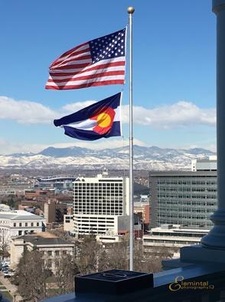

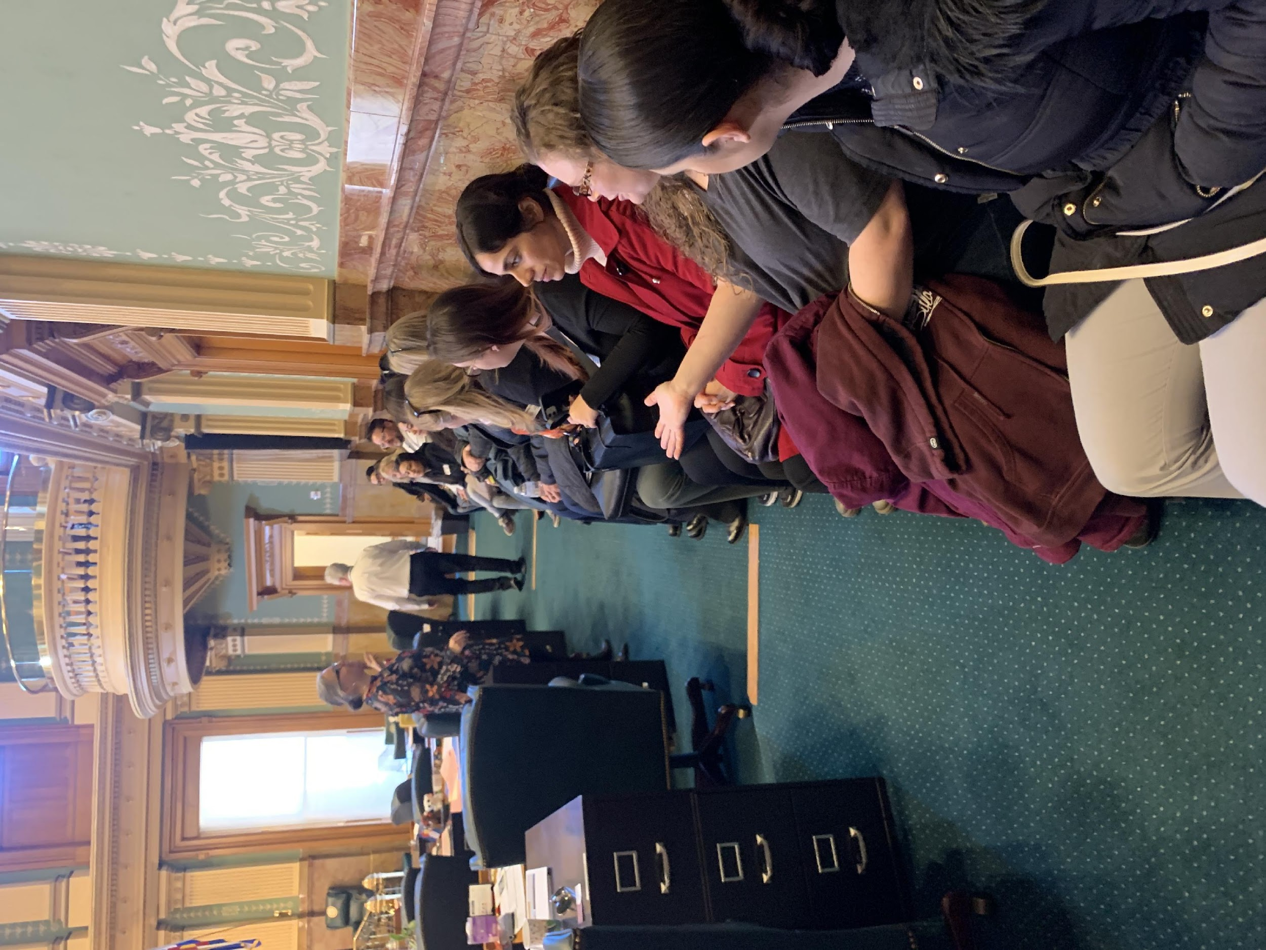
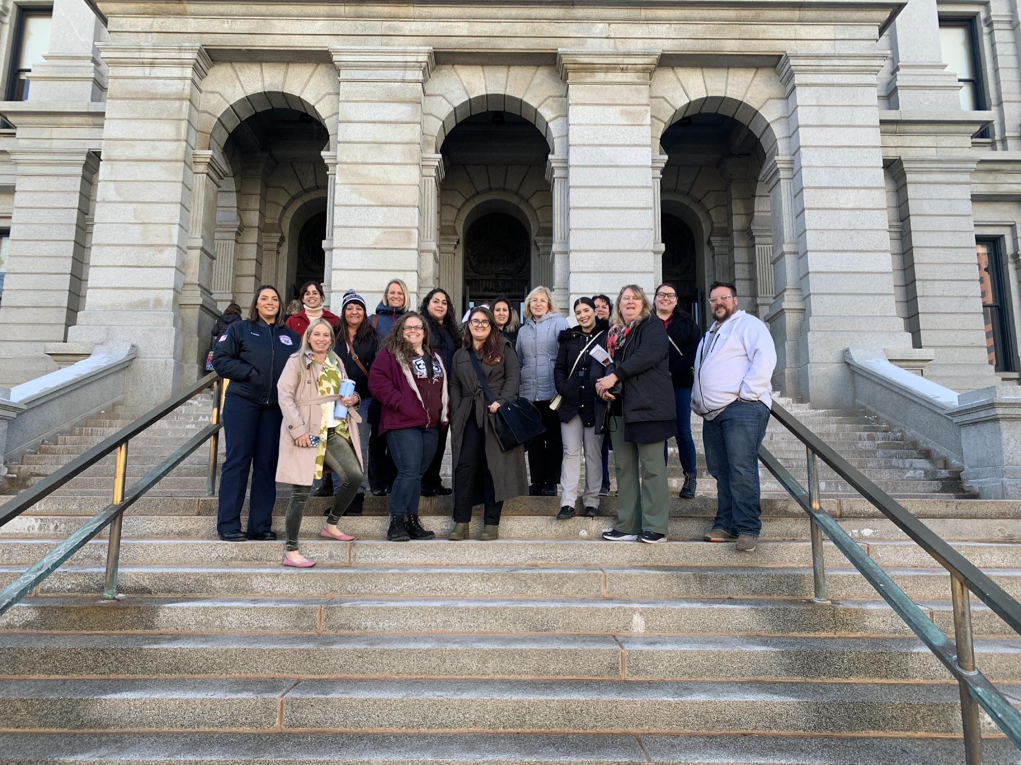

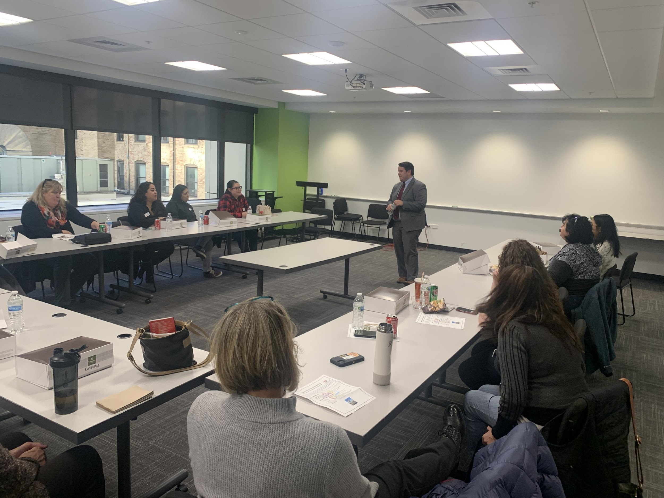
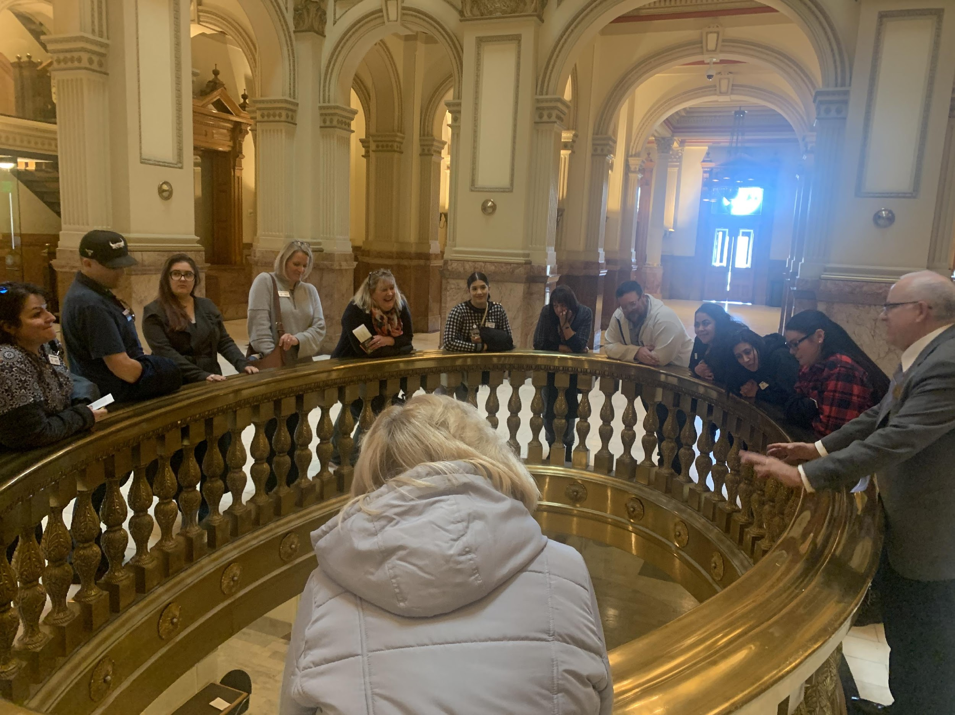
SESSION 7 (Friday – March 7, 2025) 8-4 pm
EDUCATION DAY
MEET ADAMS COUNTY SCHOOL DISTRICT 14
& BRIGHTON 27J

Strong public education is one of the best drivers of future economic growth. As leaders in the Commerce City community, it is important for you to understand the vital role our schools play in preparing all students to successfully compete in the 21st century local and global workforce, and to prepare these students to be responsible and productive citizens.
Commerce City offers a full range of educational opportunities to reach the needs and abilities of our diverse learners, including those with special needs and abilities. Innovative programs and services are available to students from preschool through high school, including vocational and technical training for high school students and adults.
Our schools reflect the communities they serve and shape. As a participant, you will visit various schools, interact with students and staff, and gain a
first-hand knowledge of the important opportunities and challenges in the 21st century education today.

Class Objectives:
1. Develop a better understanding of 21st century learning.
2. Experience K-12 educational programs in two public schools in Commerce City and Brighton 27J.
3. Experience post-secondary educational programs in Commerce City and Brighton 27J.

Class Leaders: Tonia Lopez, Janelle Ausmus
Class Outline:
1. Meet at the Brighton 27J for breakfast – 8:00 am
2. Visit schools in Brighton 27 J School District – 9 am – 12:00 pm

3. Lunch – 12:00 pm
4. Visit schools in Adams 14 School District -12:30 pm -3:30 pm

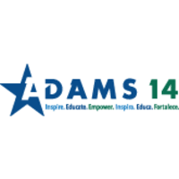


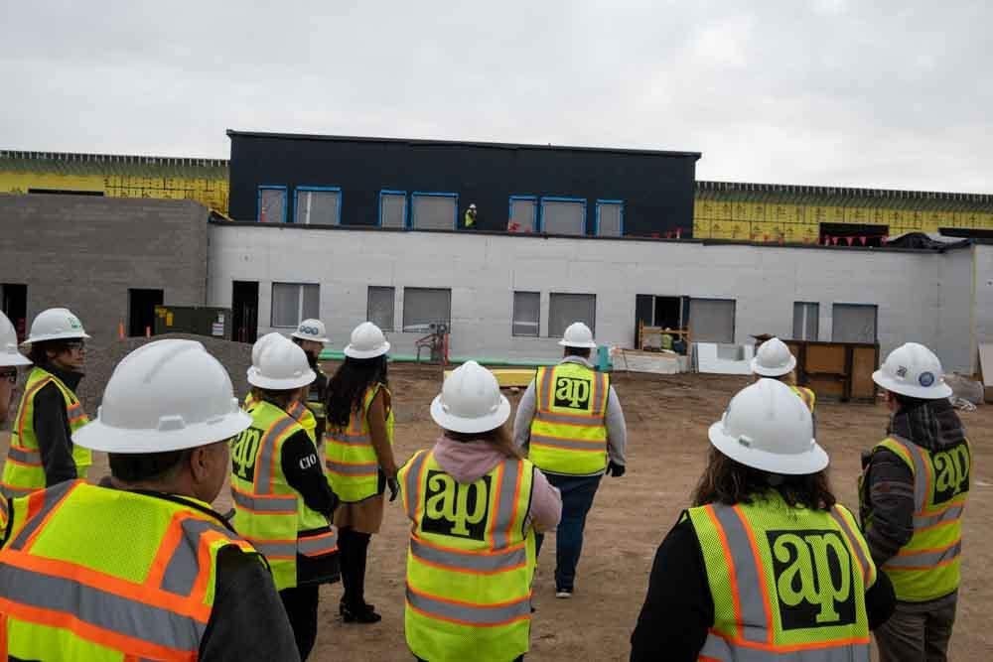
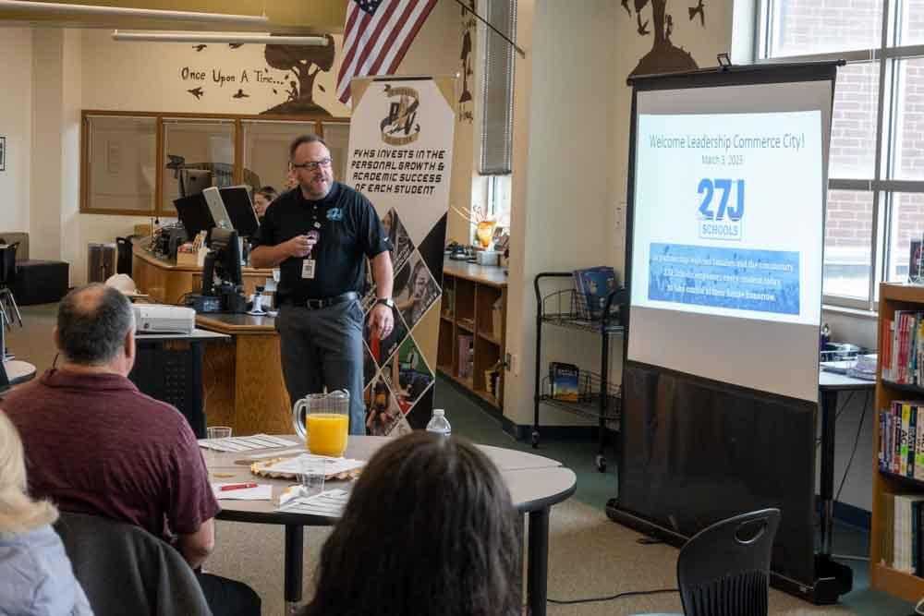

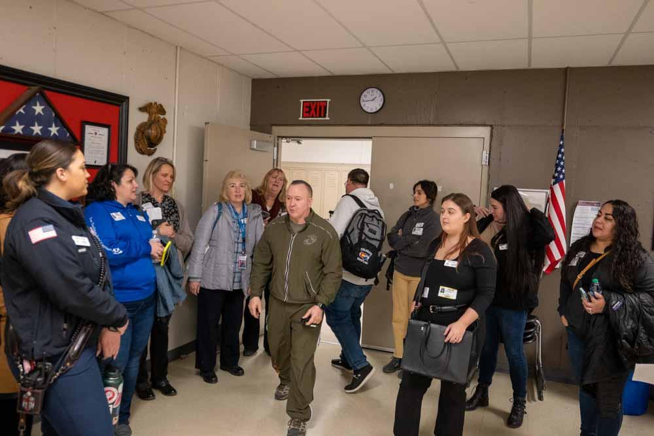
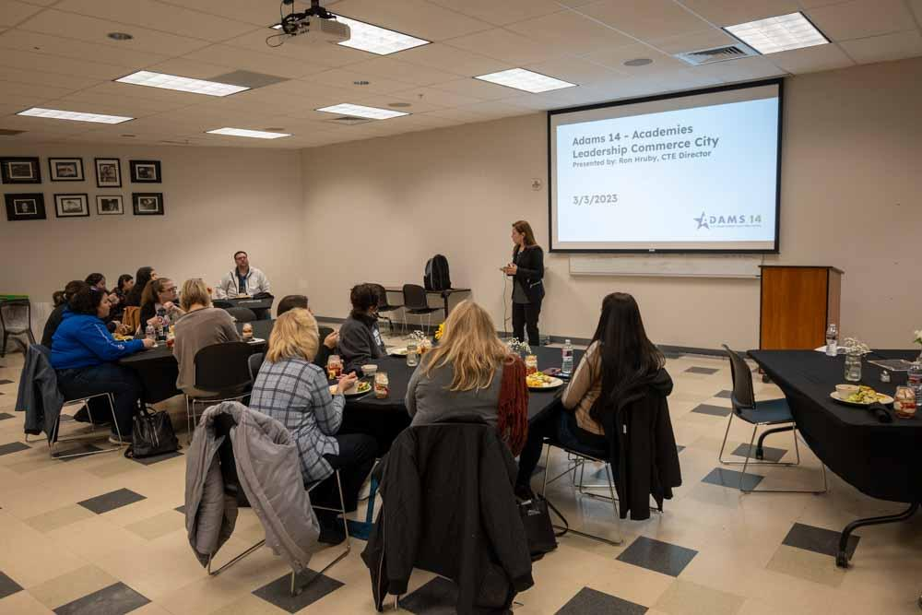

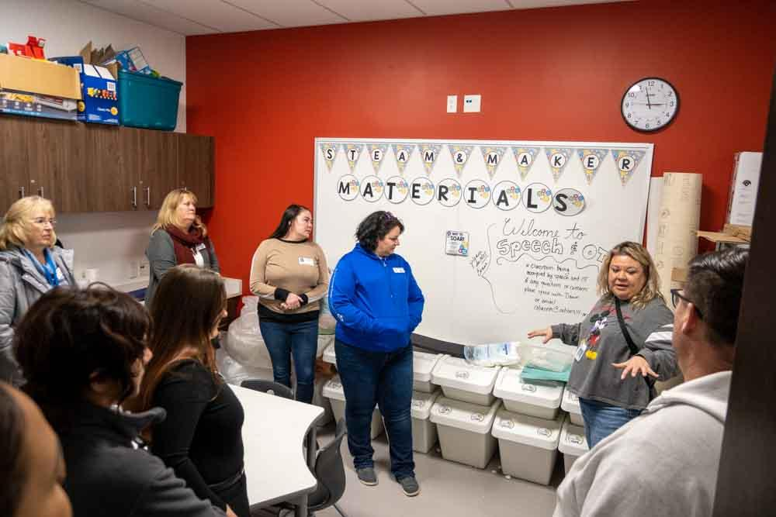
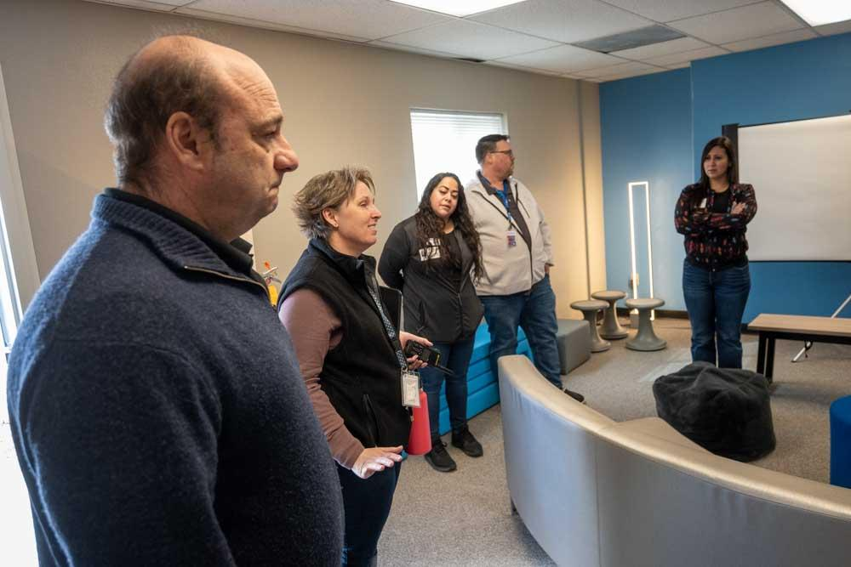

SESSION EIGHT: (Friday - April 4, 2025) 8:00-4pm
PUBLIC SAFETY
Location: AdCom, Fire Station 4
and Police Department
Summary: A variety of Public Safety agencies play a role in keeping the Commerce City community safe. Participants will have the opportunity to learn more about the operations and opportunities facing the city’s police department and the South Adams County Fire District. Participants will learn about the unique leadership challenges facing these professionals, through facility tours, hands-on experiences, and a classroom setting.

Class Leaders: Randall Weigum, Ryan Doherty, Lisa Nordholt
Class Objectives:
- Understand how public safety services are provided within Commerce City among various agencies and regional partners
- Learn about the history of the South Adams County Fire District, the District’s role in the community, and understand the changes to the modern-day fire department
- Learn about the services provided by the Commerce City Police Department, the organization’s history, and 21st century policing challenges.
Class Leaders: Randall Weigum, Ryan Doherty, Lisa Nordholt

Class Outline:
7:45 – 8 a.m. Meet at City Civic Center 7887 East 60th Avenue
8:00 a.m. Travel to Adams County Communications Center, 7321 Birch Street
8:15 - 8:30 a.m. Breakfast at Adcom

8:30– 9:30 a.m. Overview & Tour of Adcom911
-Joel Estes

9:30 – 9:45 a.m. Travel to Fire Station 4 - 8600 Rosemary Street

9:45 – 10:45 a.m. Overview & Tour of South Adams County Fire Department
-Captain Ryan Doherty
10:45 – 11:00 a.m. Travel to South Adams County Fire Department Headquarters
6050 Syracuse Street

11:00 – 11:30 Overview & Tour continued of South Adams County Fire Department
- Ryan Doherty, Captain

11:30 – 12:30 p.m. Lunch - at Fire Department Headquarters

12:30 – 12:45 p.m. Walk to Commerce City Civic Center – 7887 E. 60th Ave

12:45 – 1:30 p.m. Chief of Police-Darrel Guadnola
- Professional Standards Unit (5)
- Emergency Management (10)
1:30 - 2:30 p.m. Deputy Chief Greg Sadar
- SATF (5)
- SSTF (5)
- Investigations (10)
- NMTF (10)
- Records (5)
- Property & Evidence (5)
- Recruiting & Training (5)

2:30-3:00 p.m. Break

3:00 – 3:30 p.m. Tour of Police Department
3:30 – 3:45 p.m. Deputy Chief Greg Sadar
- SSU/ CNT (10)
- Animal Control/ CSO (5)
- SRO (5)
3:45-4 p.m. Closing
- Q & A

ADCOM 911 Inc.
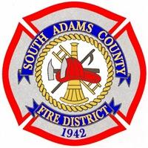
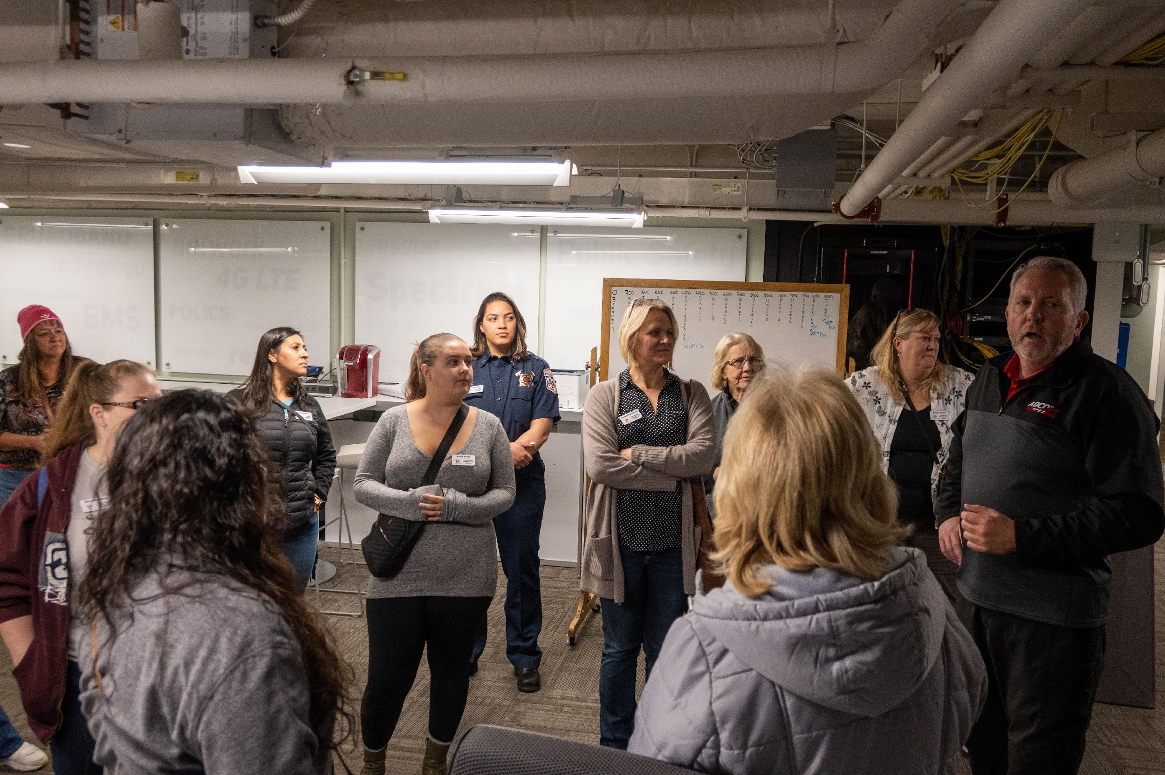

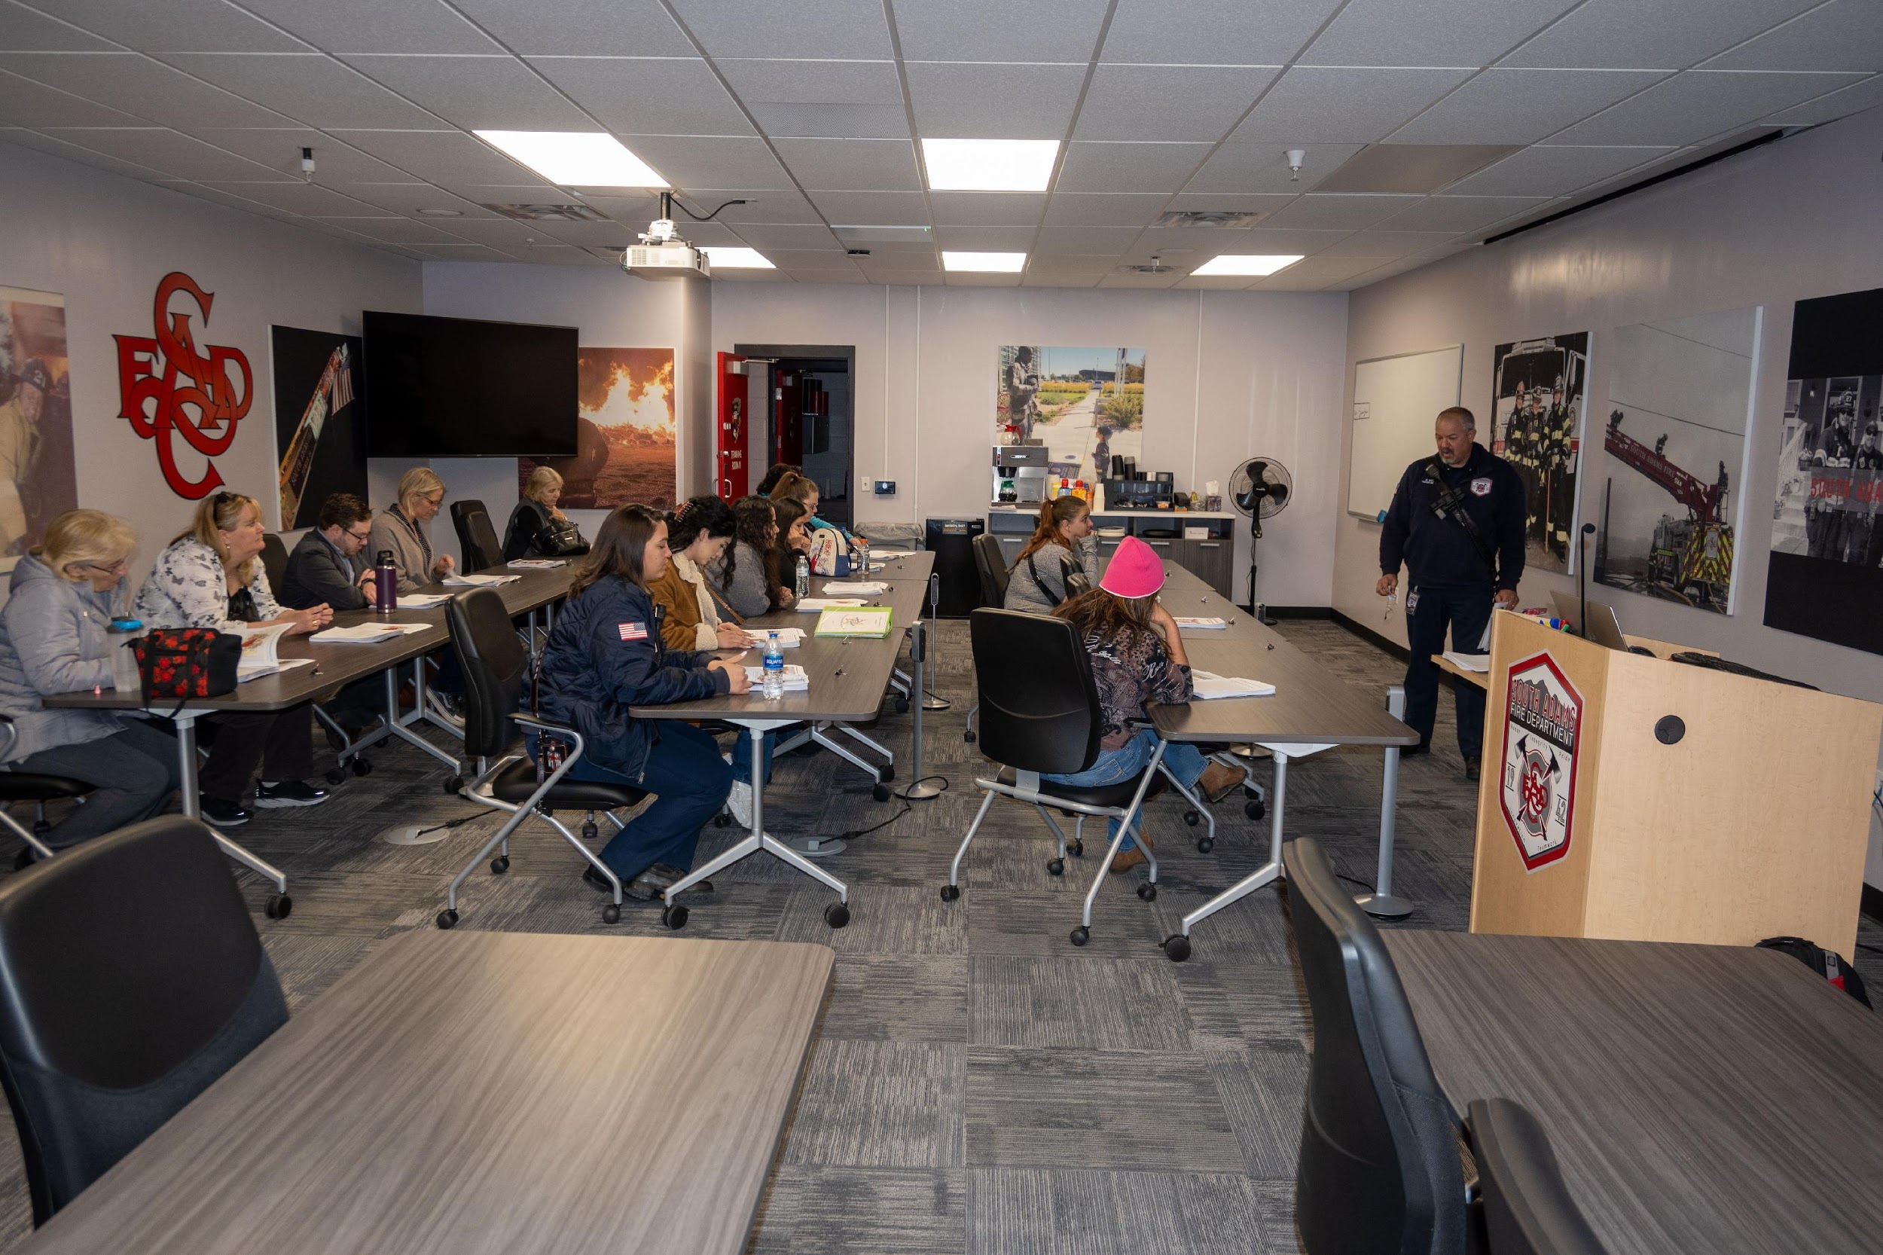

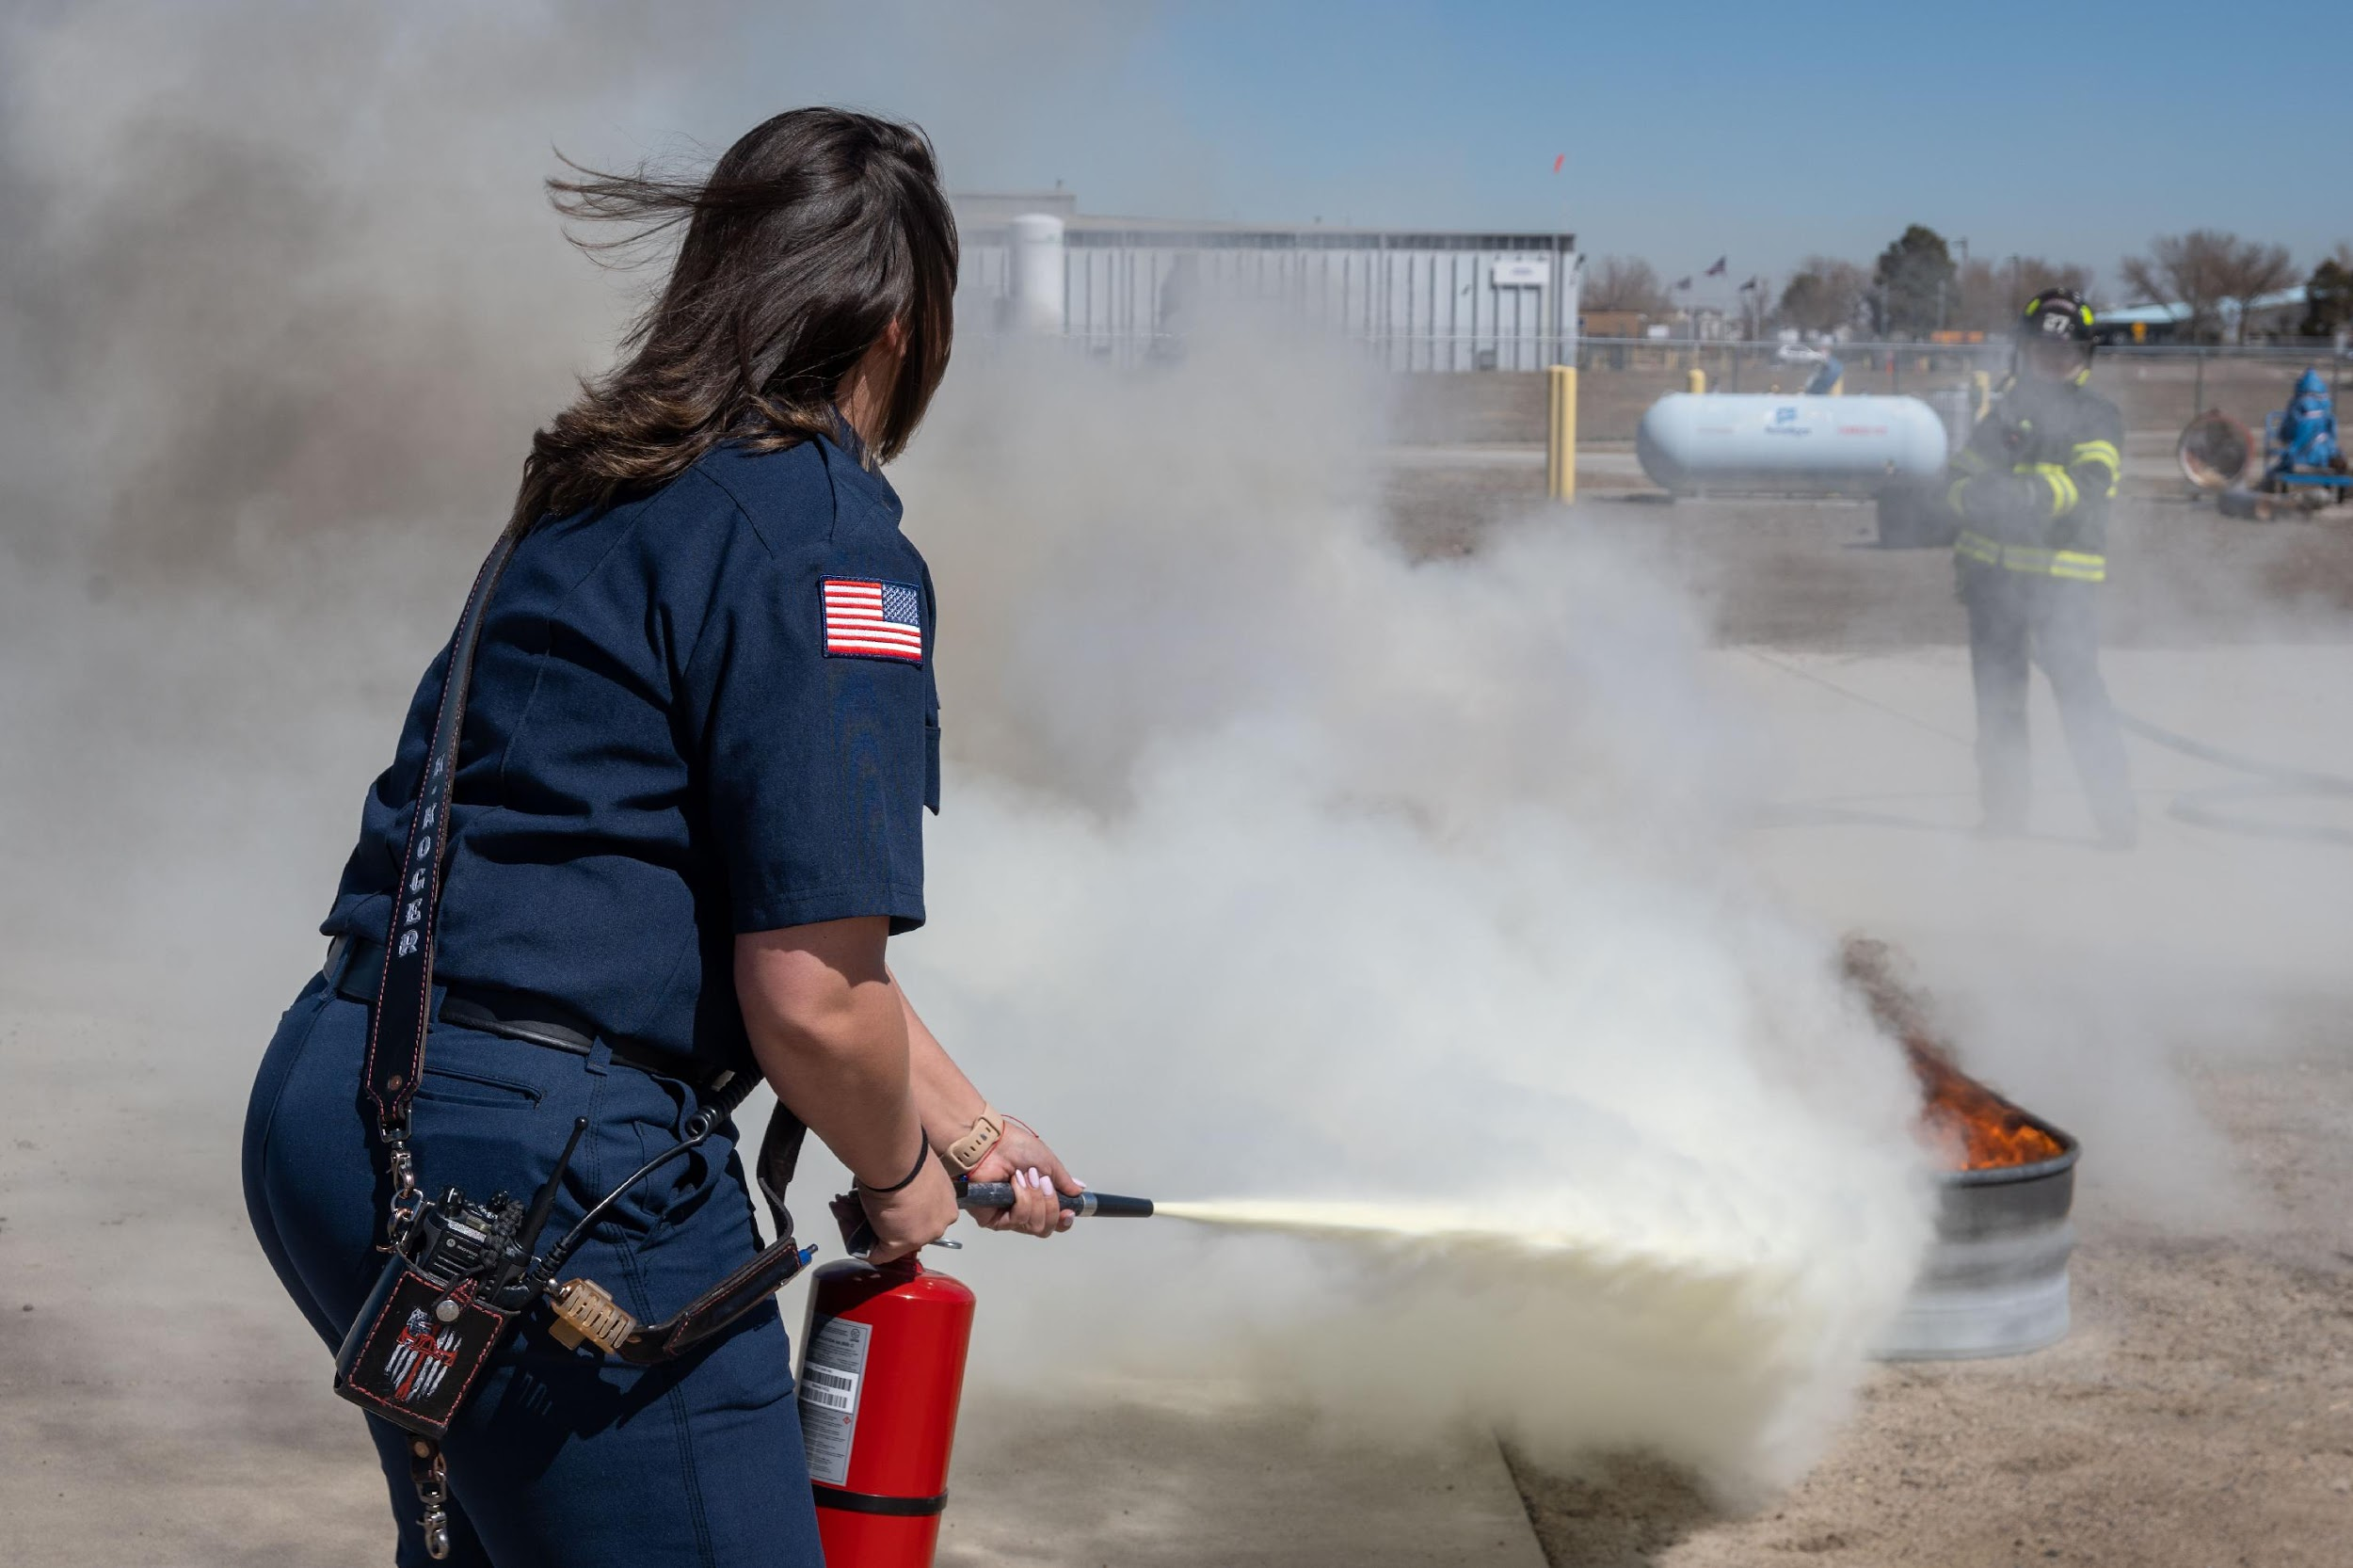

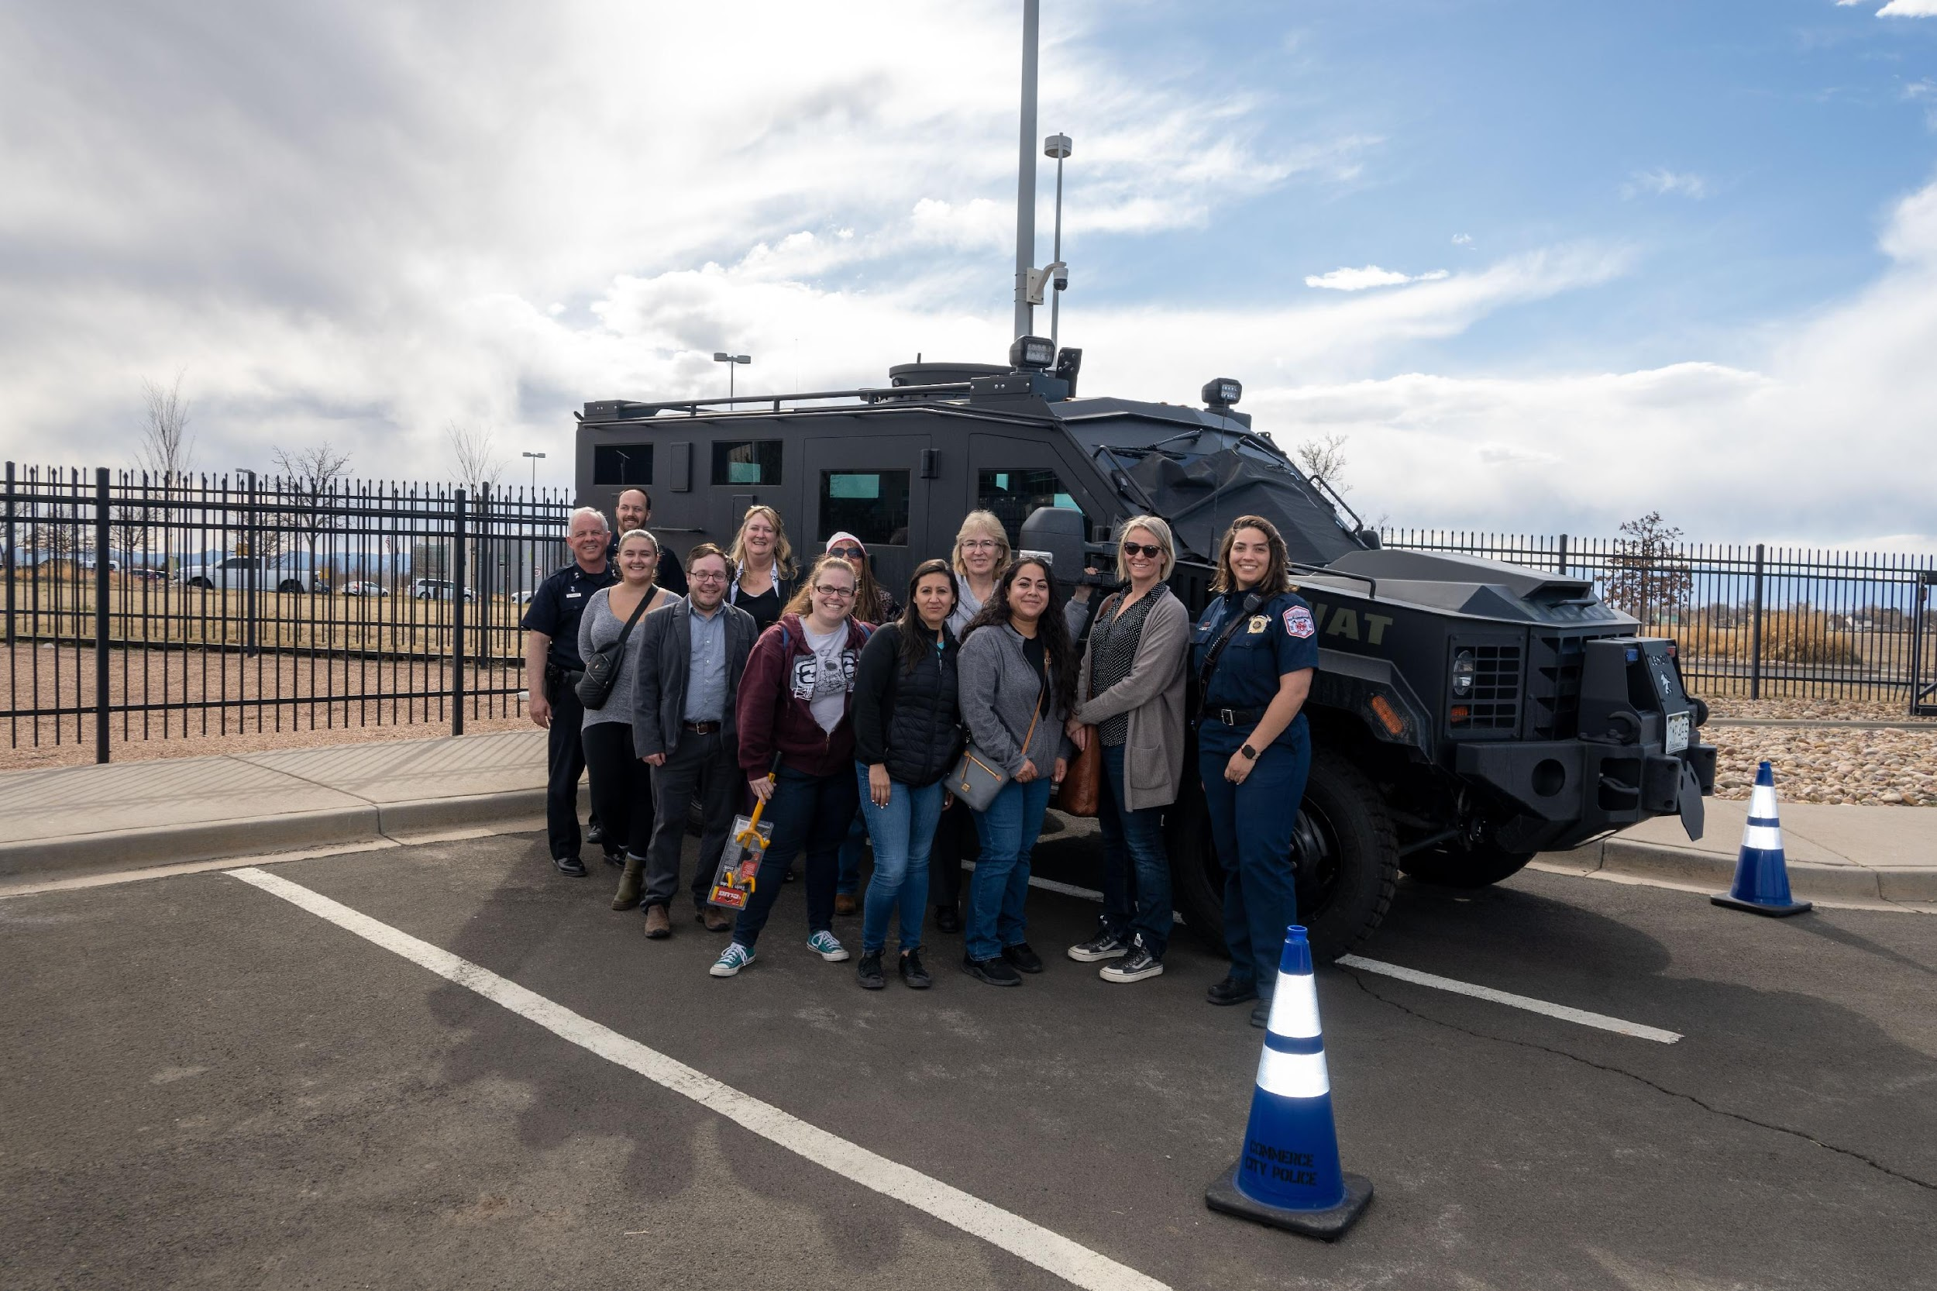

SESSION 9 (Friday – May 2, 2025) 8-4 pm
Quality of Life Day
Explore the many aspects of Commerce City including our Parks and Recreations Service. Visit the golf course and see inside our international soccer stadium.

Class Leaders: Lisa Nordholt, Lori Young
Class Objectives:
- Better understand the outstanding activates available in Commerce City
- See behind the scenes operations

The Day will include:
- 8am Breakfast
- 8:30 Welcome and Intro to Parks, Recreation and Golf (Carolyn/Chad)
- 9:00 Outreach and Special Events (Kylie)
- 9:20 Tour of Eagle Pointe Recreation Center and History (2 groups)
- 9:40 Travel to Paradice Island
- 9:55 Tour of Paradice Island (Corey)
- 10:30 Travel to Buffalo Run Golf Course
- 11:00 Tour of Golf Course
      - Talk regarding BRGC
- 11:45 Lunch
- 12:30 Travel to Rocky Mountain Arsenal Wildlife Refuge
- 12:45 Welcome to the Refuge (Dave/Sarah)
- 1:15 Archery/Leadership program (Shannon/Ali)
- 2:15 Travel to Sandcreek- Wetlands Trailhead
- 2:30 Goals of Sandcreek Regional Greenway Partnership (Mo)
- 3:15 Travel to Eagle Pointe
- 3:30 RTD Presentation (Troy Whitmore)
- 4:15 Closing
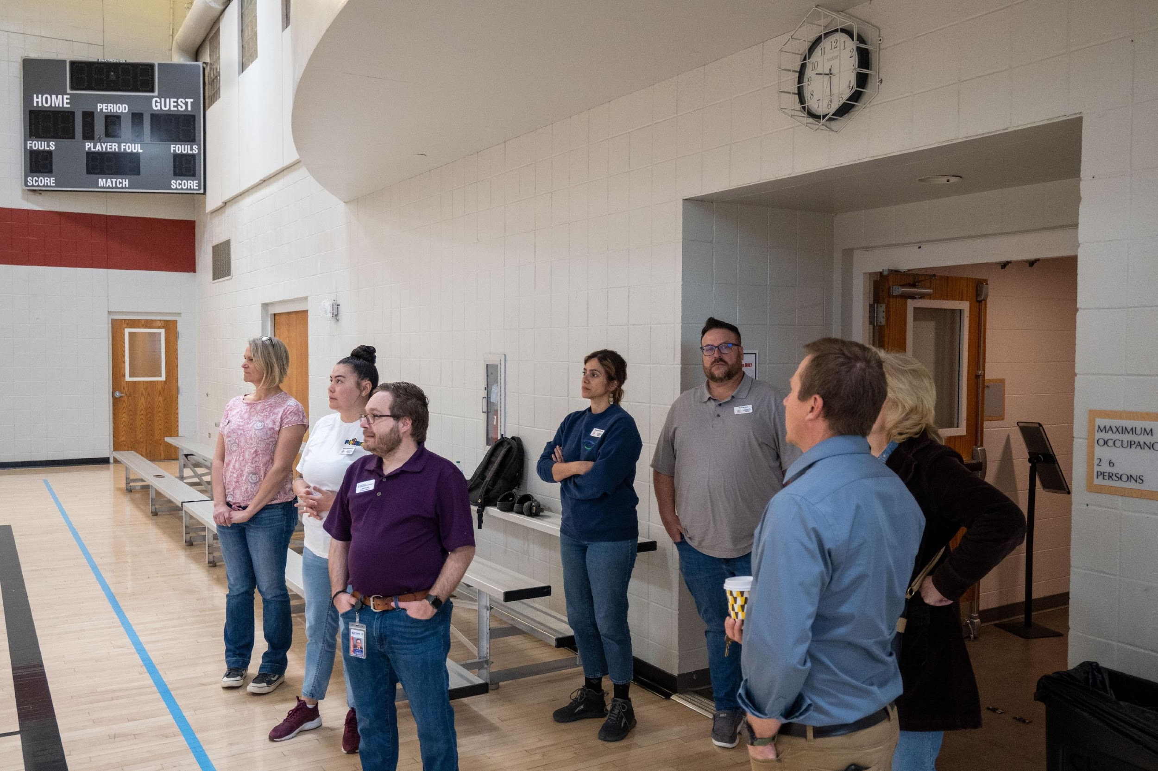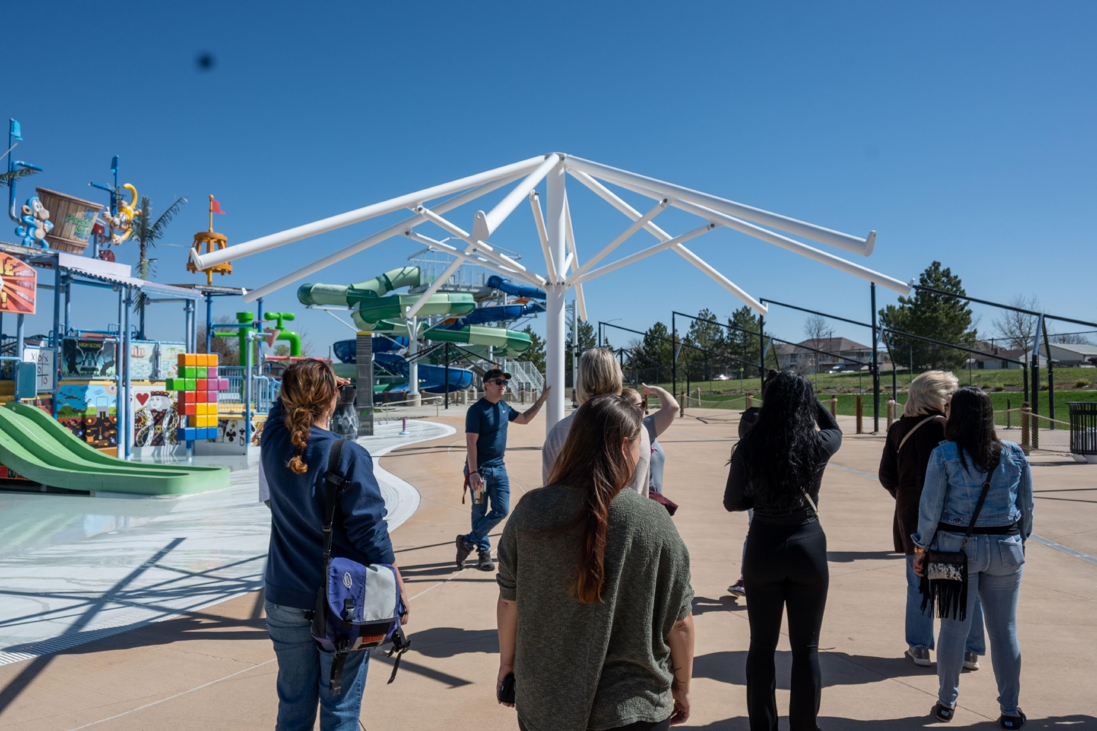
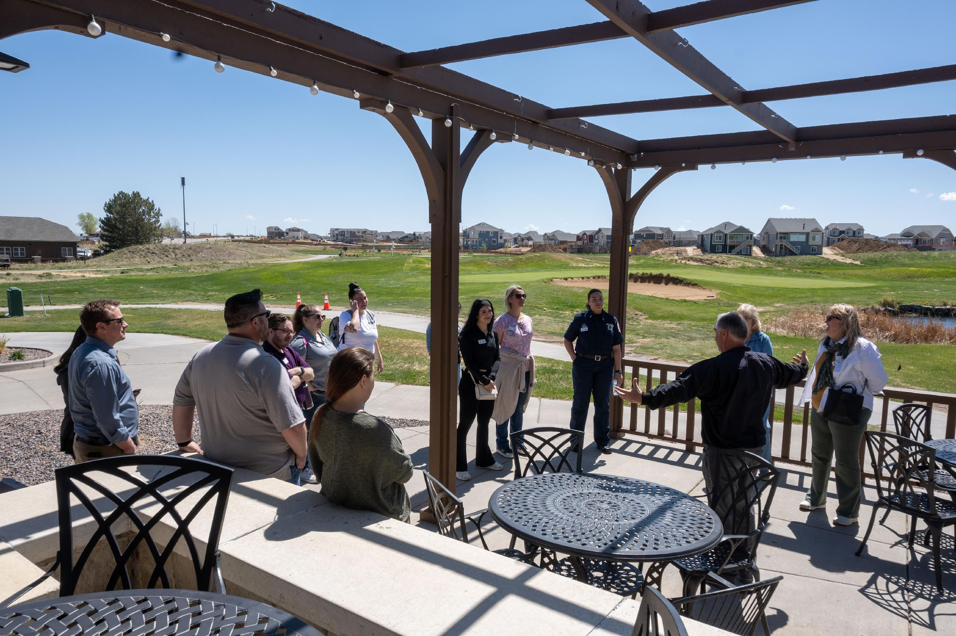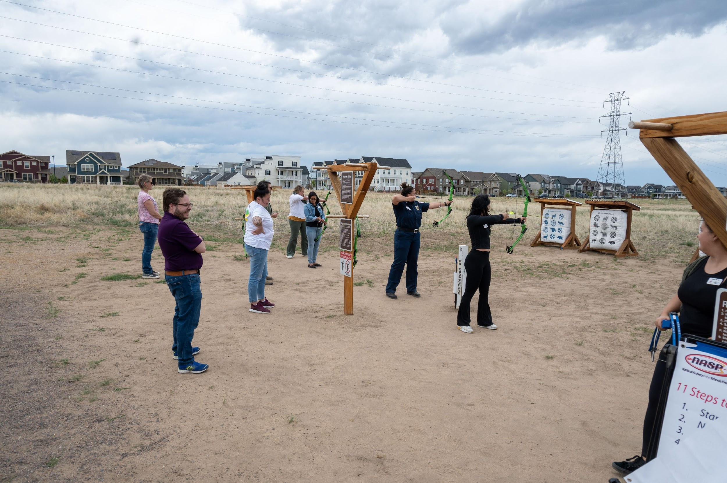
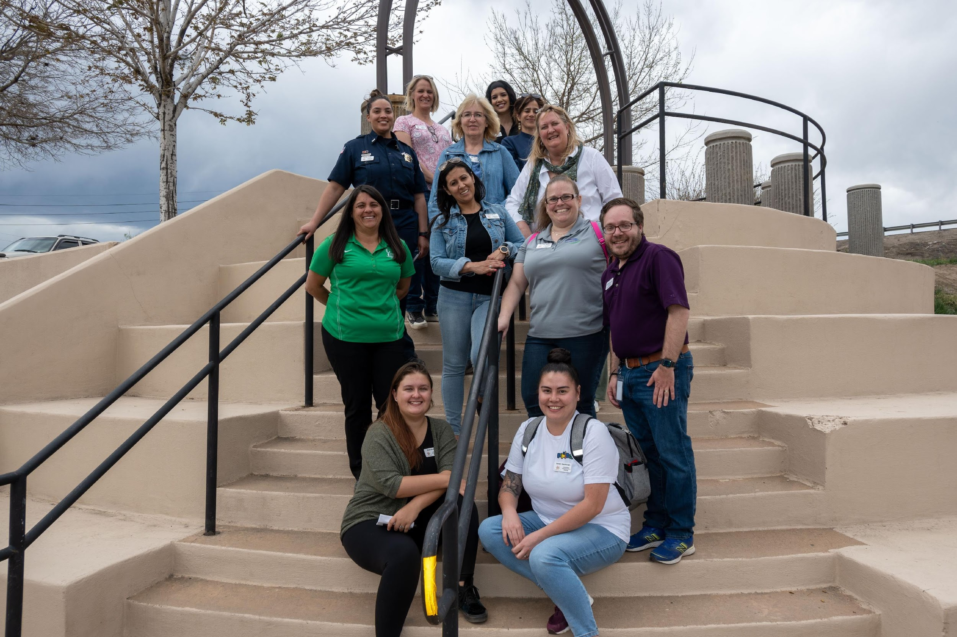

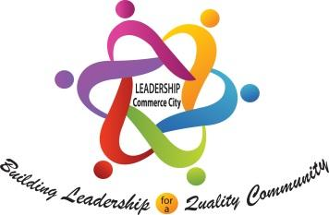
SESSION 10 (Friday – June 6, 2025) 8:00 a.m. - 4:00 p.m.
Commerce City Past and Future Development/Energy

You will learn about the Past, Present and Future of Commerce City. You will take tours of select parts of historical sites in Commerce City. You will spend the afternoon discussing Energy resources in Commerce City.
This session will focus on the history of Commerce City as it relates to energy and development. From there the class will tour parts of the city including the Core city and the Northern Range. The final stop will be at Unite Power with additional conversation regarding energy supplies in the City.

Class Objectives:
1. This tour will educate participants about the history of Commerce City.
2. Participants will learn about the city’s historic landmarks, schools, businesses and neighborhoods.
3. Learn about the development and growth leadership decisions through previous community leaders.
4. Learn about the Energy resources in Commerce City.
Class Outline:
Class Leaders: Ton Green
1. Breakfast 8:00-8:45
2. Past, Present and Future of Commerce City. 8:45-10:15
2. Tour bus to leave at 10:30 am
3. Tour of the Core City (may include brief stop at the History Museum - 10:30-11:30 am
4. Drive to United Power – Lunch 12:00-12:30
5. Energy Panel at United Power 12:30-1:30
6. Tour of the Northern Range 1:30-3:00.
7. Back to TBD – 3:00 pm
8. Capstone work session 3:15-4:00

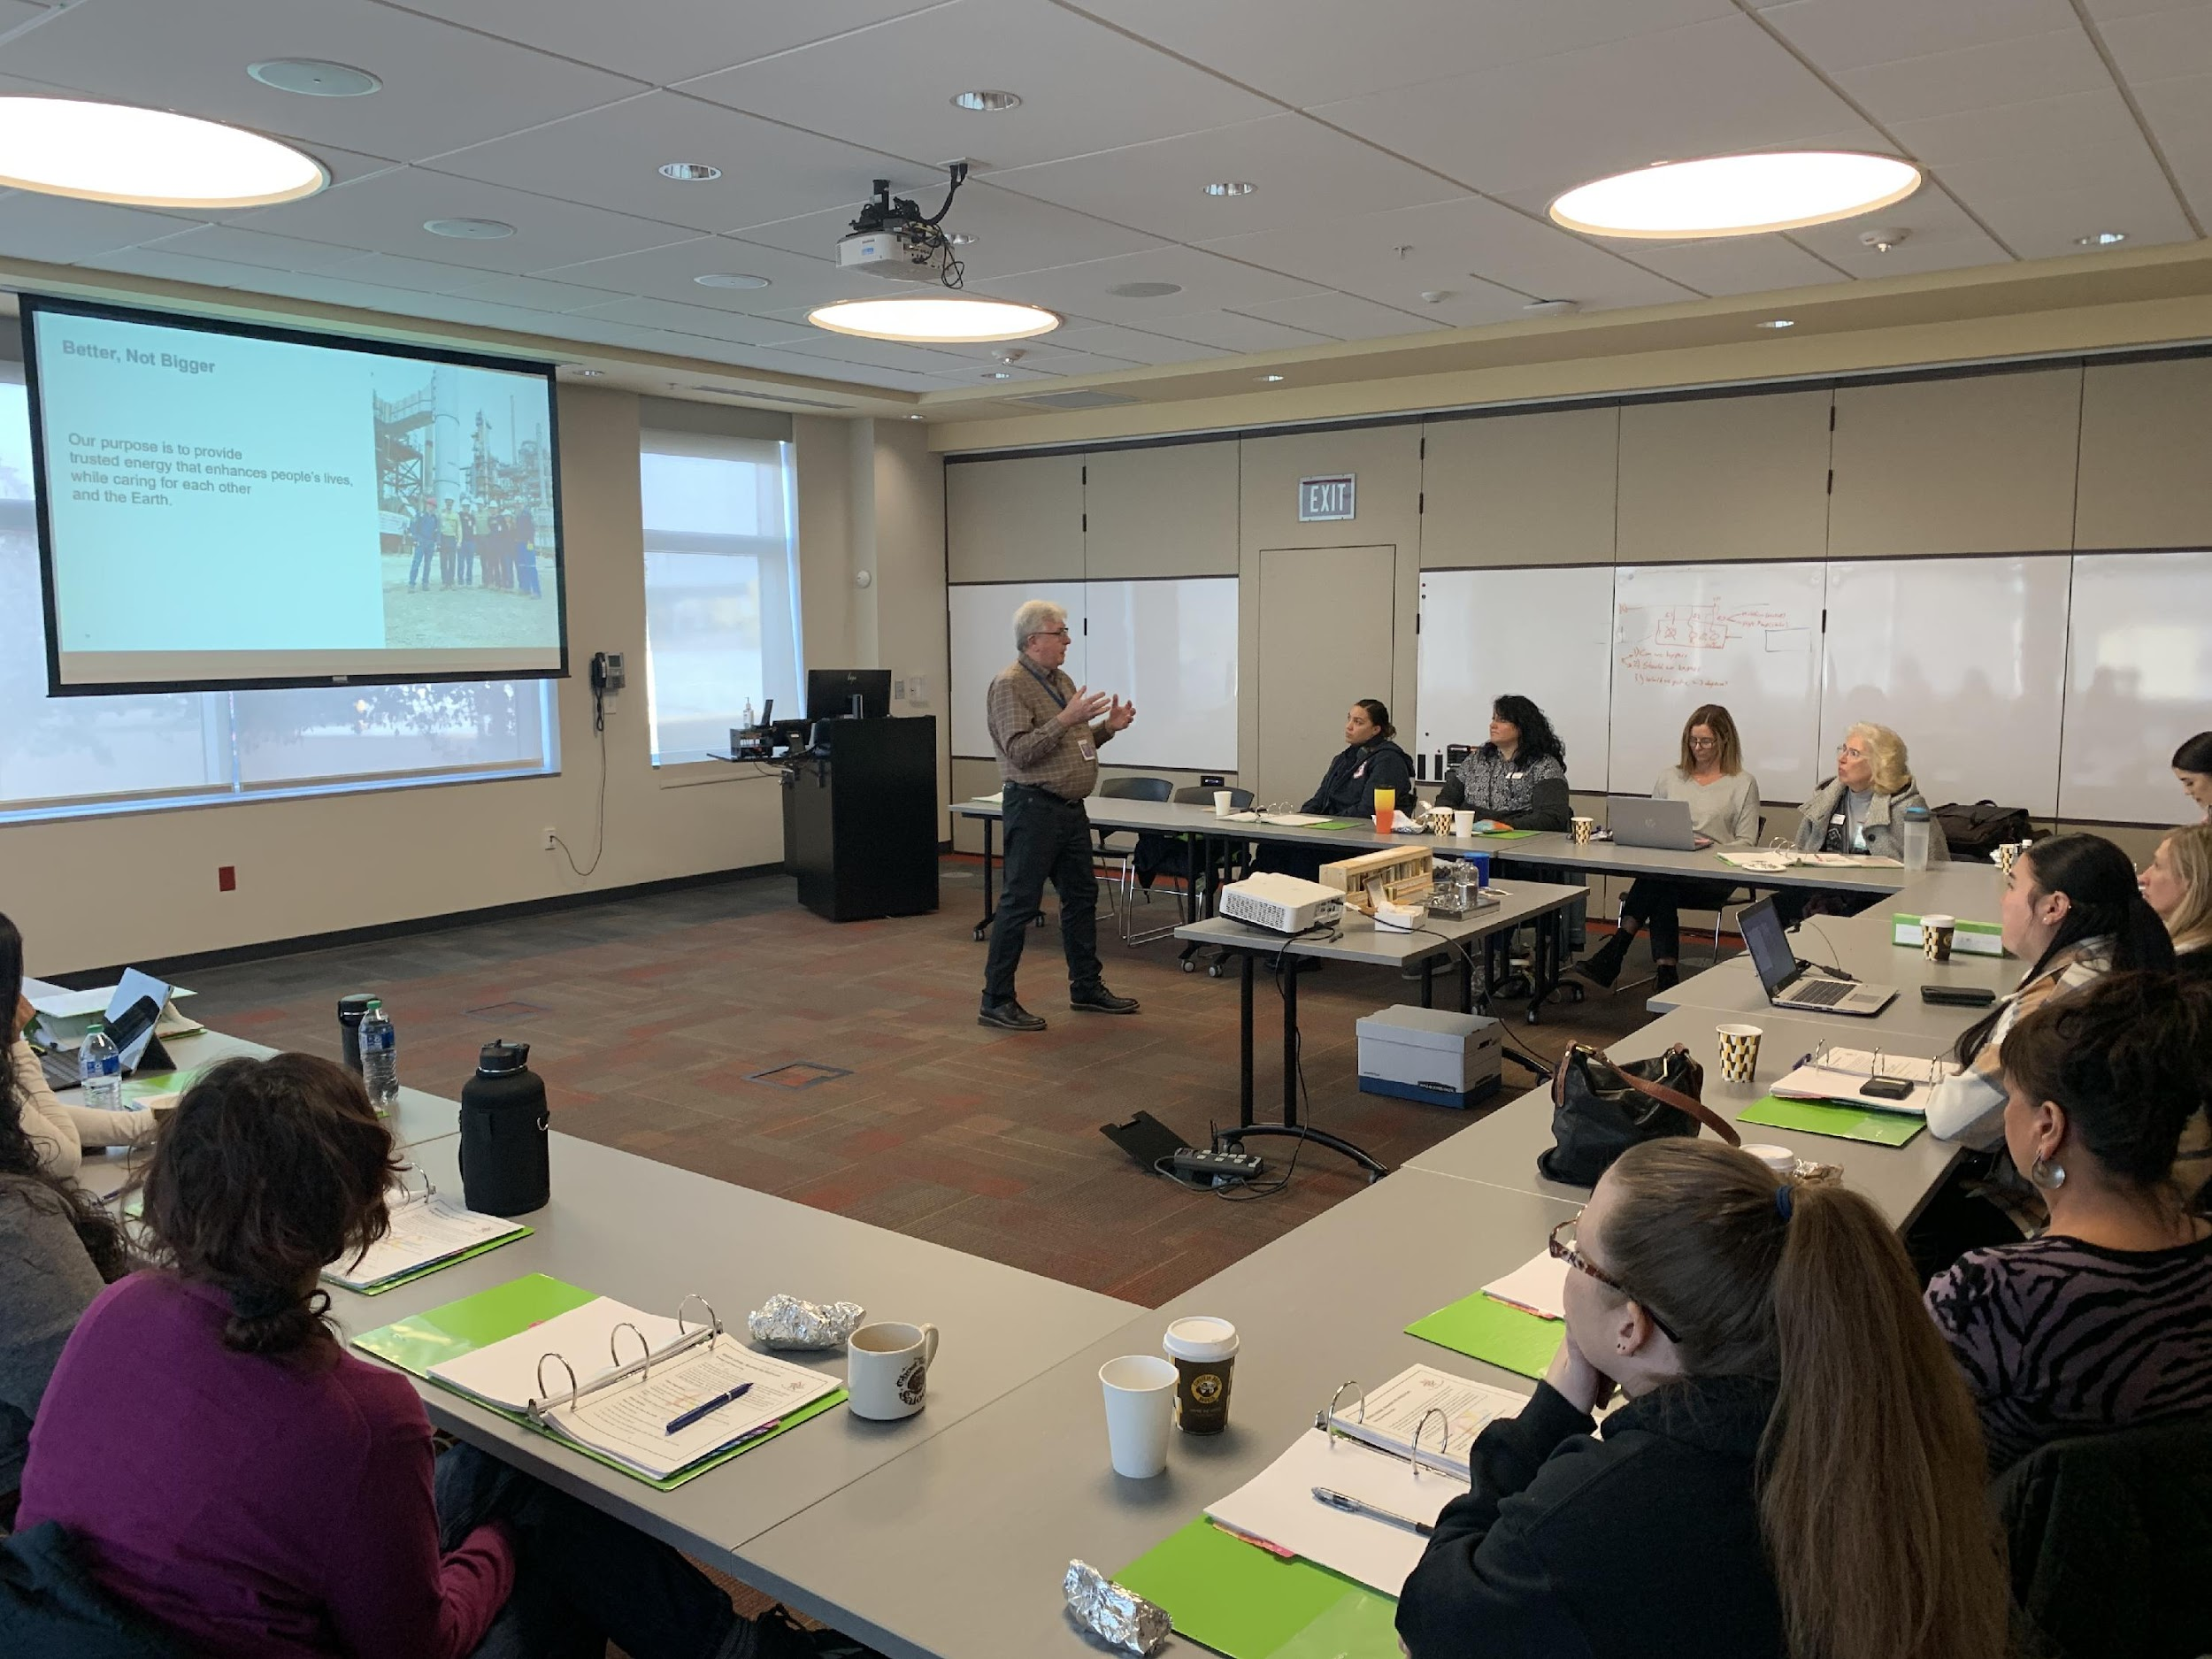
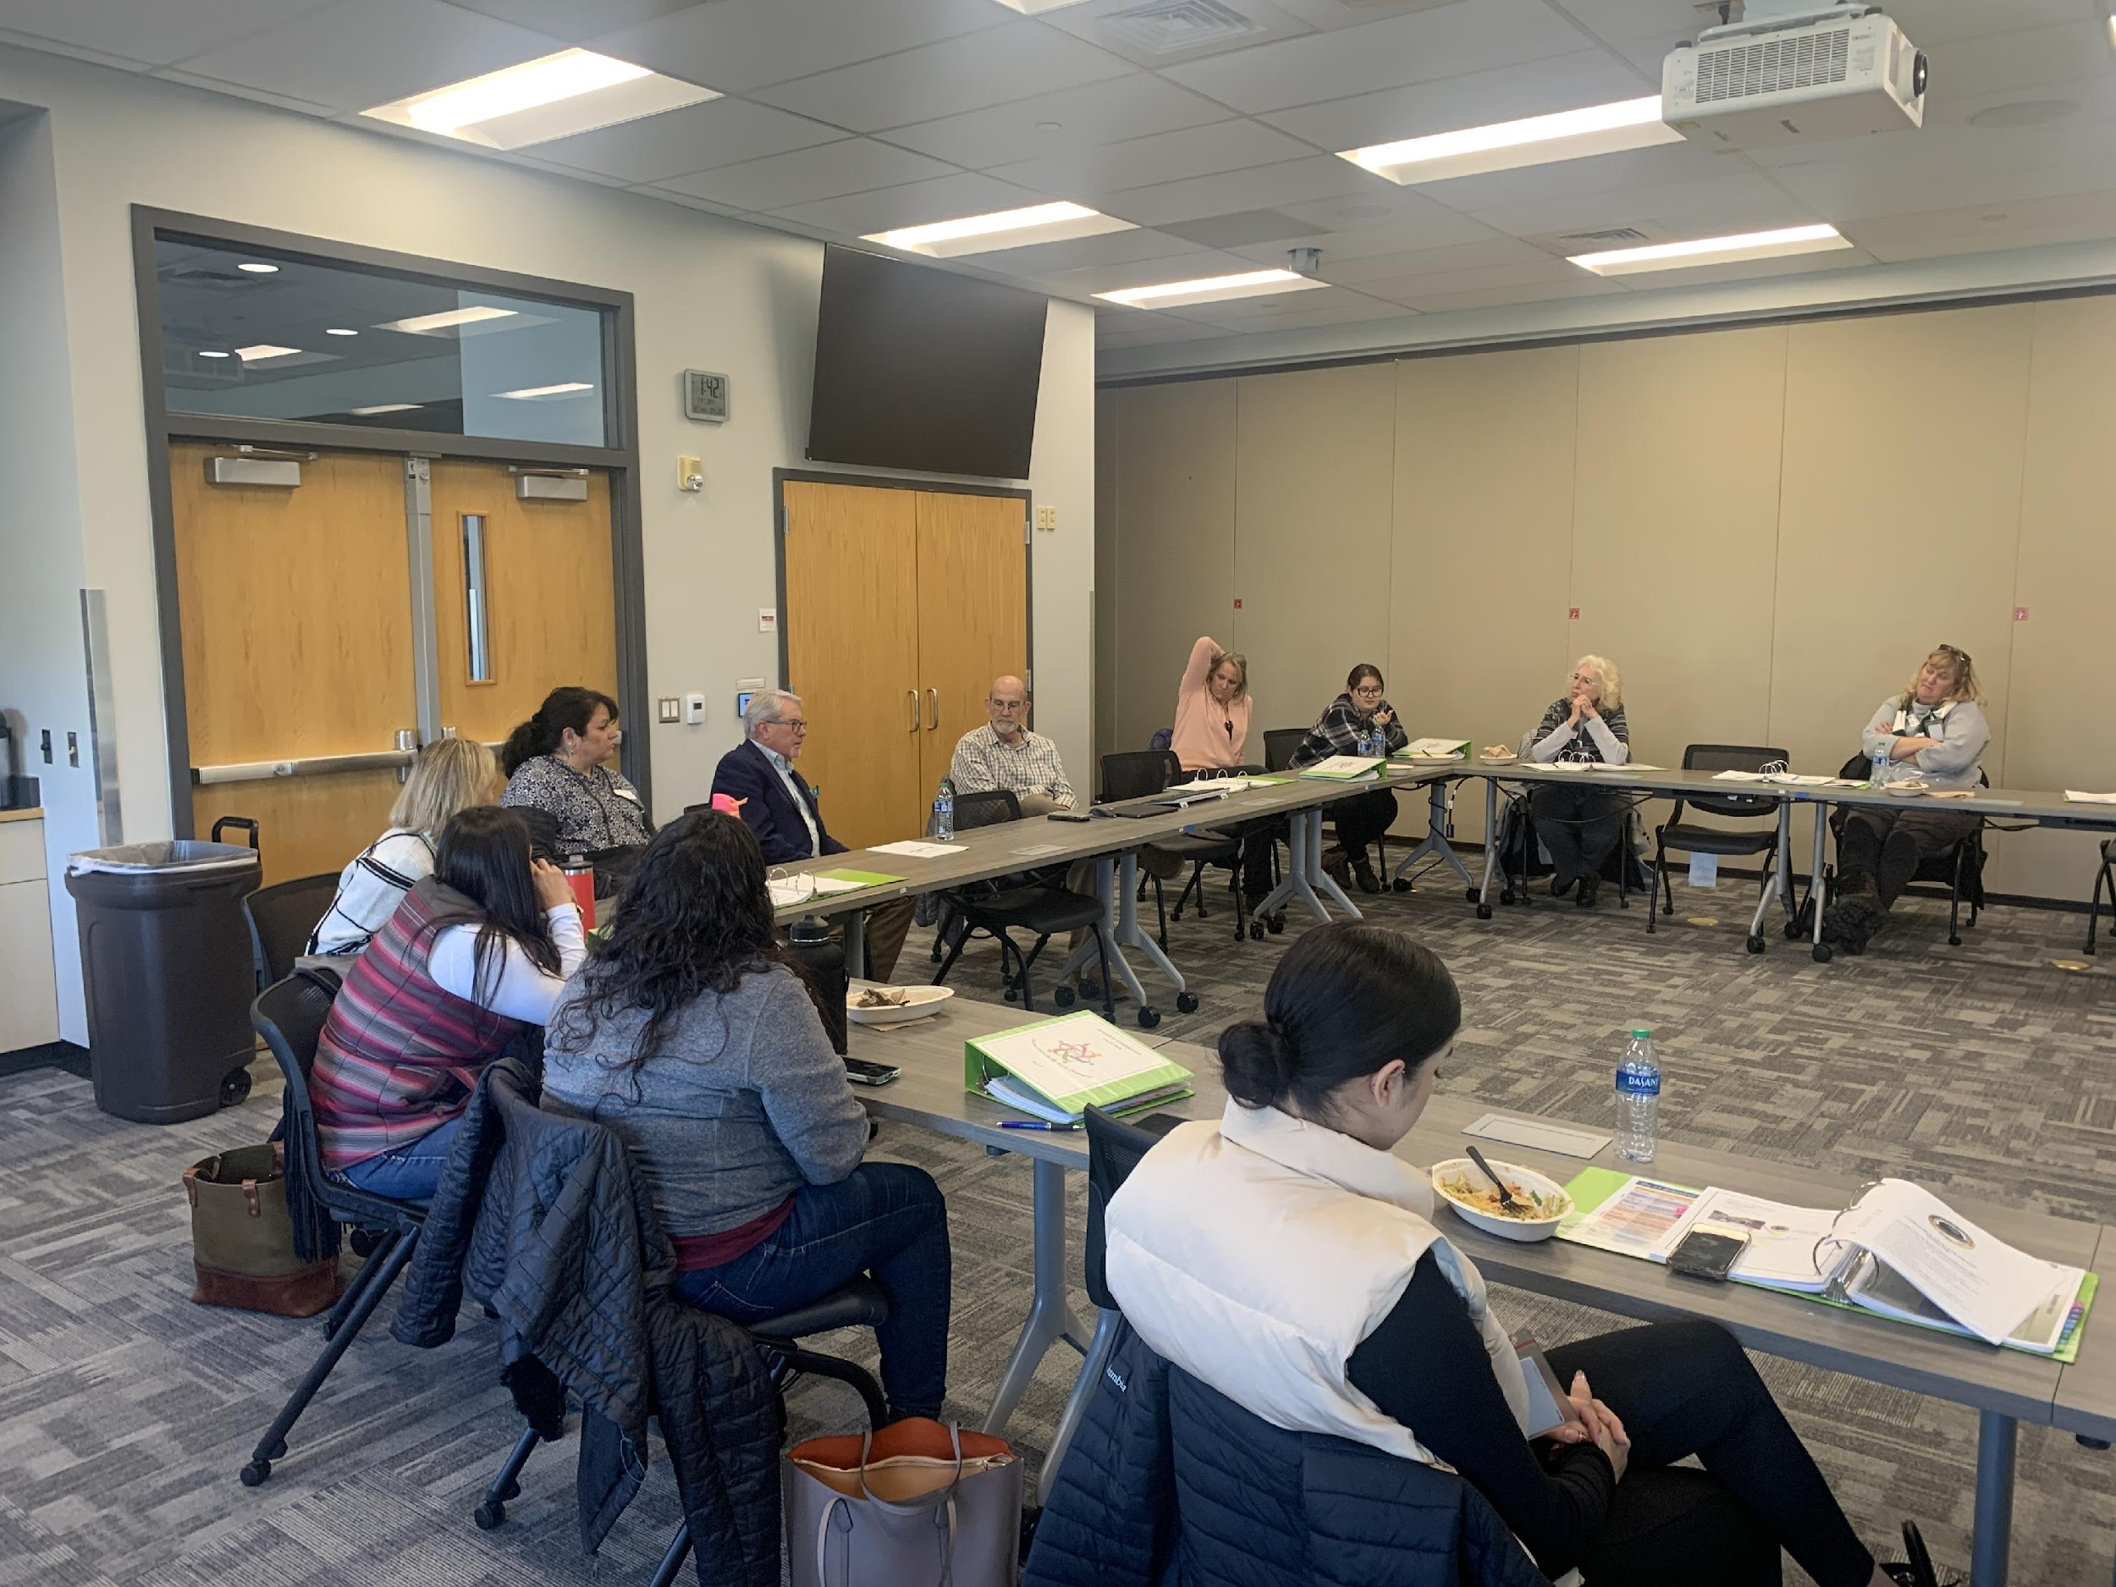



SESSION 11 (Friday - June 20 , 2025) 8:30-10:00 am
GRADUATION DAY
held at the DoubleTree by Hilton - Denver

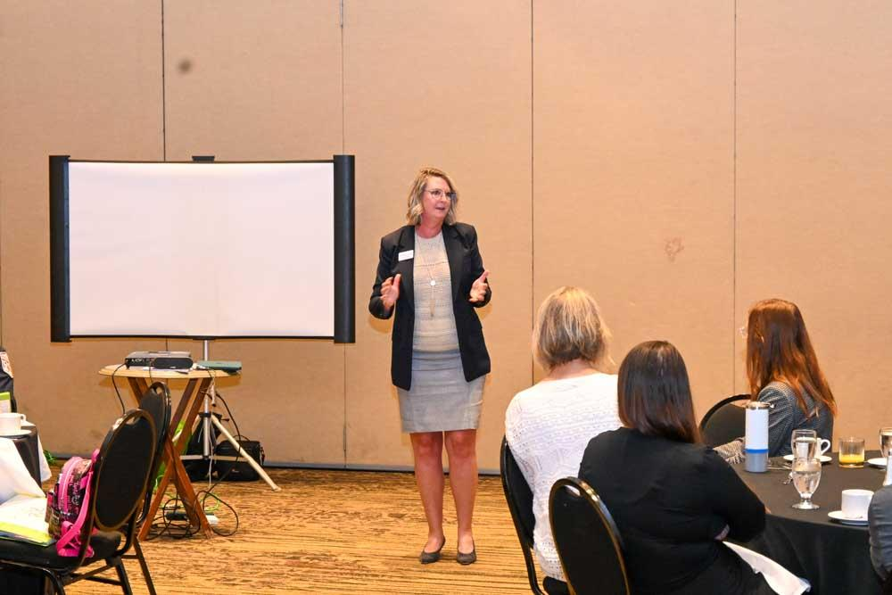
Class Objectives:
1. End of program.
2. Certificate Presentation.

Class Outline: Class Leaders: Randall Weigum, Lori Young
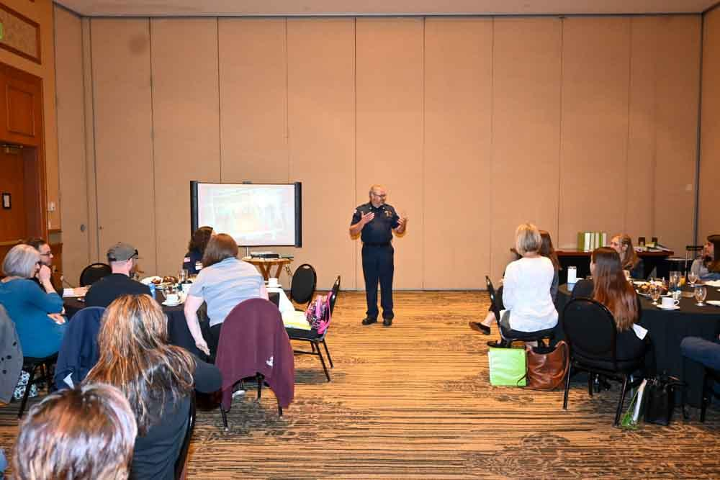
1. Graduation Breakfast -DoubleTree by Hilton Central Park – 4040 Quebec Street
2. Introductions and congratulations – Dr. Tonia Lopez
3. Graduation keynote address –
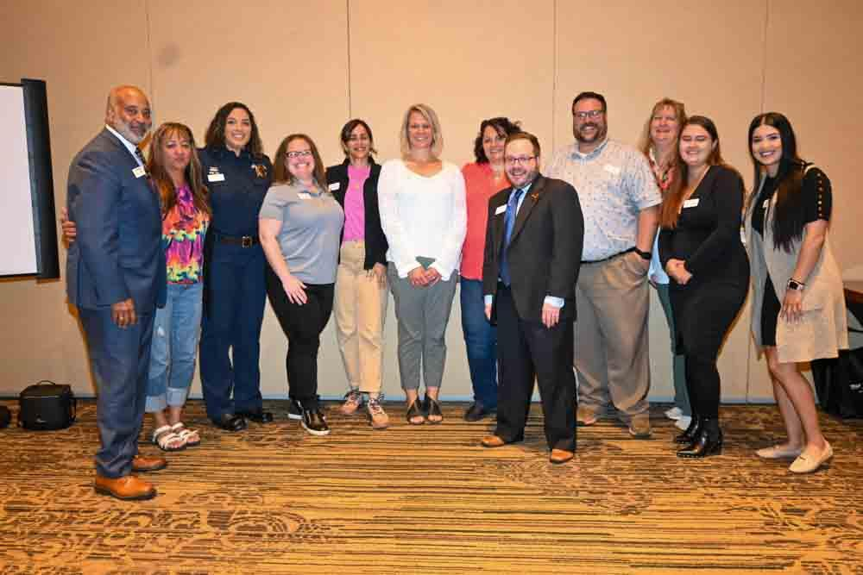

Leadership Commerce City Sponsors:
SUNCOR, Adams 14 Education Foundation, Adams County School District 14, School District, School District 27J, ADCOM, Stout Street Foundation, South Adams County Fire Department, South Adams County Water and Sanitation District, United Power, City of Commerce City, City of Commerce City Parks, Recreation and Golf, United Power, Husch Blackwell Strategies

Leadership Commerce City Committee Members:
Dr. Tonia Lopez, Lori Young, Yolanda Gotier, Tom Green, Randall Weigum, William Frew, Lisa Nordholt, Amy Fidelis, Whitney Connor Gustin, Theresa Friess, Sharleen Maier, Ryan Doherty, Josh Gold and Dale Mingilton
Leadership Commerce City Executive Committee Members:
Randall Weigum; President; Joseph Hermocillo, Vice-President, Immediate Past President; Dr. Tonia Lopez
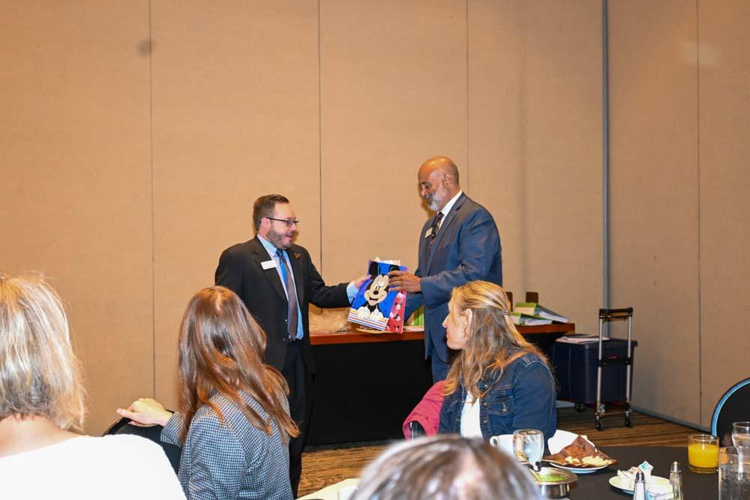

For more information please contact:
Lori Young, Adams 14 Education Foundation – 720-218-7680
Lori.young@adams14.org

NOTES…….

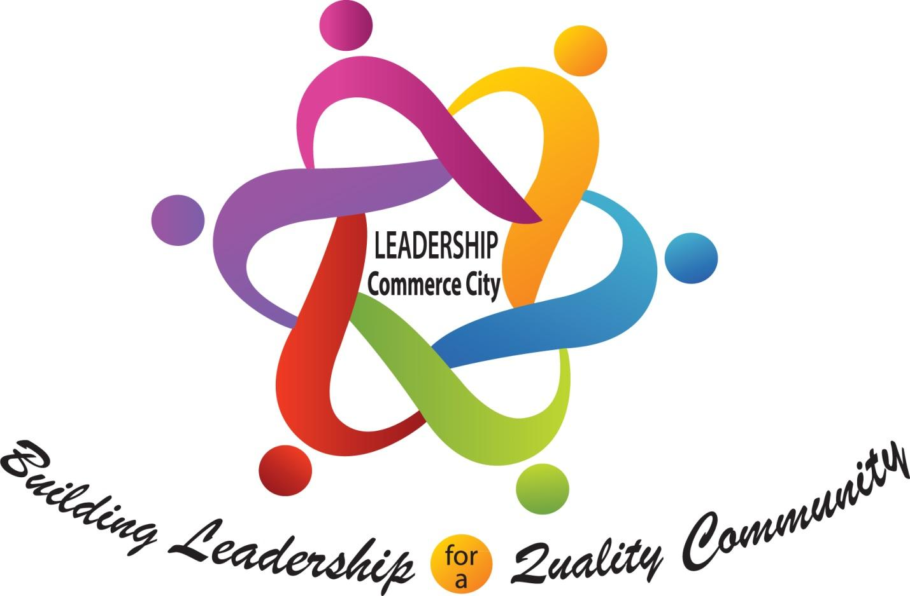

2023-24

