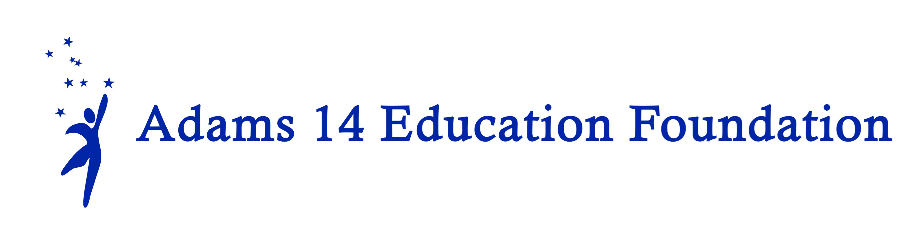

Funding the UnFunded

2021-22

(Mini-Grants)

Creative approaches to enhance student achievement and expand student learning opportunities through projects not typically supported by traditional school funding
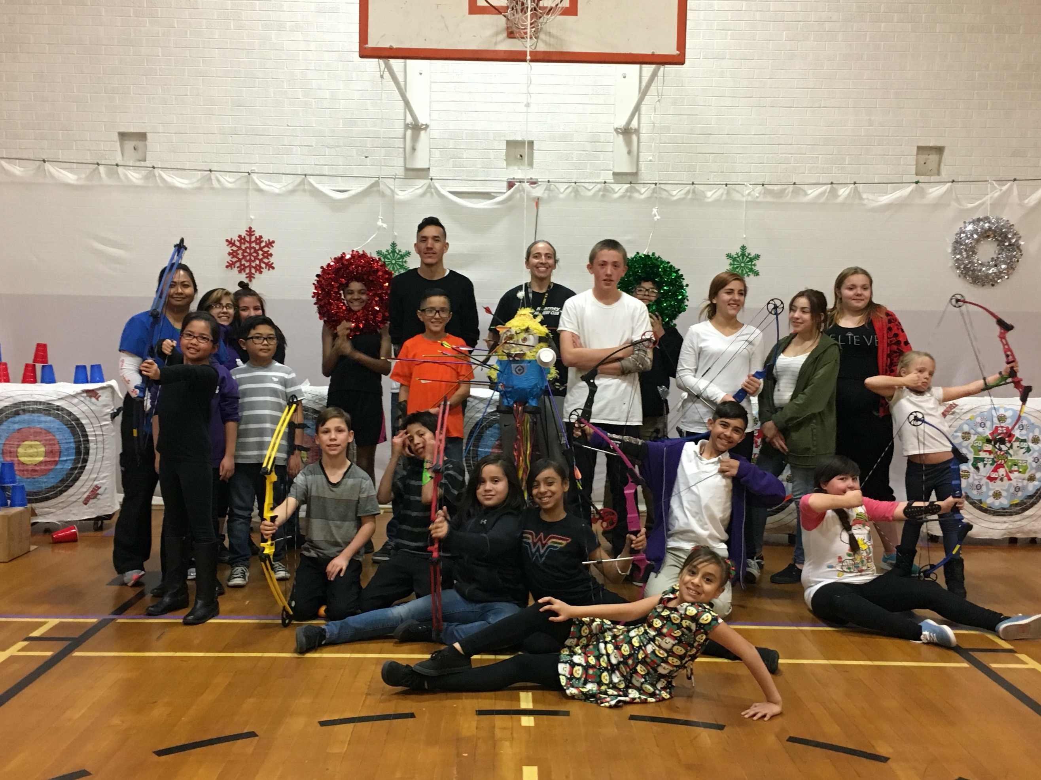

Ms. Gilmore at Kearney Middle School always looks for new opportunities for students to participate in sports. Pictured above, students show off their new archery equipment.
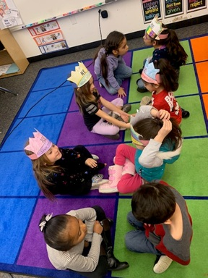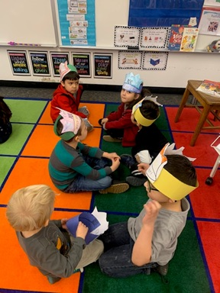

In 2020, the Foundation provided funding to purchase a classroom rug for the kindergarteners. Ms. Gamburg used this rug to help with supporting “a classroom full of wiggly 5 year olds…”

Guidelines

MISSION | The Adams 14 Education Foundation provides small amounts of funds for creative approaches to enhance student achievement or expand student-learning opportunities through projects not typically supported by traditional school funding.
ELIGIBILITY | All Adams County School District 14 employees. Teams of employees are welcome to apply as one applicant. Funded recipients may only re-apply for one consecutive grant period for the same project. Previous recipients may also submit a grant proposal for a new project
APPLICATION REQUIREMENTS | Applications must include:  - A completed funding application form. Please note that we are requesting impact data be supplied for funding. An electronic version of the application is preferred.  - Signature by the applicant and supervisor/principal (submitting by email is considered an electronic signature with cc: to supervisor)  - A detailed budget showing how the dollars will be spent. You must submit a list of purchases in accordance to guidelines from the accounting office.  - Keep the application concise. No more than three pages including the budget. Do not attach any other papers or materials.  - Successful applicants will be required to complete a brief description of the impact of their project(s) at the end of the grant period and may be expected to share their results at the Adams 14er Fest in 2022 and on the Adams 14 Education Foundation website. Results should include how the funding assisted students to increase competencies via data, (i.e. satisfaction survey or test scores.) Photographs are appreciated.
GRANTS WILL NOT BE MADE FOR:  GRANTS WILL NOT BE MADE FOR: | - Transportation costs for field trips, etc. (Possible exceptions may be made by the Adams 14 Education Foundation Board from time to time.)  - Technology hardware (e.g., iPad, tablets, e-readers, etc.) Software requests may still be considered but must be approved by the Adams 14 Technology Department prior to purchase.  - Capital equipment and/or improvements to District facilities  - Substitute Teachers  - Stipends for District staff to attend conferences, seminars or classes  - Staff salaries  - Honorariums  - Projects normally funded by the school district’s regular operating budget.  - Duplicate proposals for the same project.  - Proposals identical to previously funded projects without a report or summary of the project’s previous impact and success.
AMOUNT OF GRANTS | From $300 to $1,000 per project  PLEASE NOTE: Grant funding must be obligated by the end of the school year according to district accounting guidelines.
APPLICATION DEADLINE | There will be one grant cycle.  Applications are due on Monday, October 11, 2021,  5 P.M. Electronic submissions preferred.  dmingilton@adams14.org
NOTE TO LAST YEAR’S RECIPIENTS | Be sure that you have submitted a final report on your previous project and provided accounting with a list of your expenditures. You will not be eligible for new funds until the program and accounting report for your previous funding has been completed.
If you have questions, please call or e-mail: | Dale M. Mingilton, Executive Director  (303) 853-3253 (Office)  (303) 517-1914(Cell)  dmingilton@adams14.org

Review Process

A committee made up of Foundation Board members will review the grants and make the final awards. Remember that not all readers will be familiar with all grade levels and/or curricular areas. Please give a complete explanation of the project to assist the readers in their review.

Committee members will read and rate each application using the criteria listed below. Maximum score is 50 pts.

(10pts) Clarity: Project is clearly stated, describing project’s objectives and activities. Reviewer is able to visualize project "in action." Relevant project dates are included. Application is typed.

(15 pts) Originality/Innovation/Enrichment: Project involves a creative, unique approach to meet student needs while supporting district and school goals for achievement. Please note that mini-grant funds are NOT intended to pay for general supplies or activities normally supported by the basic curriculum or general budget. Mini-grants are expected to be "pilot" projects, and the Foundation does not expect to fund multiple or duplicate grants for the same project, whether year-to-year or from different teachers whether from the same or different schools. Collaborative proposals are encouraged.

(10 pts) Impact on Students Served: Project clearly describes how it will serve students including the number of students and parents. Please indicate if the project is sustainable and will serve students in future years.

(10 pts) Evaluation Process: Project includes criteria for measuring success. Specifically, what problem is being addressed? What results do you want to see?

(5 pts) Budget: Budget is detailed, complete, and realistic. If total project funding exceeds more than $1,000, include sources of any additional funding.

