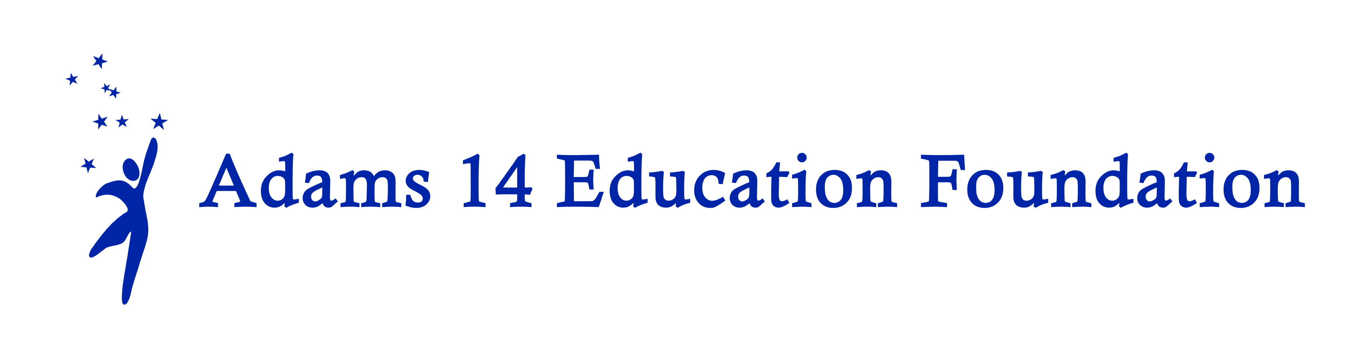
SY2022-23 Adams 14 Education Foundation
Funding the Unfunded Report

NOTE: Please be sure to answer question number 1. Your feedback is important in helping us to understand the impact and effectiveness of funding these projects.

Date: Is this an interim report? Yes ___ No ___
Name
Contact Info | School: | Grades:
Contact Info | Telephone: | E-mail:
Name of Project |  | Number of students served:

1. Describe how students were impacted by these funds? How did the funds enhance literacy and/or student achievement? Please be specific.

2. What, if any, recommendations do you have for the funding process?

3. Do you intend to submit a Funding the Unfunded application in the future? | Yes ___  No ___  If no, why not?
4. Was the funding award amount adequate? | Yes ___  No ___  If no, how much do you think the maximum should be?

